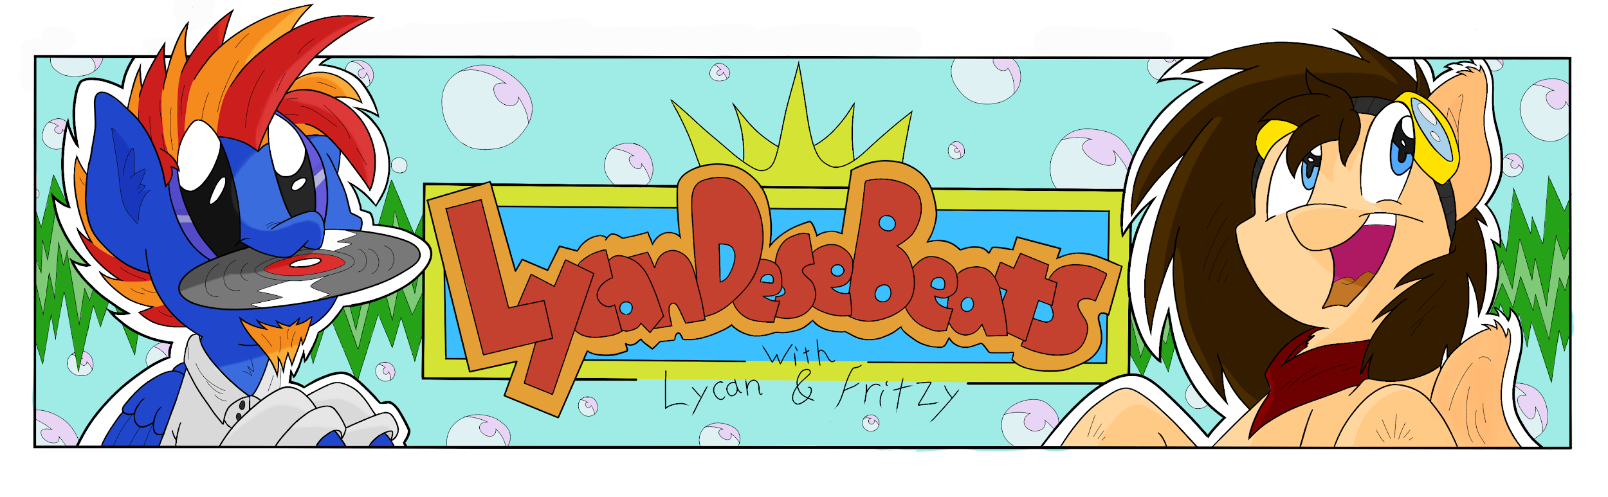
Hello everyone!

Last year, in June, we saw the release of a “Lycan Dese Beats: Beats Me” album. The purpose of this album was to allow all types of musicians to contribute music towards an album which was to be released for EVERYONE to download and listen to. There was an incredible variety of music and we’re not planning on stopping at just one album. We’re proud to announce that we’re opening for submissions for our next album… Lycan Dese Beats: Beats Me 2.

In keeping with the first album, the purpose of this one is to encourage musicians to contribute towards an album. We are not looking to be the best of the best in the fandom (although we do want high quality and enjoyable music), but rather to feature interesting and fun music. We want music creation to be fun and enjoyable, not feel like a chore or “work”. If you aren’t having fun, you are doing it wrong! So experiment, go with the flow, attempt something you may not have tried before… It is all up to your imagination!

As with last time, the album will be free to download and will be premiered on the radio for everyone to listen to and enjoy.

Important information:

Submissions Form: https://goo.gl/KjcKfW

Soft deadline: 2nd June 2016
Hard deadline: 16th June 2016

Feel free to submit finished tracks to lycandesebeats@gmail.com or via the submission form at any point before the deadline. As a soft deadline we will do our best to contact you so that we can provide you with feedback and make any changes you want to be made based on the feedback before final submissions are due. It’s highly recommended that you make use of this (note that taking any feedback given into account will not guarantee you a place on the album, it will just help to increase the quality of your submission).

Frquently Asked Questions:
Why should I take part?
This is a great way to take part in a group effort to create something great, improve your craft, collaborate with others and be a part of something awesome, as well as the exposure brought by being on the album! The Lycan Dese Beats album was a great way for new musicians and veteran musicians alike to get involved in an album. Whether you're new to music, or an experienced artist, we will try our best to show your creative side.

What kind of music does it have to be?
This is a general compilation album, so any kind of music is acceptable for submission! Although we encourage you to have fun with the album and try something creative, we may have to reject songs that aren’t of the quality we are looking for. In the past, we’ve had submissions of all genres, and we aim to have something for everyone in our releases, so don’t feel like you have to submit something in a specific genre. Although we’ve never had a yodelling death metal song submitted to us, it might be difficult to include in the album because we aim to make our album enjoyable for most people.

How many tracks can I submit?
You can submit as many songs as you want (within reason). Two songs from the same artist may get in without any problem, but over that number (not counting collabs), we might only take the best two of them.

What about collaborations? Remixes?
Collaborations are definitely ok! Remixes are also acceptable, but only if permission is granted by the original artist, or in such a way that we can verify that permission has indeed been given.

Will a collaboration I do count as my one entry that can get onto the album?
Nope! We like to encourage collaboration as well as promoting individual artists. So, if you collaborate with somebody else and it gets onto the album, you’re also able to get onto the album with a solo entry. We don’t want to discourage collaborations, so a collab between artists A & B will effectively count as an entry from a new artist C.

How will tracks be selected for the album?
The tracks will be judged by a group of judges and songs will be included or excluded based on their quality. The number of tracks on the final release will depend on the number and the quality of the submissions. Judging feedback will be available should you request it after the song list has been finalised.

FAQ continued next page...

Where does the money from the album go?
The album will be released on BandCamp under the ‘pay what you want’ release model, starting at $0 for those who don’t wish to donate. You aren’t under any obligation to donate, but if you choose to donate, we are certainly grateful. All donations will split 50/50 between the running of Lycan Dese Beats and the Bronies For Good charity of choice, which is currently the Against Malaria Foundation. As it is, I have personally spent over $1000 USD in total to create the Lycan Dese Beats show every week and to promote albums like this one. This includes hardware, software, artwork, etc. If the album reaches this amount covered, then ALL donations from that point on will go towards the charity, Against Malaria Foundation.

When can I release my track?
You can release your track as soon as the album is released on BandCamp. Before that, feel free to show it privately to whomever you wish, but waiting until the album is out before a public release is much appreciated. Releasing works in progress to the public is perfectly fine.

Is there a way I can share progress with others and get help?
We have a Skype group for general discussion and providing feedback to each other. To be added to this Skype group, just send a Skype contact request to rhys.christy, and make sure to include something about wanting to join the group in your contact request.

If there are any other questions, feel free to ask any of the team, or send us an email at lycandesebeats@gmail.com

Release Date: Weekend of July 2nd

BandCamp: https://lycandesebeats.bandcamp.com/

Thanks,
The Lycan Dese Beats Team (Lycan, FritzyBeat, Spectra, Chord Catcher)

