I've been curious about the technology in MLP because I'm a headcanon-toting fanfic-slurping nerd that thrives on that.

I know that most tech we see in MLP that seems out of place is purely due to artists/writers not giving a shit about consistent lore or following rules set by Faust. Some art throw-away gags.

- TRANSPORTATION
  - Trains
  - helicopters and rudimentary flying machines that use rotating blades to produce lift
There is a toy prop airplane (s6ep3): 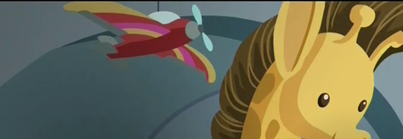
  - they actually do have automobiles! They use parade floats in the Babs Seed episode, but maybe they use some other system to get them to move since they didn’t have motors or exhausts.
  - Zeppelins, semi-rigid and non-rigid airships or other airships
  - Hot air balloons
  - Hang gliders
  - Jet Set has a jet airliner cutie mark??? Maybe he’s an investor in new tech? Gizmo also has a robot cutie mark.
  - Handcars, mine carts
  - Sailboats, pirate ships (just pirate-commandeered 16-17th century style sailing ships, meaning there is a healthy mariner community), yachts, rowboats, etc
- INDUSTRIAL
  - weird apple cider machines?
  - Weather factory (prolly the biggest factory in the country idk)
  - Dams
  - Construction equipment
  - Steel mills (evidenced by skyscrapers and other advanced metal construction)
  - Agriculture processing plants, like Cherry Jubilee’s factory
  - Giant motorized fans
- HOUSEHOLD
  - washers, dryers, modern plumbing, running water
  - printing presses and typewriters
  - sewing machines
  - Gas ranges and ovens, possibly some with heating coils instead
  - Electric countertop mixers
  - refrigerators and freezers (granted very old fashioned ones)
- ENTERTAINMENT
  - Cameras ranging from early 19th century cameras, to polaroids, to modern compact digital cameras. Digital cameras have been around since the 60s, but it’s so jarring to see little ponies using them. I don’t know how they would even process the image without digital storage. Then again this is a magic world so there is likely some plausible way to take pictures with a digital camera without other modern technology.
  - record players and records
  - speakers, turntables and mixing boards (techno music!)
  - Electric guitars, keyboards, etc I feel like I’ve seen a lot of non-acoustic instruments. Regardless, digitally produced pop music does exist within the canon of the show.
  - TVs have appeared in non-show media like in the comics or, ha, tv ads
  - A FUCKING COMPUTER??? (from “Saddle Row Review” s6ep9)
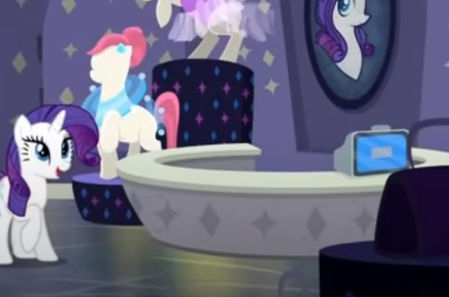
  - Arcade games
  - Cassettes and cassette players
  - I've seen telephones, but those seem rare
- MEDICINE AND SCIENCE
  - Various forms of telemetry. Twilight hooks Pinkie up to a silly brain wave machine in season one.
  - Microscopes
  - Calculators
  - Sophisticated math, chemistry, physics, astronomy including knowing how far away the sun is and its angle when it crosses the meridian, etc etc they even have Schrödinger’s time-dependent equation, which suggests an understanding of quantum mechanics??? This means that they know what sub-atomic particles are, what atoms are, what elements are, and how they relate to each other even in the theoretical realm.)
  - Ponies do have electricity, but perhaps it’s not very wide spread. They have electric lights but I've seen fireflies used for light too. Twittermites are a viable source of electricity.
  - rainbow dash dressed up as an astronaut once, so space travel is at least a part of the culture, albeit not proof that they can go to space yet (beyond a well placed spell lol sorry luna) Danny Trottance also has a rocket on his sweater
  - There’s also randomly airport security during Discord’s Glass of Water song: 
Guess it’s up to the individual to decide whether this is real or not. It is Discord after all.
  - heart monitors
  - x-rays, stethoscopes, head mirrors, head lamps,
- MISCELLANEOUS
  - Various synthetic materials, namely plastic
  - early weapons like bows and arrows, spears, blowdarts, catapults etc and they've made references to tanks and bullets

ANALYSIS

Based on the vast diversity of technology, think of Equestria being around mid-late 20th century. More modern technology is few and far between, and 19th century technology is seen more commonly. Faust herself was pretty careful and more or less consistent with her technology, giving MLP s1 and s2 a very timeless vibe. Latter seasons however clash with more modern technology, coming off as modern day but with ponies. Justification for why ponies have human-like items could be that Equestria is a post-apocalyptic Earth or technology leaks through humans coming through the Equestria Girls portal. I’d prefer the latter, despite the questionable canon-ness of EQ. Ponies with very non-Equestrian cutie marks are prime candidates for EQ immigrants. Perhaps there are other portals to the other world, and people/ponies have been taking advantage for years, brining new, strange and very human-like tech into the pony world. But that opens a whole can of worms about duplicates, how ponies would even use the tech, how certain tech would even be powered, etc. I mean, EQ was a total mess in itself, but it does provide some explanation for things.

