TECHNOLOGY IN MLP
These are my notations and screencaps for each bit of technology I saw in each episode. At the end of each season, I’ll provide a quick tl;dr analysis of everything in the season, as well as the overall impression technology had on the series.
SEASON 1
EPISODE 1: FRIENDSHIP IS MAGIC PT 1
2:53: An observatory built into the towers surrounding Twilight’s home
3:24: I don’t know what this machine could be but it looks important! Maybe it’s a heater or something?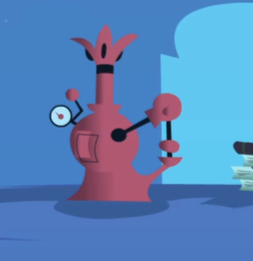
4:46: This isn’t technology-related (unless you count the giant hourglass) but when Twilight passes in front the hourglass, the unicorn bust turns into Nightmare Moon. Pretty cool. 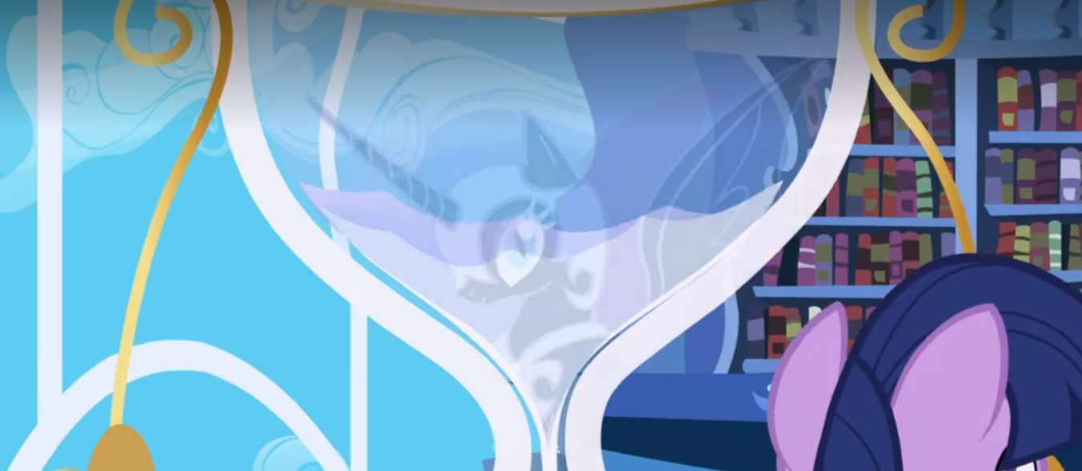
18:14: Lamps exist
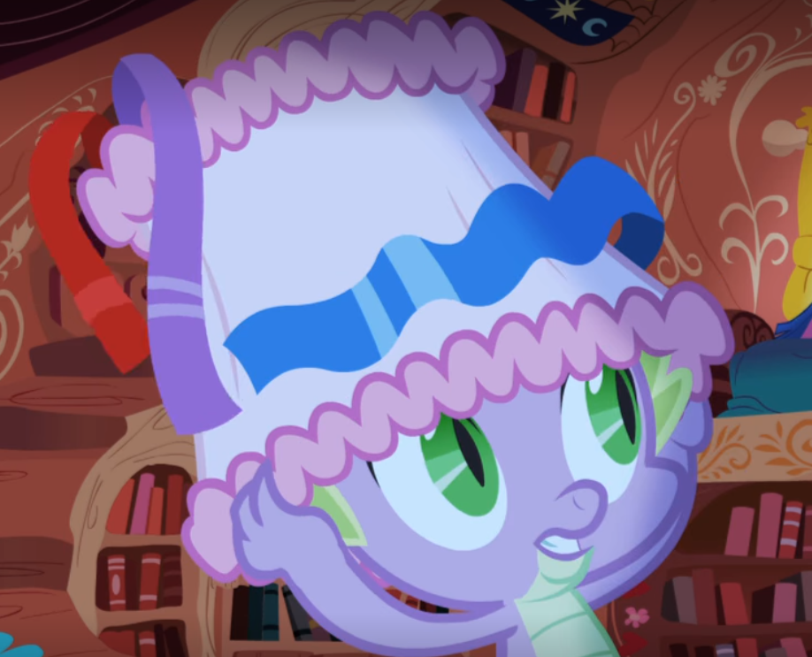

18:19: Cuckoo clocks exist
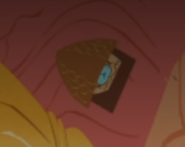
EPISODE 2: FRIENDSIHP IS MAGIC PT 2
21:29: Can’t go without a good windmill
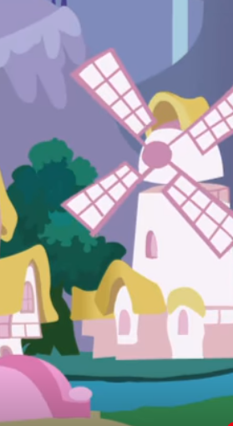
EPISODE 3: THE TICKET MASTER
2:30: A handy dandy orrery demonstrating a geocentric model
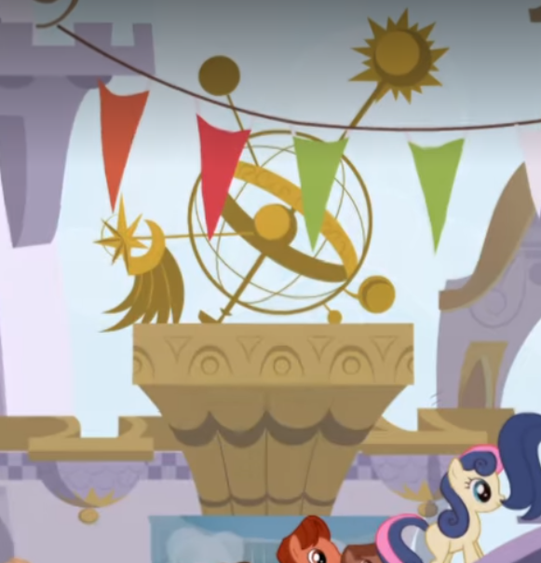
2:53: It’s a modern-looking walker so I’m counting it just in case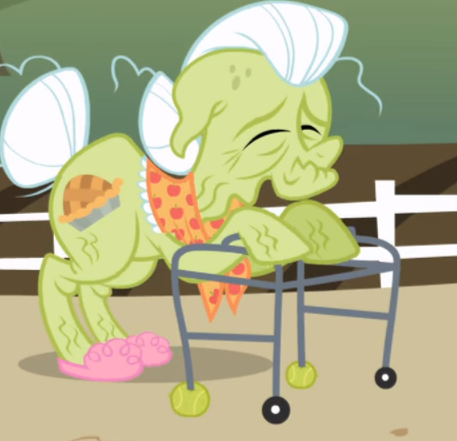
5:44: A water spigot 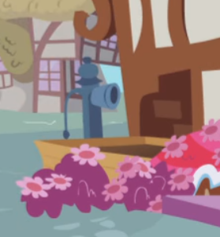
6:21: Ponies use lightning bugs for lighting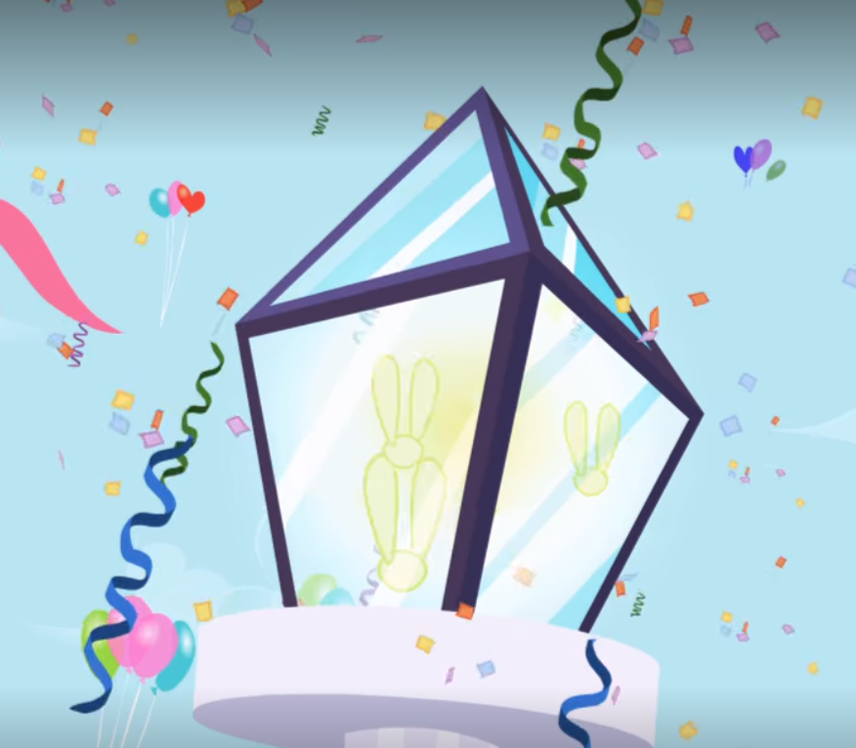
6:38: First camera of the show! An accordion-style camera with some weird light bulb. Also photobooths are a thing.
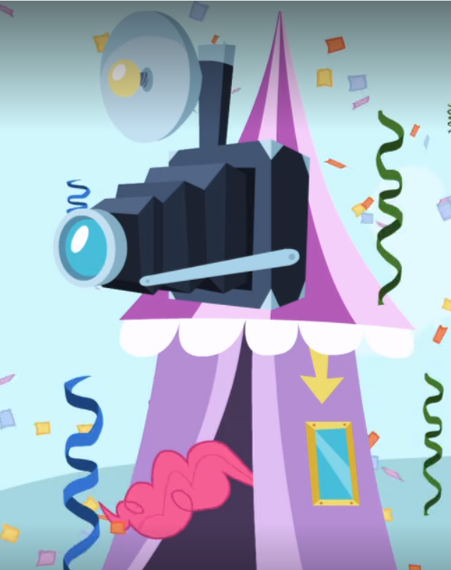
6:43: Helium/hydrogen tank 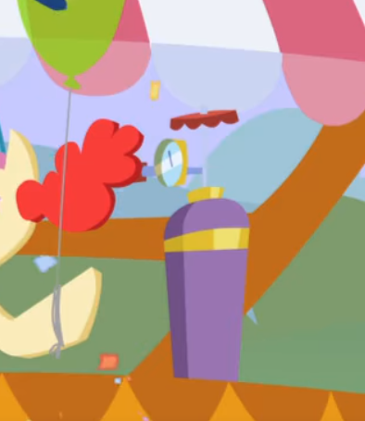
11:00: Forgot to mention that wells are a thing too
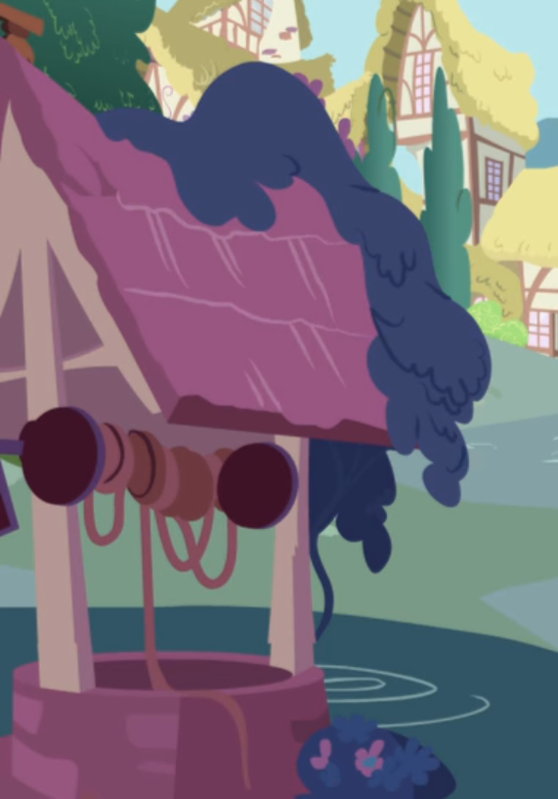
11:03: Neat pulley system to bring hay into the loft of this restaurant. Pretty funny since this restaurant probably mostly serves hay or things made of hay.
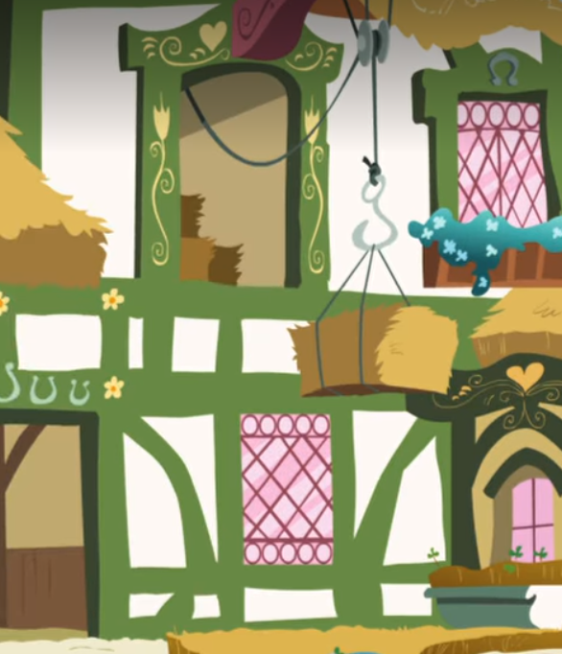
18:33: Twilight blows this lantern out. Probably an oil lamp like the ones seen around the town.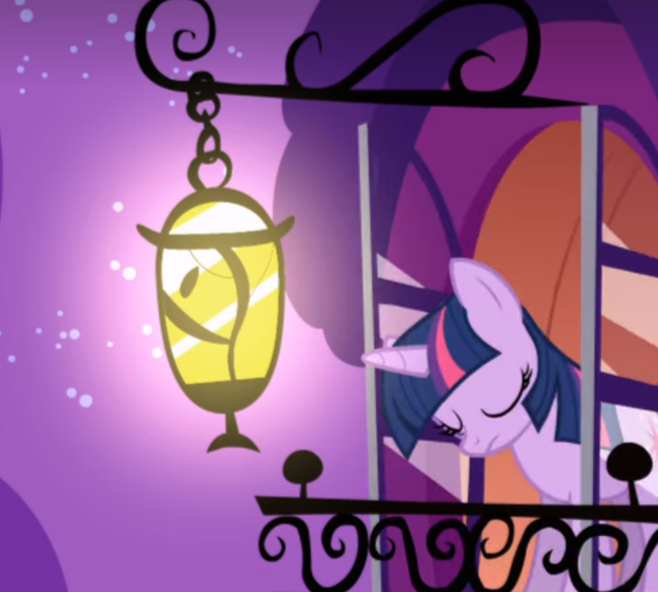
18:36: All of the lights in the library magically switch off, so the place obiouvsly has electricity
EPISODE 4: APPLEBUCK SEASON
10:18: Catapult! 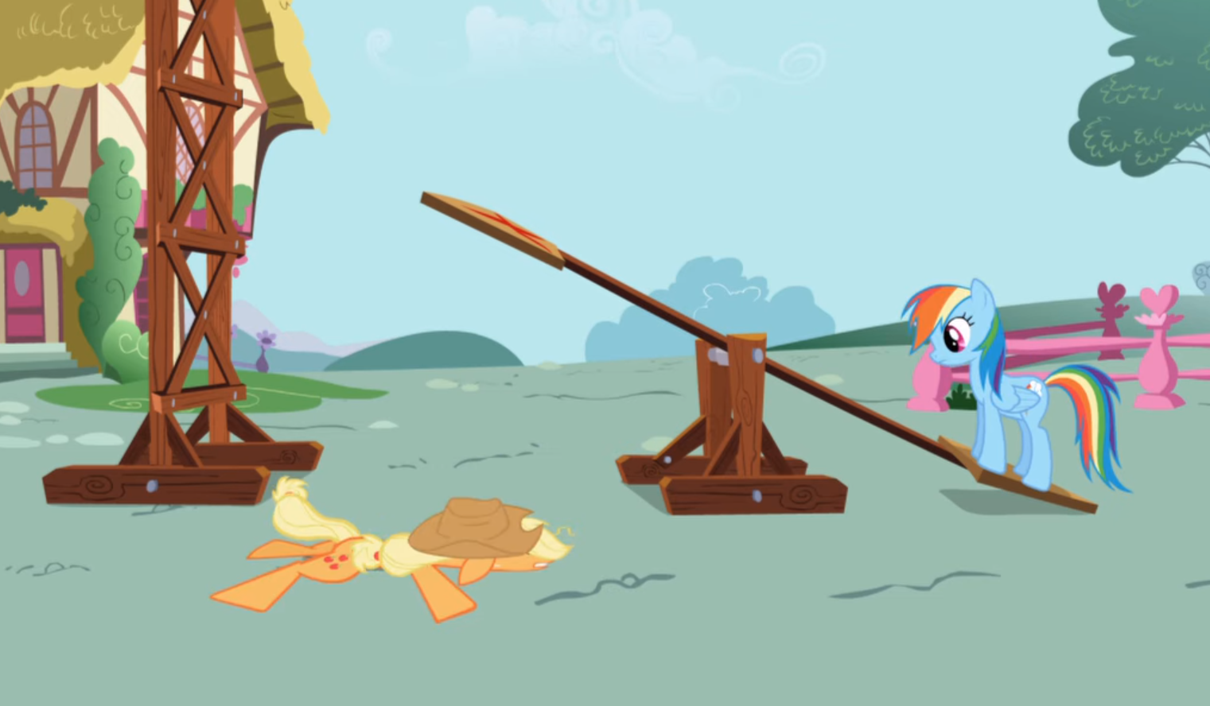
13:59: The not-so-impressed old fashioned woodfire stove and a sink (these ponies have indoor plumbing!)
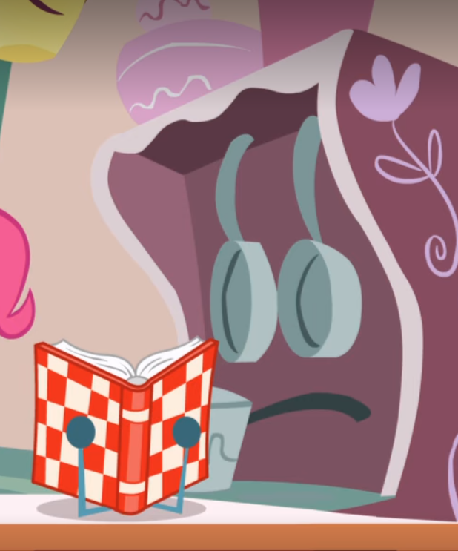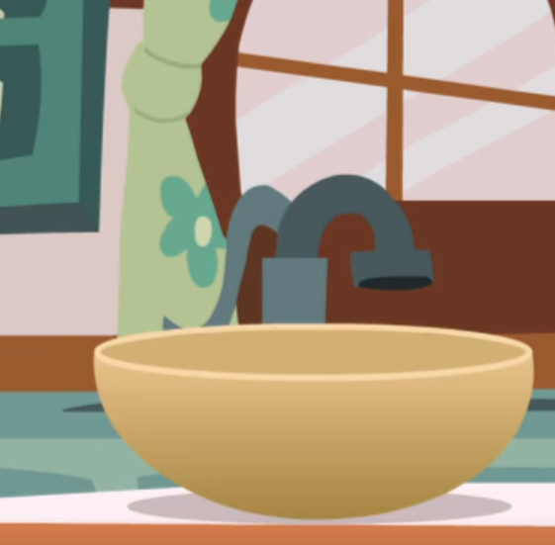
14:19 and 14:36: A refrigerator! 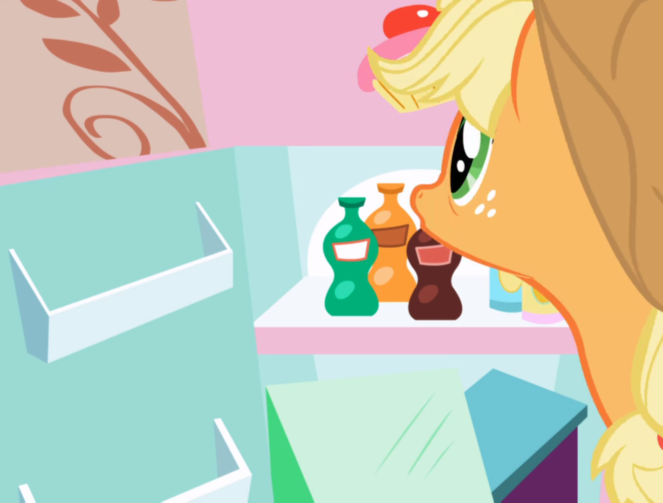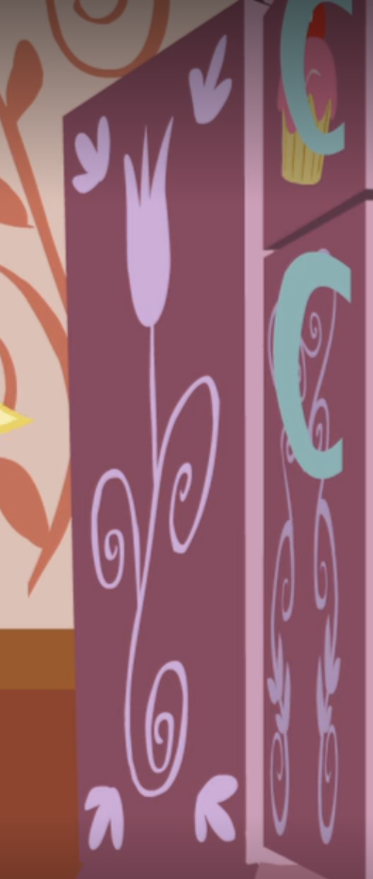
15:13 Thermometers and one of those ice-pack things for fevers
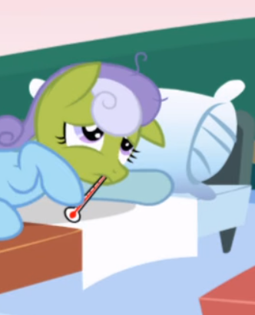
EPISODE 5: GRIFFON THE BRUSH OFF
2:46: Plastic/rubber snorkeling gear 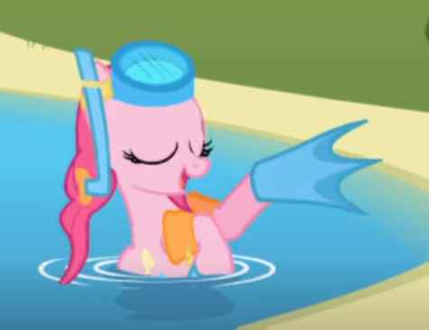
5:10: An electric doorbell! 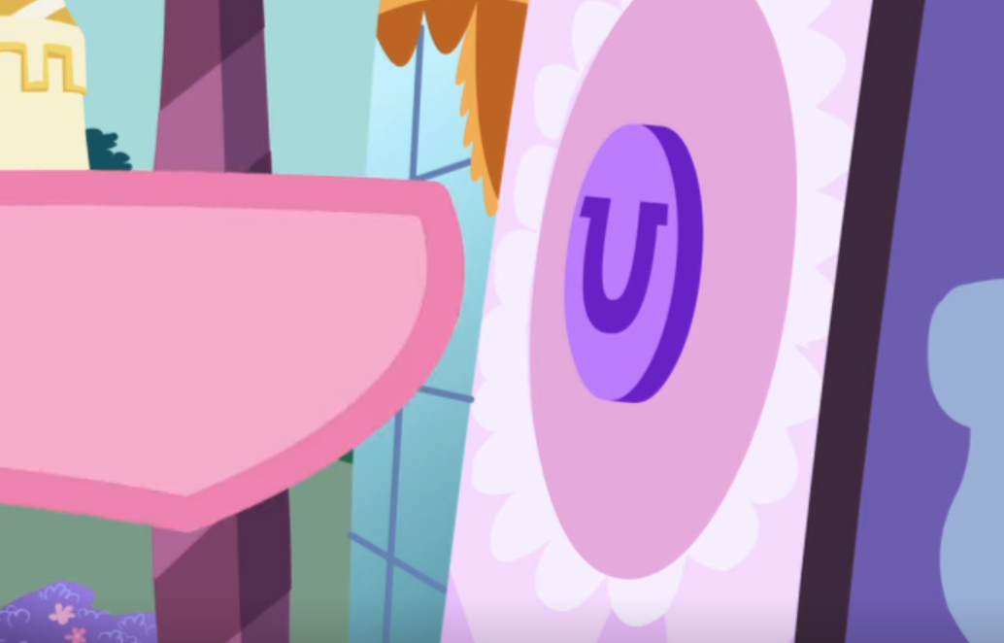
5:27: Talcum powder 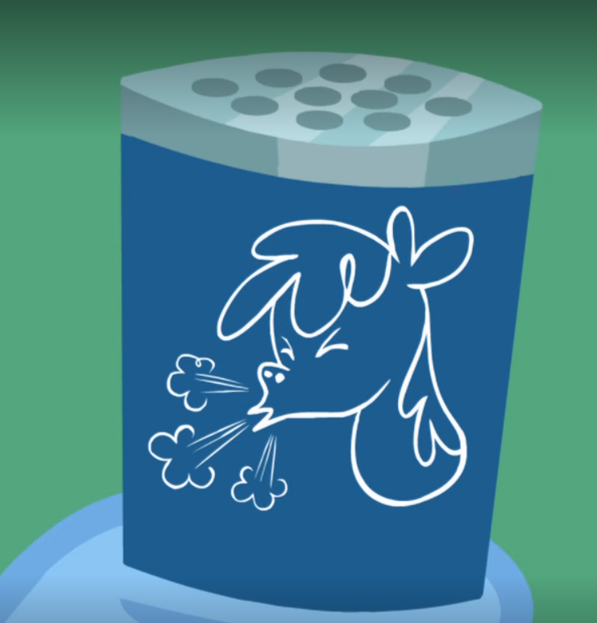
5:40: Chemistry set
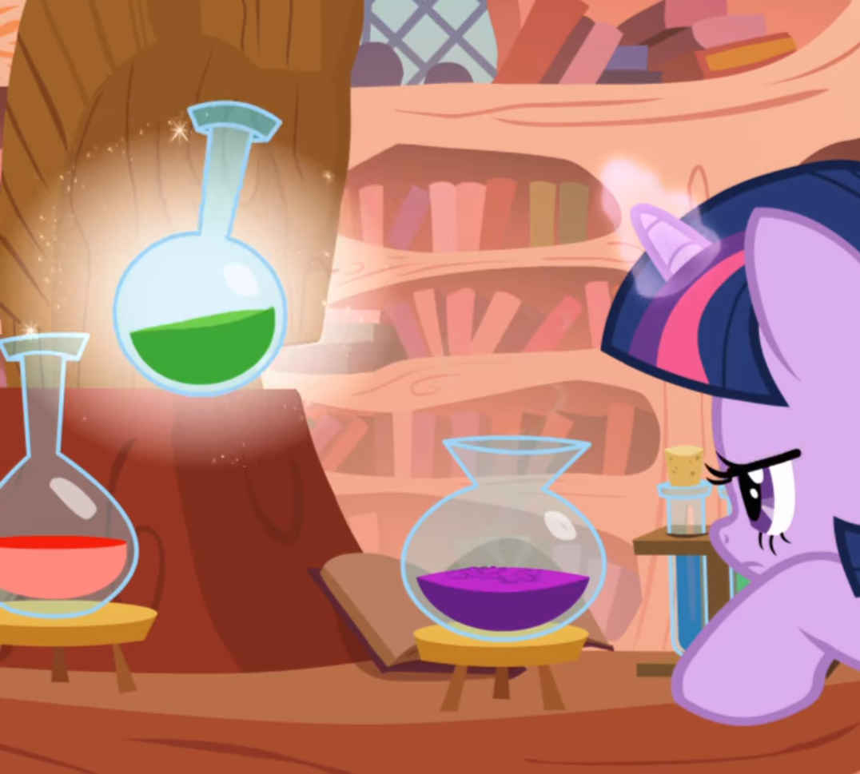
5:50: Disappearing ink is made of “thymolphthalein indicator, ethyl alcohol, sodium hydroxide solution, and water at pH 11.” So uh, ponies have all those things I guess. Or it’s magic. Fuck I’m so tired already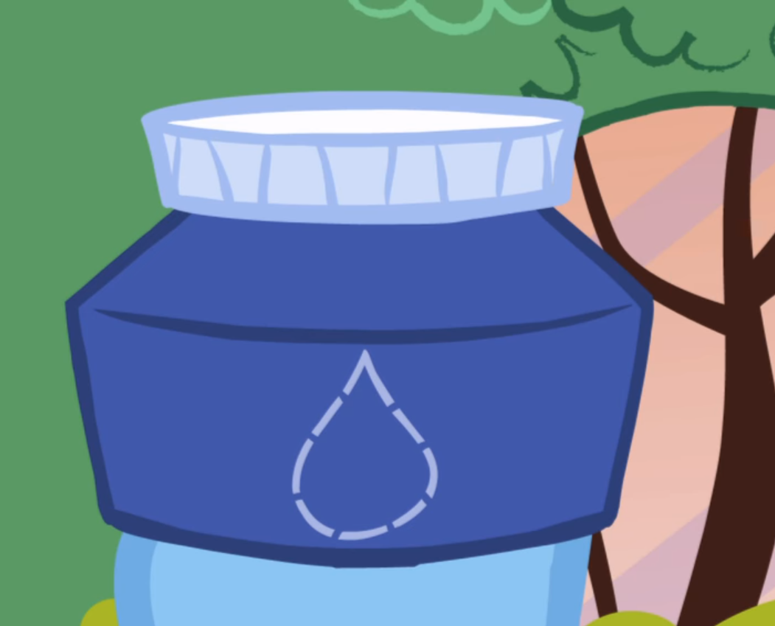
6:36: A very nice telescope for a very silly purpose
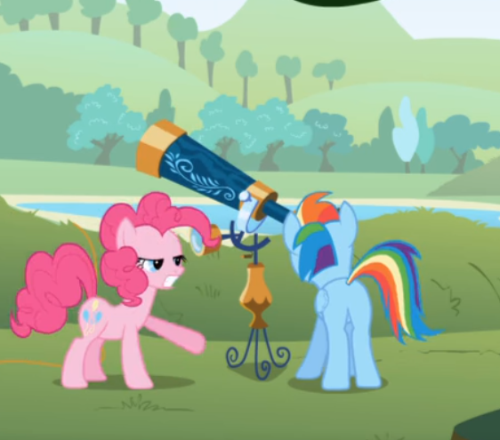
9:18: Did you know the first trampoline was invented in 1934? Pretty recent for something so simple. 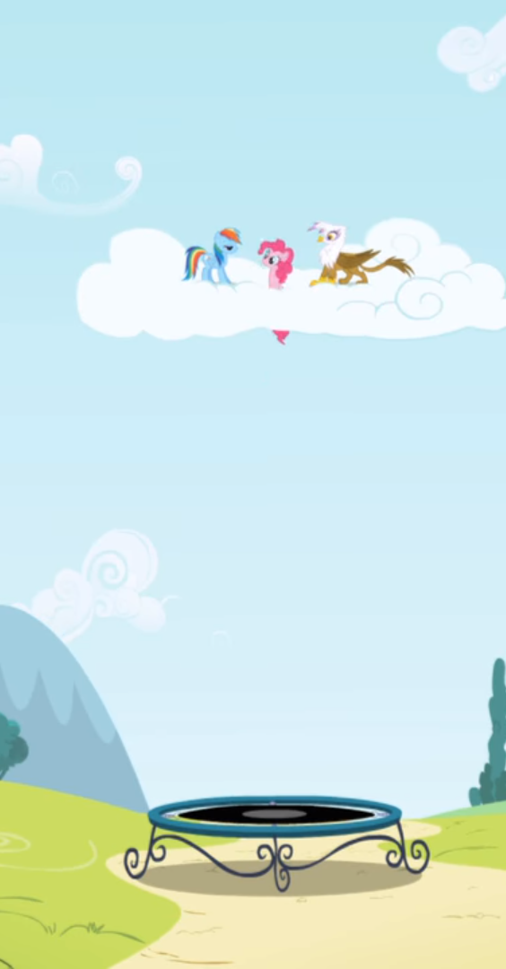
10:23: A pedal-powered autogiro
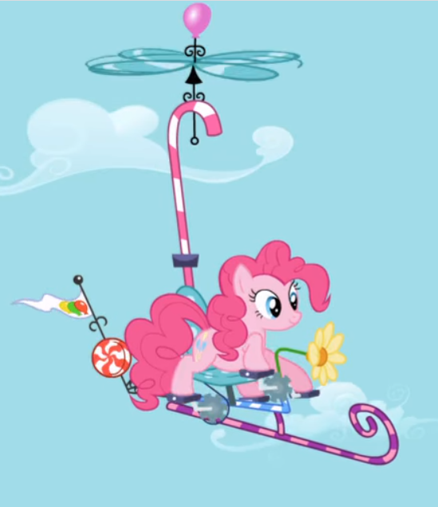
12:27: by the way, there are oil street lamps everywhere in Ponyville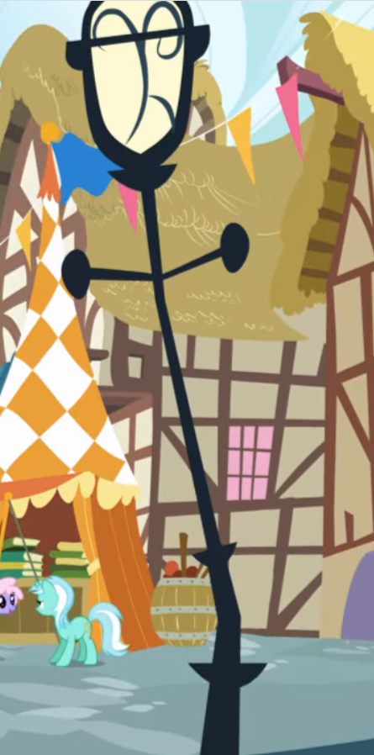
14:59: Joy buzzers are a little older than trampolines, invented in 1928. Though they don’t actually emit an electric shock. Rather it’s just a coiled spring release system that vibrates the thing super fast so it feels like an electric buzz.
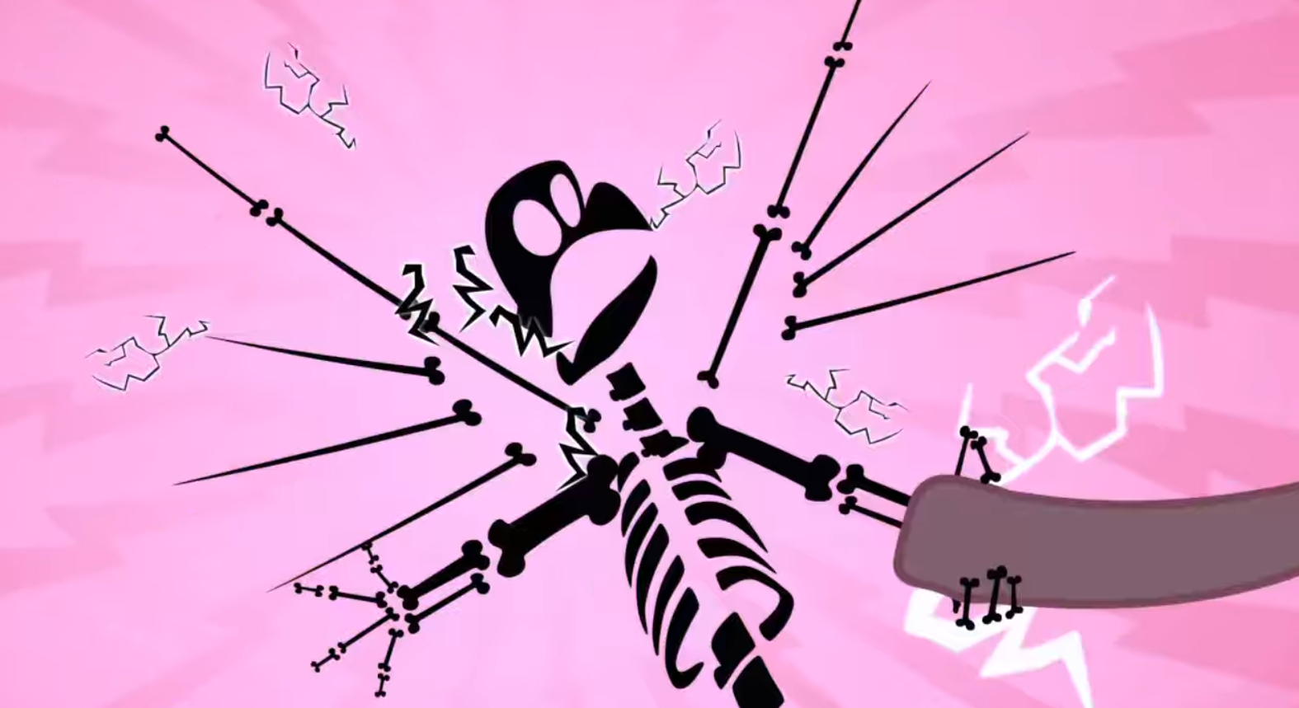

EPISODE 6: BOAST BUSTERS
5:24: Trixie has the greatest and most powerful pyrotechnics
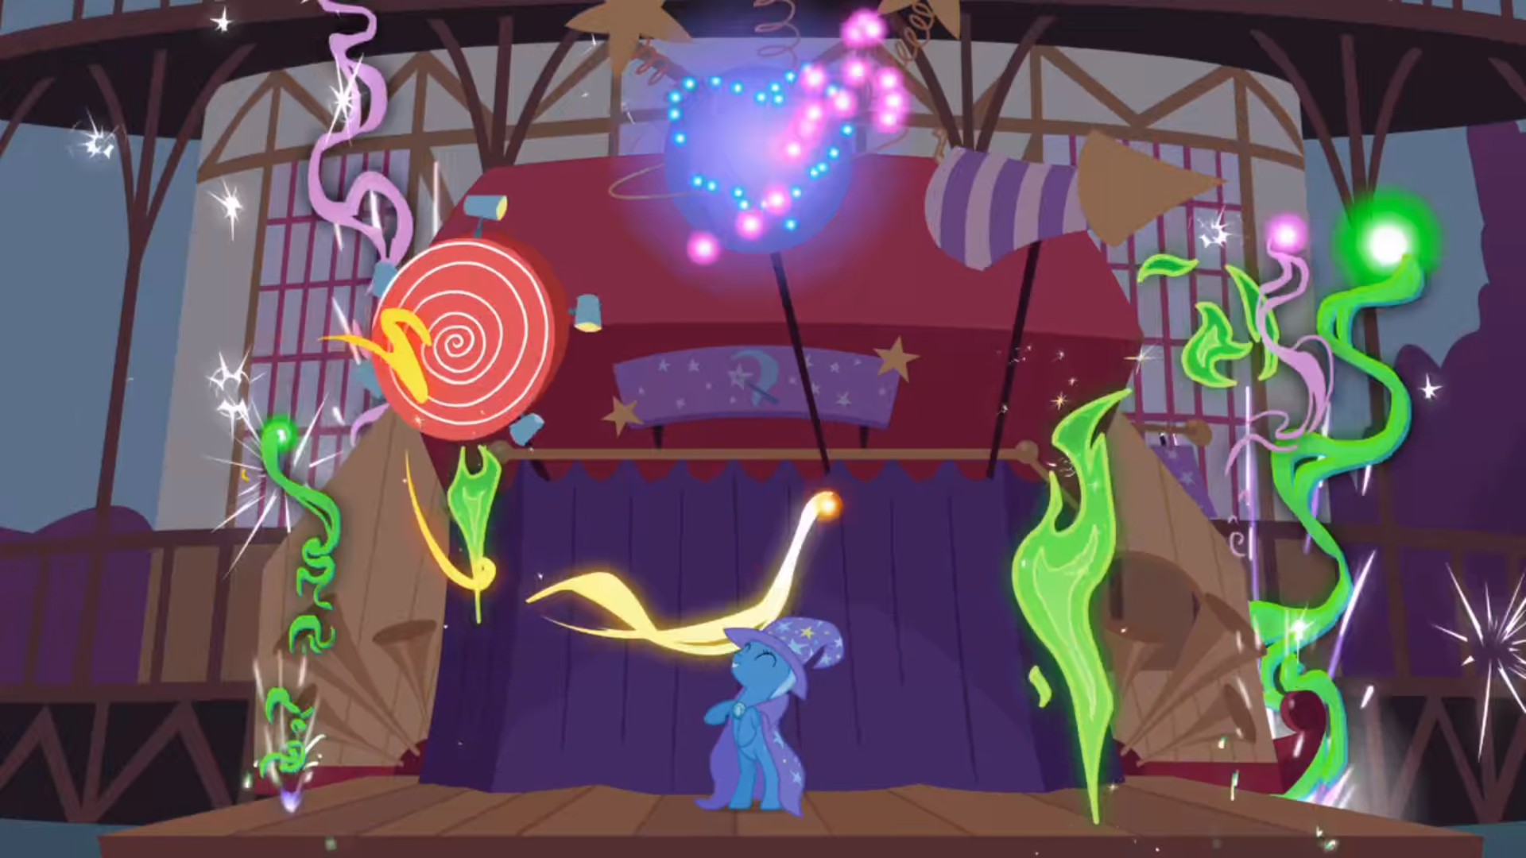
10:16: I think it’s worth mentioning that they have plastic/Styrofoam cups 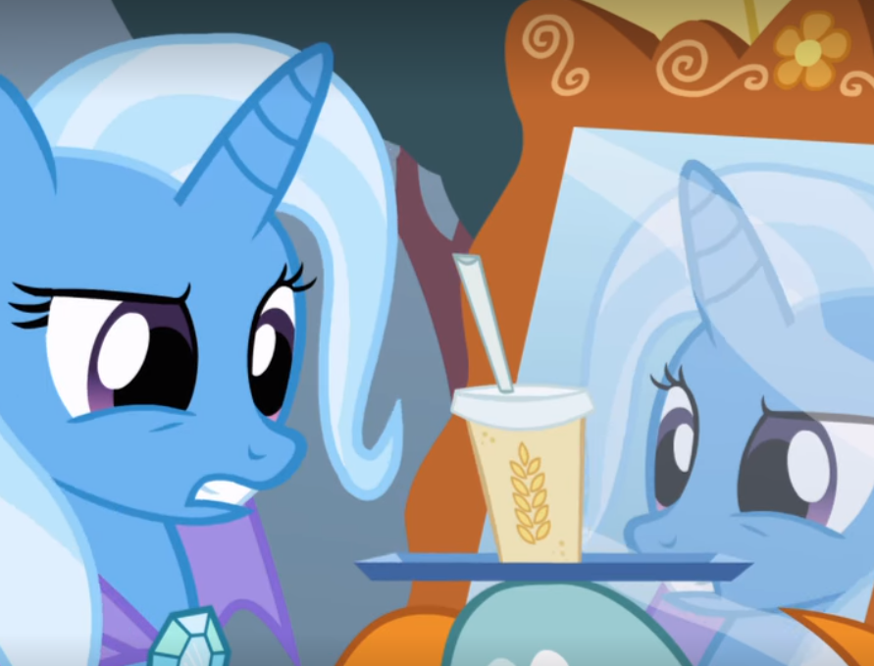
17:15: They’ve got water towers too! 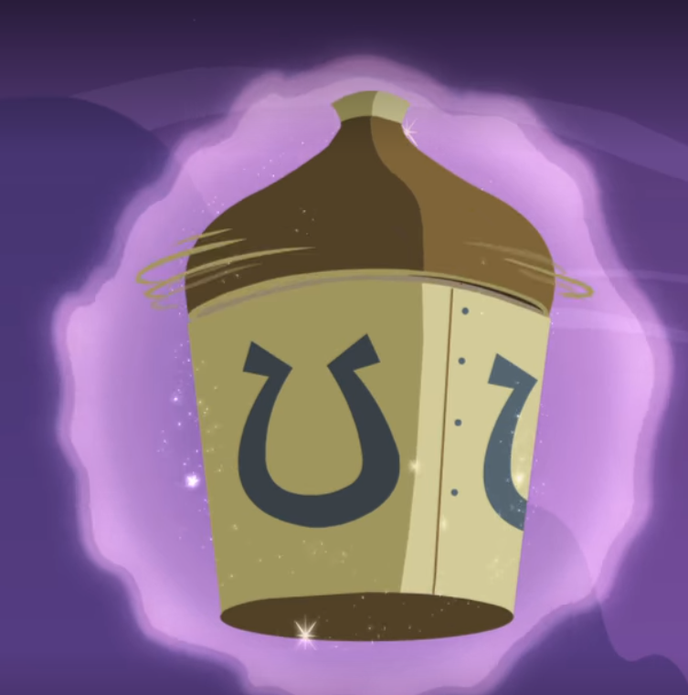
17:21: I’ve always wondered what these things do. Apparently they’re water pumps that harness wind to pull water from underground.
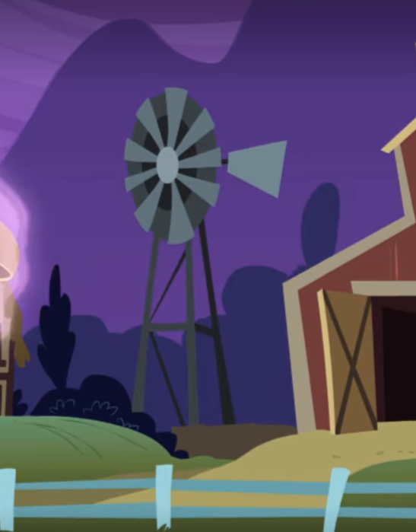
EPISODE 7: DRAGONSHY
4:32: Nice ghille helmet you got there Rarity 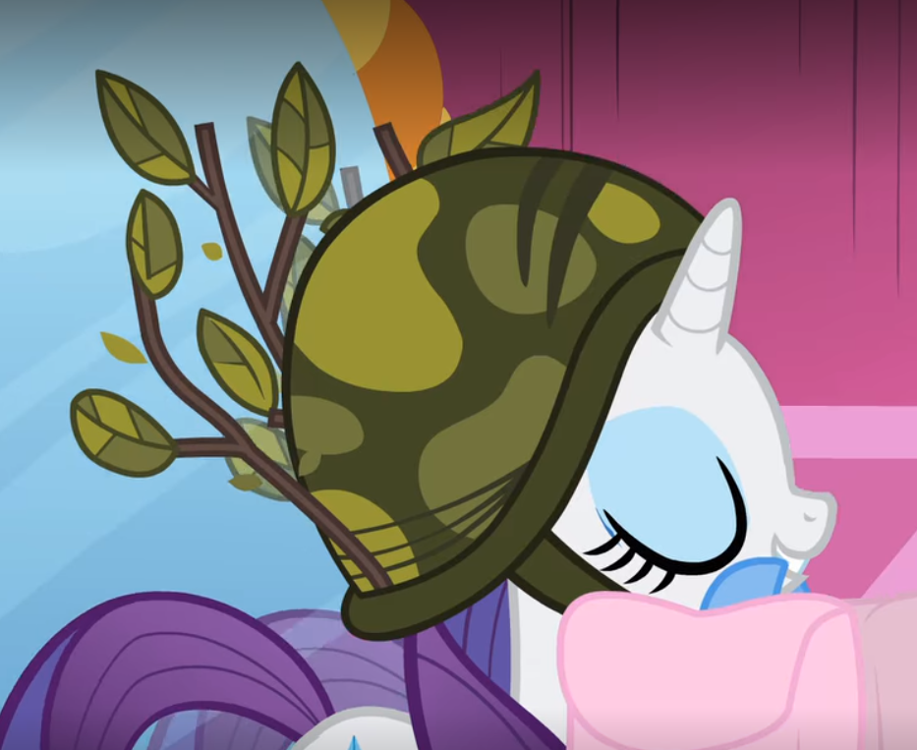
4:41: Fluttershy in American football gear and floaties for some reason? 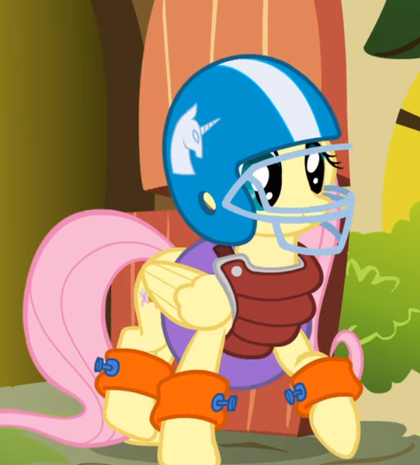
17:37: Just a lot of plastic and latex 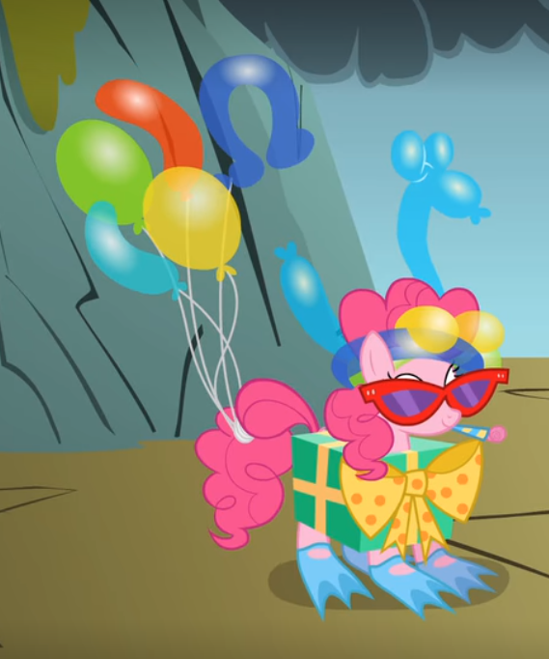
EPISODE 8: LOOK BEFORE YOU SLEEP
0:18: Another variation of oil street lamp 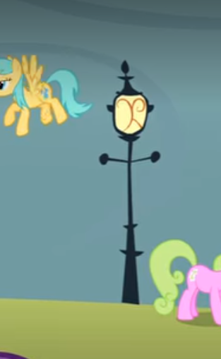
5:38: Earth ponies once against screwed over. No wonder she prefers her hooves dirty; anyway it’s a rubber hose with an adjustable nozzle
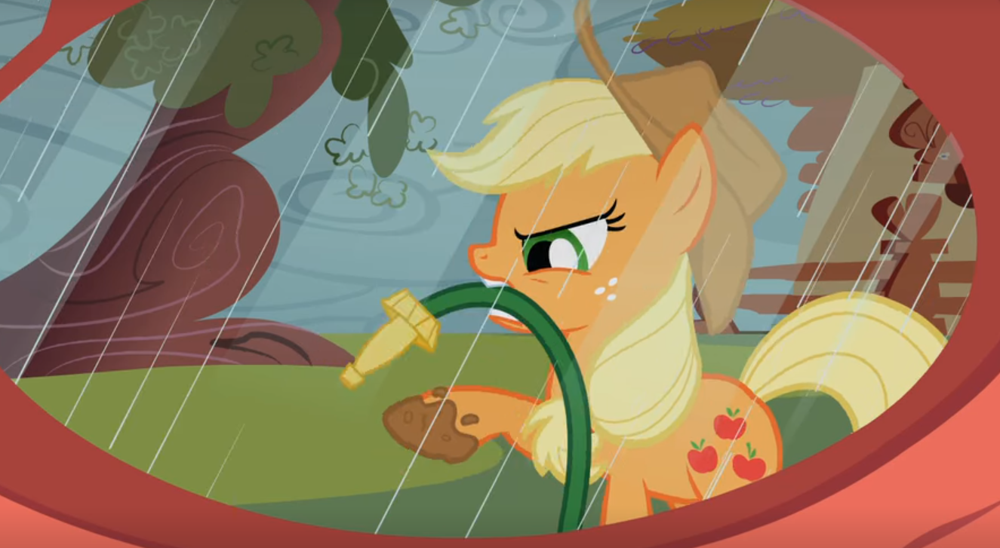
9:13: Once again using bugs for lighting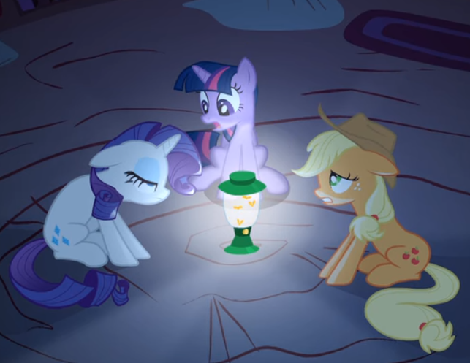
14:59: A better shot of Twi’s cuckoo clock
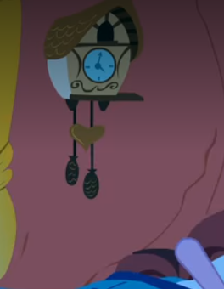
15:36: Another telescope 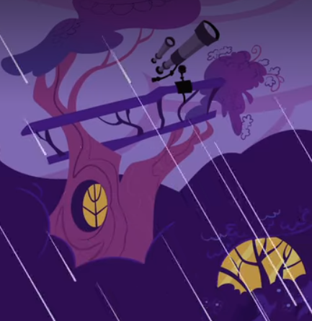
19:54: Aaaand another telescope 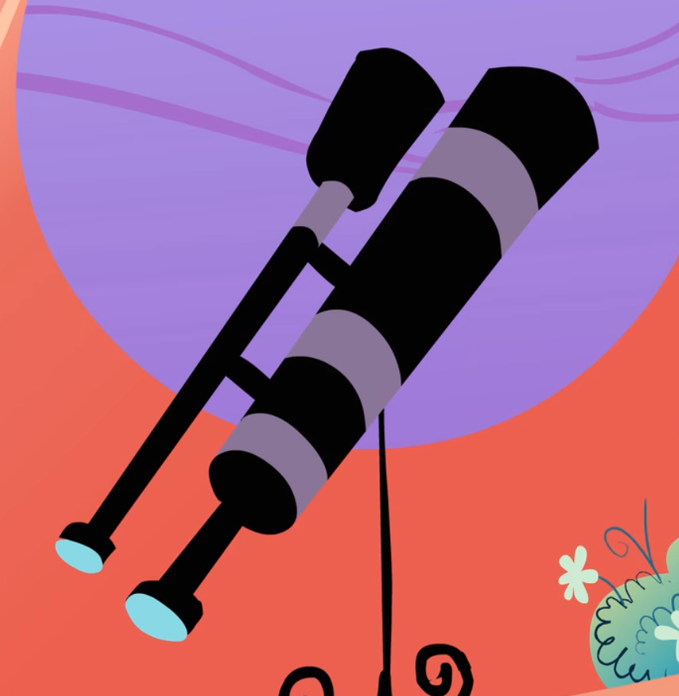
EPISODE 9: BRIDLE GOSSIP
0:33: The modern perception of a “zombie” probably came from George Romero’s 1968 film Night of the Living Dead, although the word is of course much older than that and exists in different cultures. But we know what kind of zombie Spike is referring to. I don’t know how to apply this to pony culture; maybe their zombie comes from horror novels or slideshows
EPISODE 10: SWARM OF THE CENTURY
5:19: Rarity’s got some kind of fucked up hair straighter. 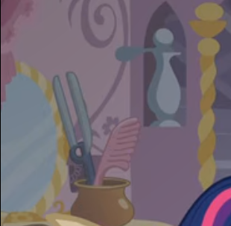
16:11: They’ve got pesticides 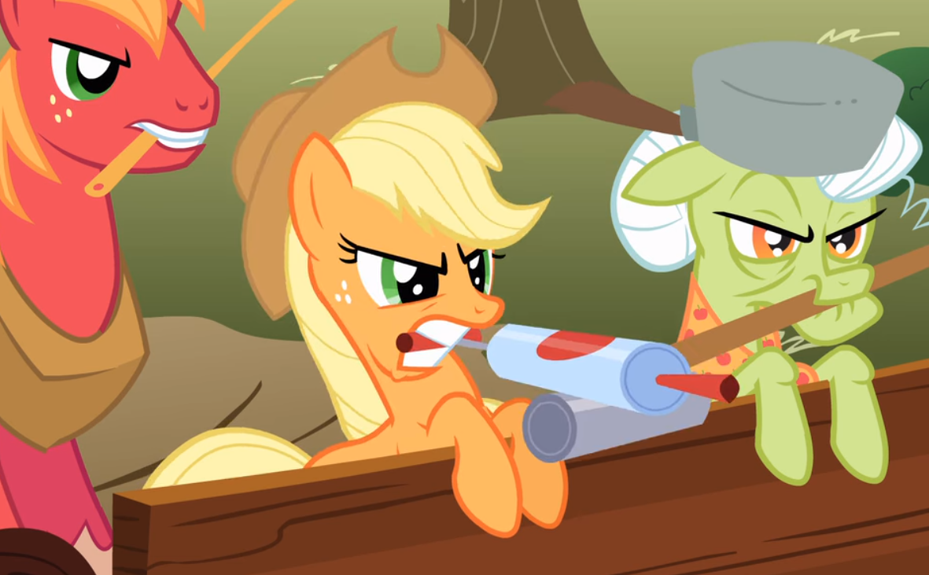

EPISODE 11: WINTER WRAP UP
12:45: Of course they have these neat snow plows 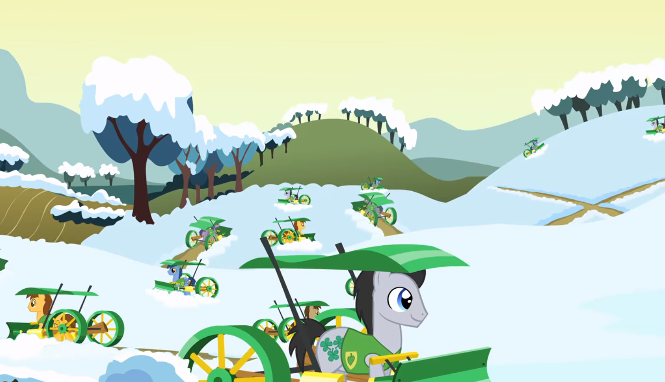
18:28: Blueprints! 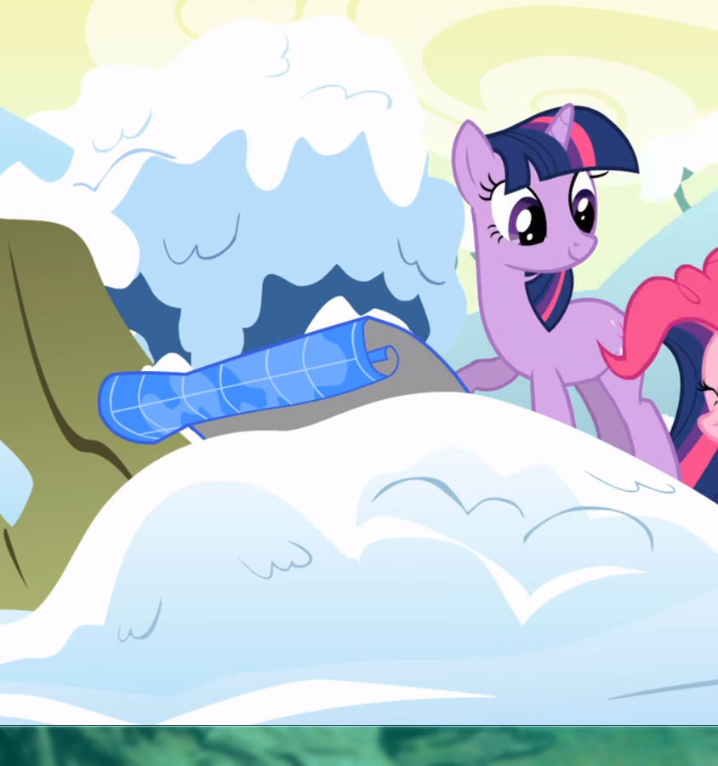
EPISODE 12: CALL OF THE CUTIE
0:02: Along with the terrifying recolors of Scootaloo and Sweetie Belle, there is some math on the board, as well as Saturn for some reason, and a rolled up screen for a projector 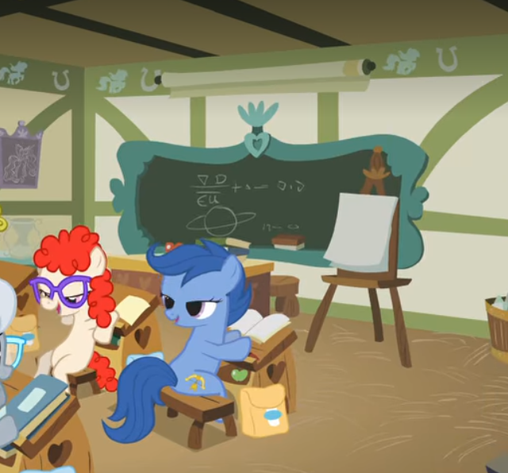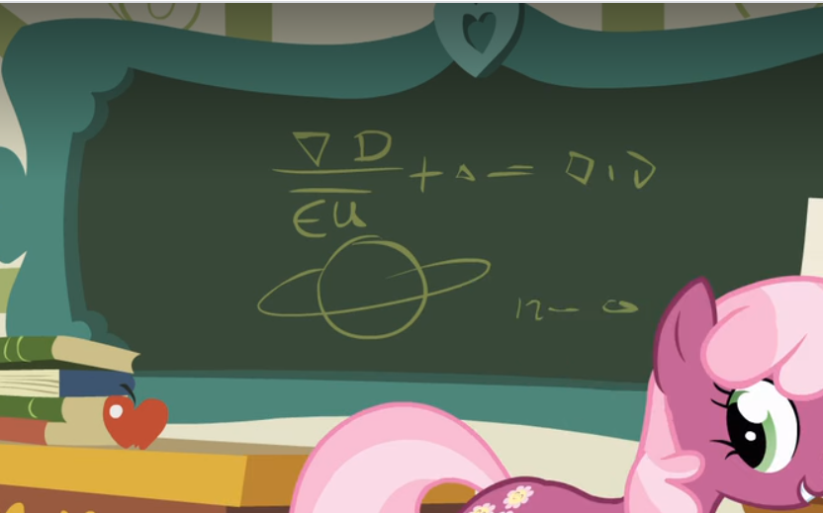
0:43: Posting for cute Cheerilee, but also ponies have braces and they went through an 80s phase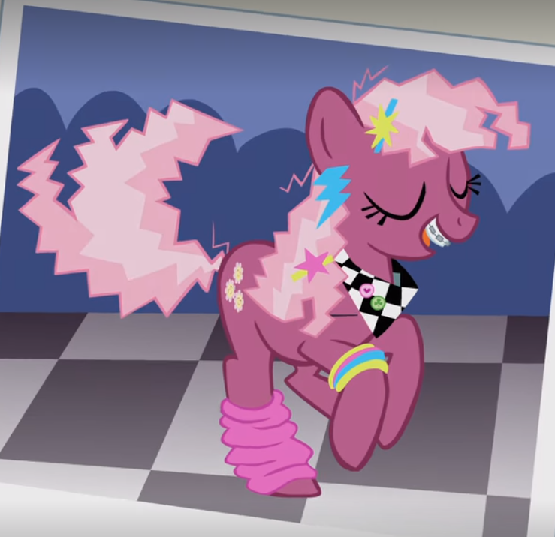
10:09: Some kind of glider thing though it doesn’t end up flying 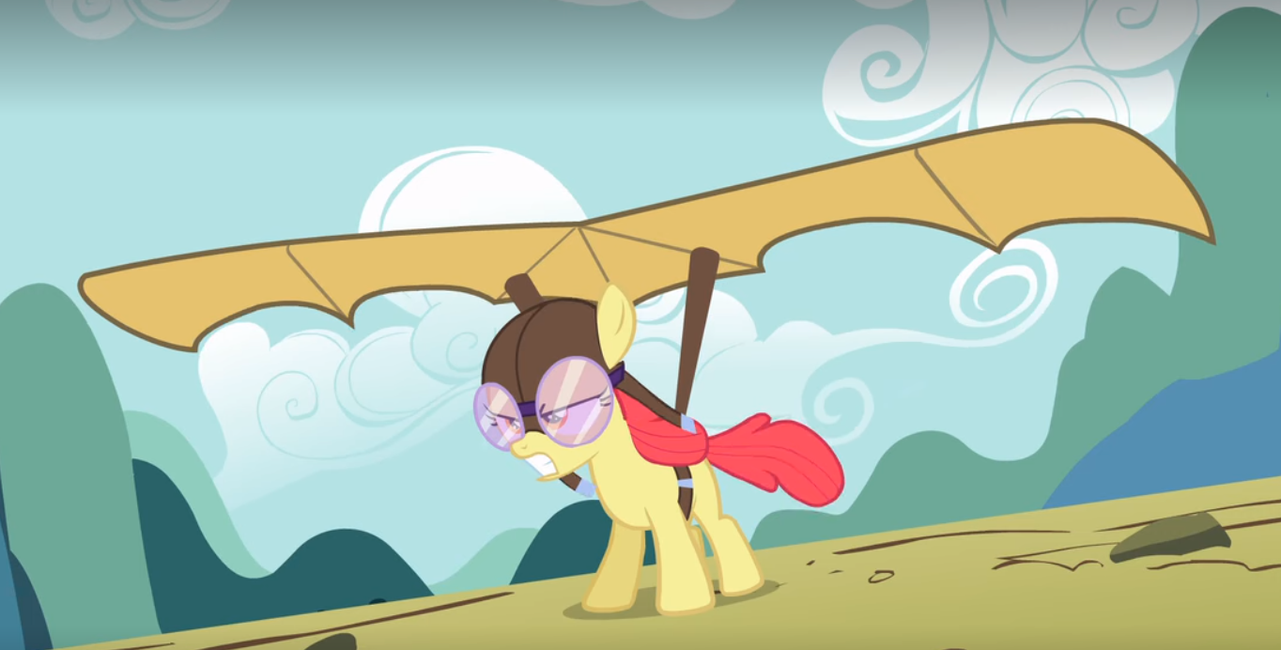
12:47: An electric mixer 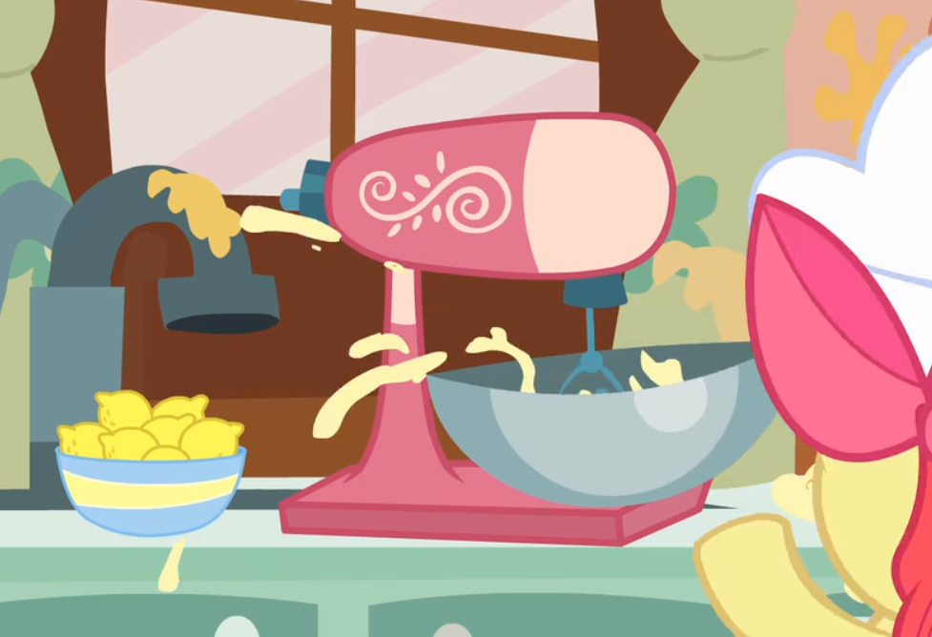
12:51: Once again, Earth ponies screwed over. Also, a gas or electric oven.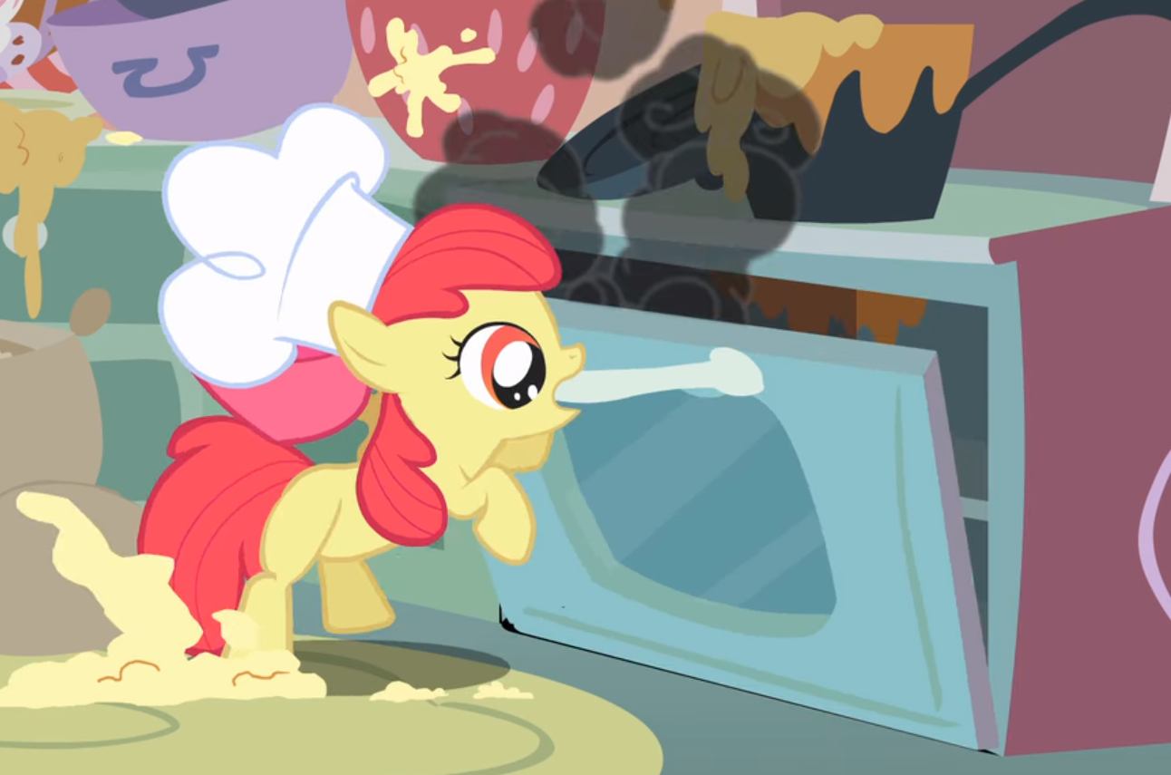
18:09: A good ol record player. 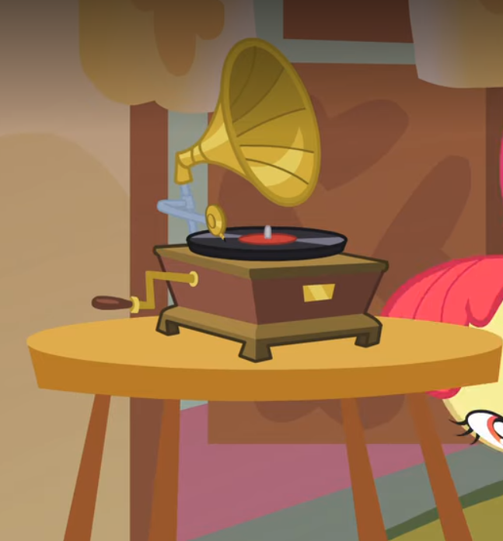
EPISODE 13: FALL WEATHER FRIENDS
3:14: A stopwatch 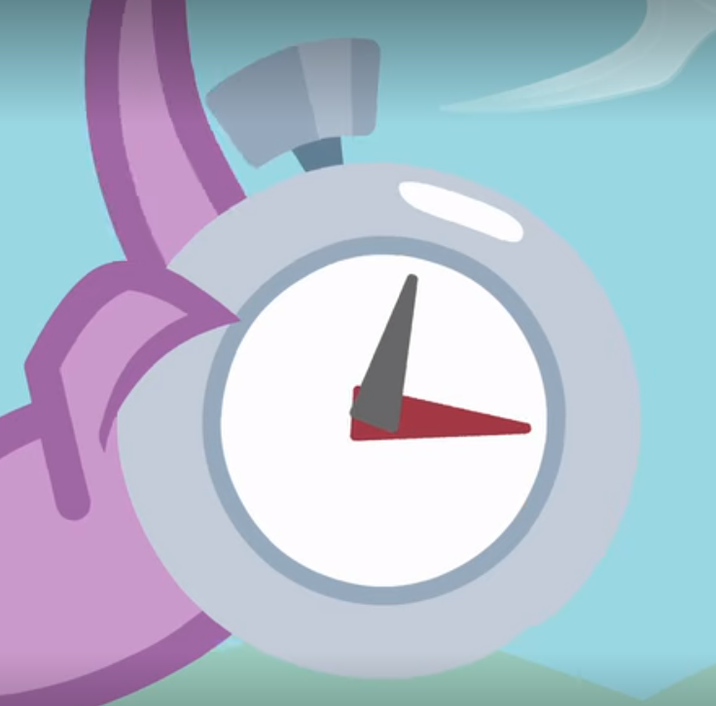
4:12: A high striker. In th 30s, carnival dudes would rig these things so no matter how hard you hit them, you couldn’t ring the bell
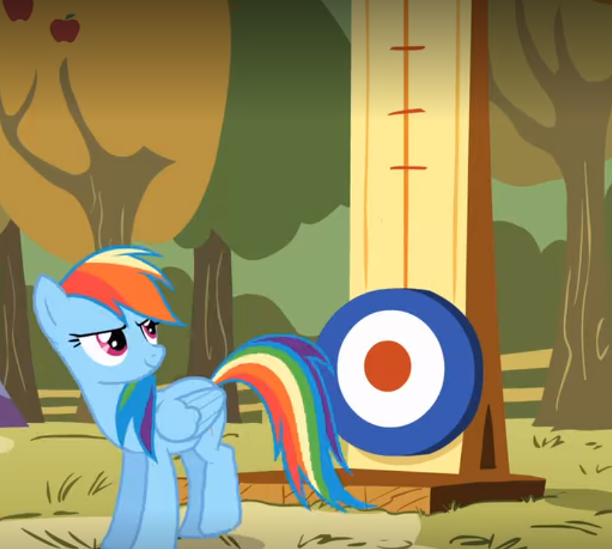
8:53: Hot air balloon and megaphone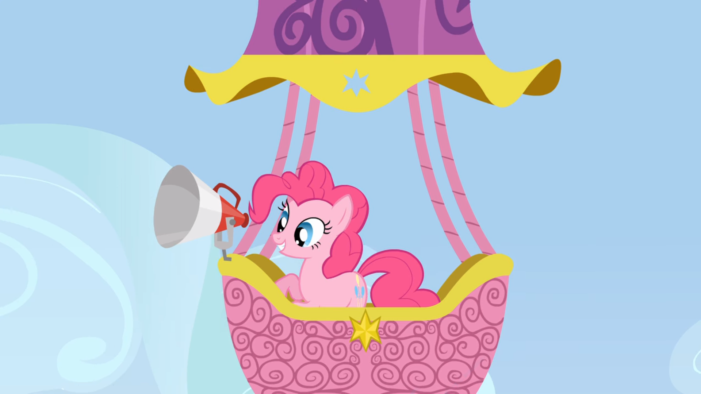
11:55: Spike got the mic  It looks like a Shure Brothers Unidyne 55S, introduced in 1951
17:39: Sap or resin harvesting has been around since Romans had their Empire, but this set up is more likely from the 19th century
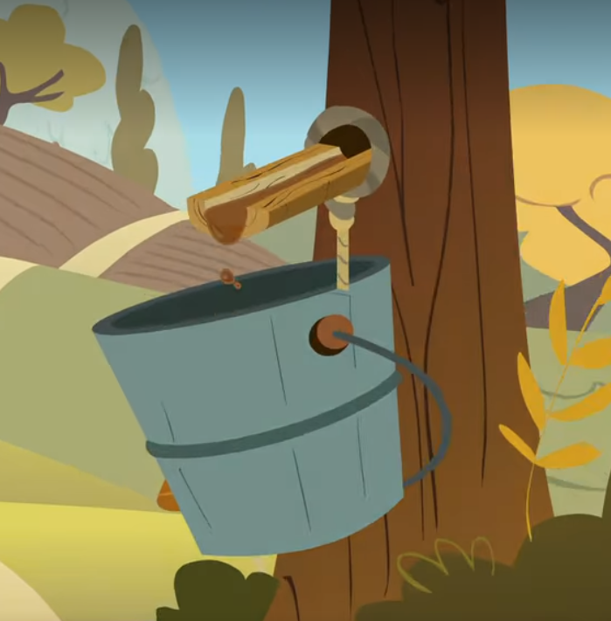
EPISODE 14: SUITED FOR SUCCESS
0:28: a sewing machine, probably from around the 30s 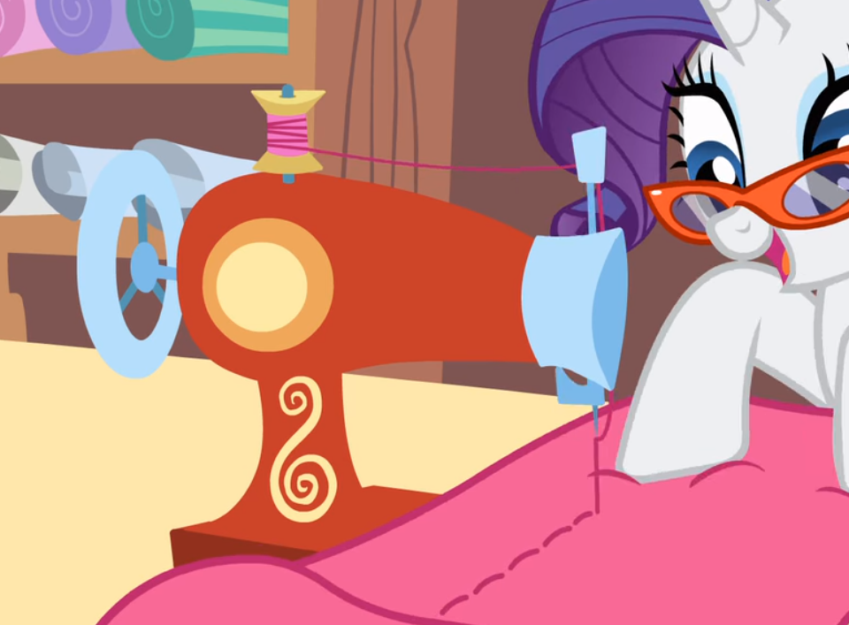
0:46: they’ve got glue and other crafting supplies 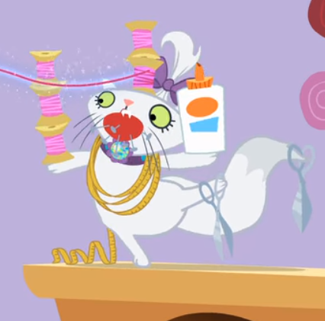
5:33: Rarity mentions tanks here
5:47: They’ve got irons 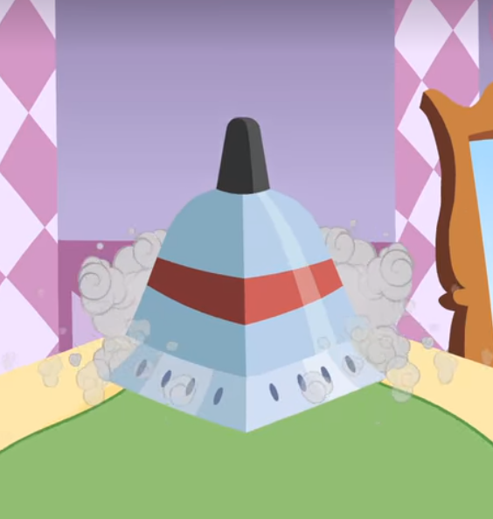
10:55: An electric light 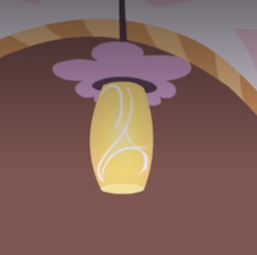
13:45: And of course turntables, audio mixer and very modern music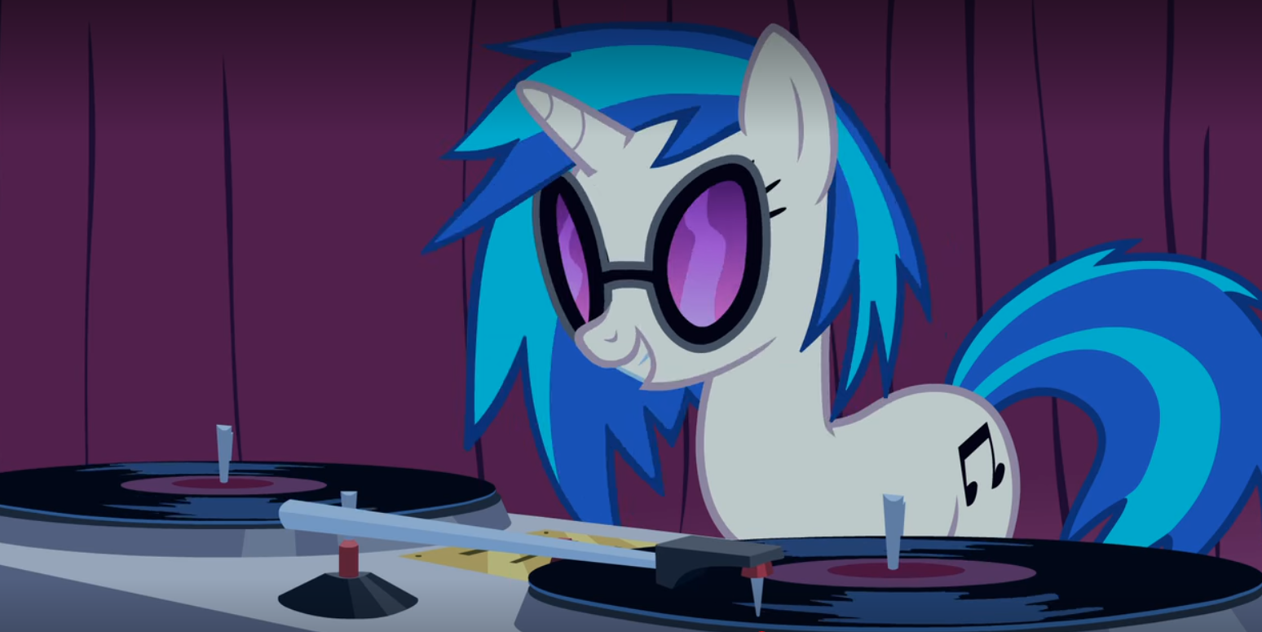
13:48: Looks like a Fresnel lantern with barn doors 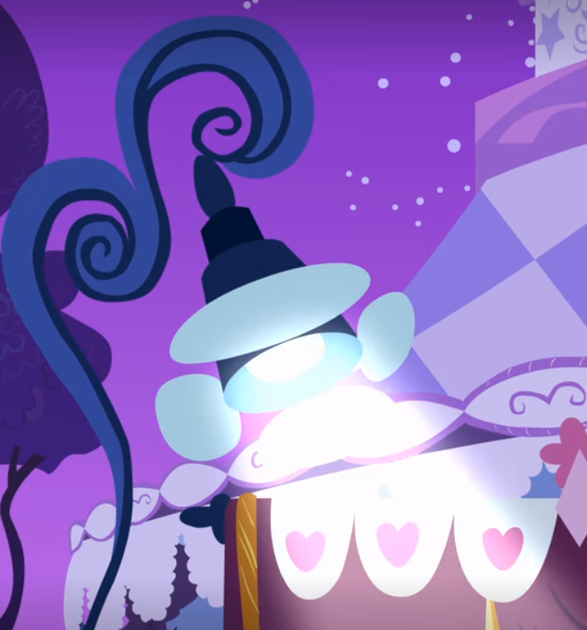
14:58: The kitchen sink and nothing else 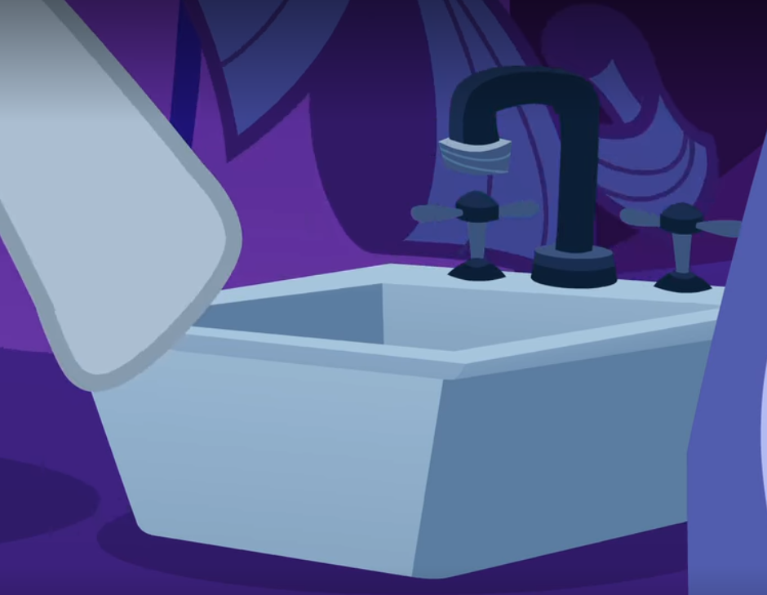
16:14: A bedside lamp 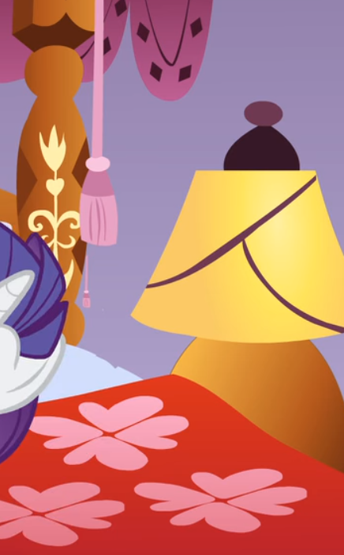
(had to pause to watch Rarity’s fashion show. It’s so good.)
Gonna stop here for now but the project will be ongoing for a while.

