Anon Ymous

(You)

PragurUniversity

8 January 2020
a
/mlp/’s Fanfic

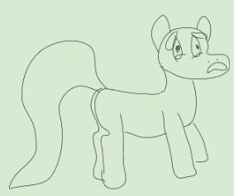
fucking google ziggers not letting me copy+paste <--I don't want to see what stupid shit (you) have copied
Fuck 4gag /mlp/, UwU. Nej!
My dick just broke

>lost another ball stretcher
Why do i even bother anymore?
Gypsy master race 4ever
PONIES ARE COMING ON!!!!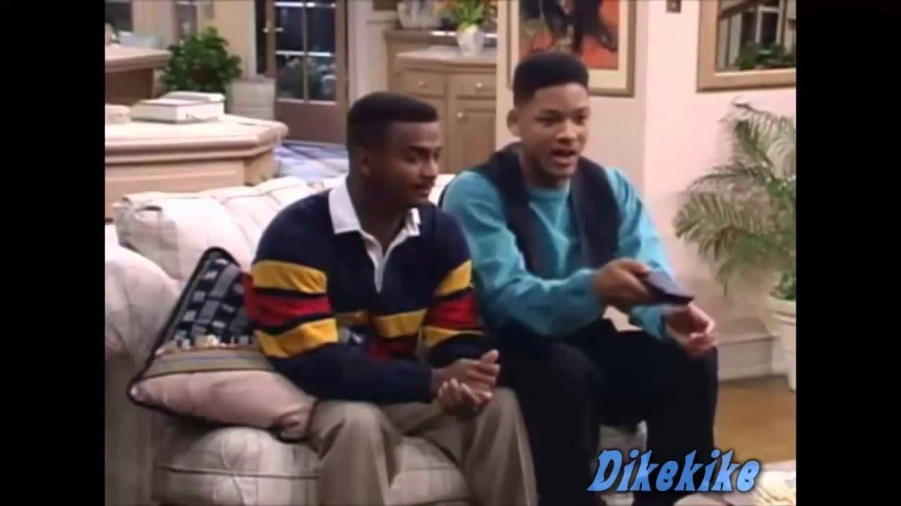
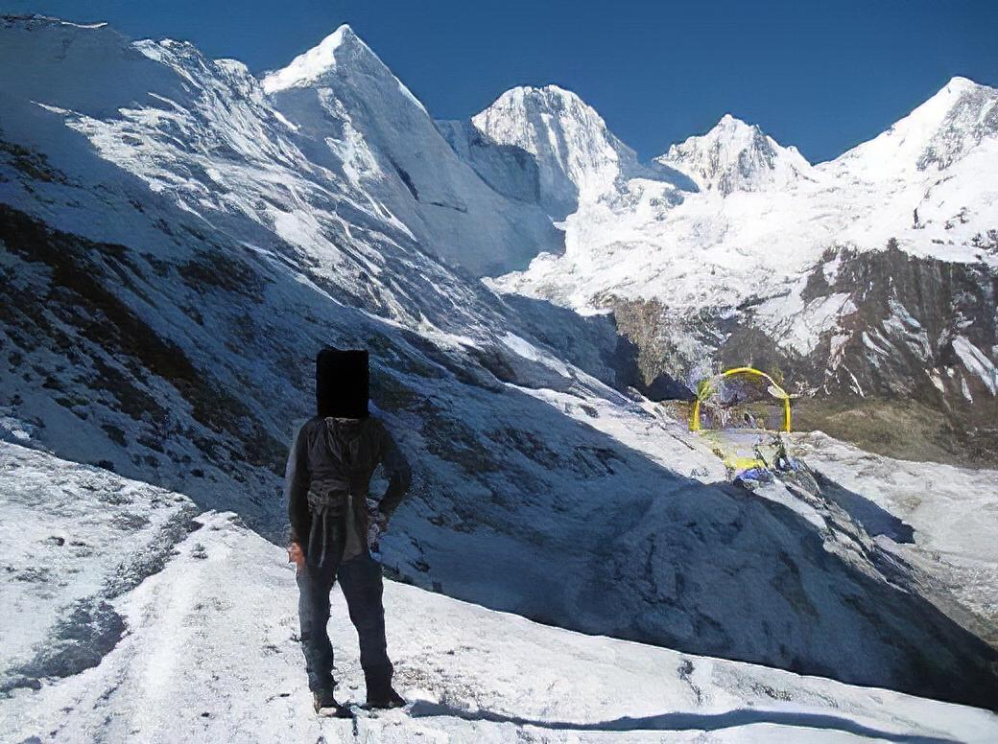
HORSE PUSSY sponroed by raið shadow legend

CHAPTER 1: DANTE
May Celestia bring (you) fresh farts
Once upon a time in Equestria…
>rape
>You awaken to find (you)rself trapped inside the urethra of Celestia's pendulous mare[censored]
>“[censored]s tongue my [censored]”
>Those are the first word’s (you) hear as (you) wake up
>”Anon! (you) are awake!”
>”
H̵͖̿̅͌͐̏̓̎́̿̑̈́̌͆͠͝e̵̠̐̌̚ ̵̨͉̪͈͉͎̳̱̥͔̪̓͛͐̉̽̓͊̀͂̔͗͘͝ć̶̰͕̱̞̮̮͉̪̫̎͆͝ò̸̡̡̨̪͓͓͕̘͔̰̖̠͉̰̽̓̅̋́m̷̨͕͇͖͙̩̦̮͙̀͛̓̅̚ë̶̛͓̻̥̲͇́͋̐̾̎̔̄͐͐́̔̌͘͝s̸̻̚͘̕.̵̙̭͕͙̞̖̗͙̞̃̽̄̀̓̄̄́͐̎͘
>”WHAT IS WRONG WITH (you)R EYE’S ANON!”
“Don’t tell me I have Nyx eye’s, [censored].”
>The smell is overwhelming
>”God, when is it going to start?”
>Do (you) know what they are?
>Oh no
>It’s zebras
>Well it’s race war time
>You remember thats why (you) are here
>Its the birth rates
>The zebras have babies at incredible speeds
>You take out (you)r full-auto AR-15
>You begin shooting
>The bullet’s stop mid air, zebra magic is too stronk
>One Zebra whip’s out her dick
>19 inchs
>Oh no
>You remember (you) have a knife with (you); surrendering to the zebra’s will turn (you) into a zebra
>Better start slicing
>Unlucky (you)! It was a butter knife.
>The penis starts to quickly expand
>12 feet now.
>It begins to wrap around (you)r neck.
>You start choking.
>The power if horse(zebra) pagina compels (you)
>You will not die as a [censored]$∩_{↕≪ϑ†≠\sqrt{\frac{αβν}{}}}{}$
>You will live as one instead. (you) are a zebra now.
>Twix Stix is flying towards (you).
>MAGIC Jo
>You are a human again
>frick those transformation buddy’s
>”Thank (you) twinkle sprinkle”
>”frick (you), Anon”
>The race war is over, (you) are finally free to buy a cupcake that will give (you) 1.9 sat [1]
>You go to the sugarcube corner, only to find out there are no more cupcake’s
>Saddened by this, (you) decide to visit Applejack: the background pony.
>Before she could say “Y’all”, (you) go visit Twilight.
>Twilight angrily says the Navy Seal’s pasta to (you).
>”Shut up, Twigs. (you) sound kind of robotic now”
>”Sorry, Anon. It’s just that I didn’t have my daily hug’s [spoiler]and because (you) were a zebra[/spoiler]”
>You ask her what she thinks about Pringle’s
>She is even angrier because (you) were dense enough not to hug her
>But (you) still need to know her opinion on Pringle’s
>”Anon, hug me”
>”WHAT DO (you) THINK ABOUT PRINGLE’S, JUST TELL ME, TWIG’S”
>”How can someone be this retarded?”
>”Are (you) still a zebra, anon?”
>”IF (you) DON’T TELL ME WHAT (you) THINK OF PRINGLES, I will not pay child support NAND alimony anymore”
>”I should’ve never brought (you) to Equestria anon… I hate (you).”
>Twi begins to clip clop away
>”TWi please! I’m sorry! I don’t know what’s gotten into me... isn’t there a magical spell or something that can fix this?”
>”No, anon. (you)’re character is far too debauched for any fixing.”
>You begin to cry
>You remember (you) have a knife
>But it’s still a butter knife, so it won’t do anything
>I mean, (you) could still poke (you)r eye out or something
>You decide to commit sudoku to end (you)r misery
>You wake up in Equestria right next to Celestia with a worried look
>”Anon, this is the 6th time (you)’ve tried to kill (you)rself. Don’t look so surprised.”
>”As punishment, I will use (you)r body as if it were a cum sock.”
>Celestia pulls out her massive 13 metre [censored], which is curled and inside out as to not take up too much space.
>She unwraps
>The sun begins to set
>The sun also begins to get an erection
>It takes 49 minutes for the erection to complete, due to the massive penis
>It is now 68 fricking metres long
>It is going to be inside of (you)
>Celestia will make (you) feel every single slide as she keeps (you) alive with her magic
>You will not enjoy this
>It’s now night time
>You can no longer feel pain; (you) can no longer feel anything.
>You wish (you) hadn’t asked Twilight about Pringles so much.
>But (you) still needed to know.
>Celestia is finished with (you)r punishment… on her part.
>She goes to sleep.
>You finally have a moment to sleep.
>Someone is coming.
>”Did (you) forget about me, anon?”
>It’s Luna.
>”I want to thank (you) for taking care of my sister.”
>”As a reward, I will use (you)r body as if it were a cum sock.”
>After dealing with Celestia, (you) can deal with anything. (you) no longer feel pain.
>You await the huge [censored]. The monster of the night.
>It’s 2 inches, erect.
>You can’t help but chuckle
>Laughter has brought back, at least temporarily, (you)r sense of pain but also (you)r sense of joy.
>”Wherefore doth thou laugh?”
>You look at it a little longer and notice it has armour
>You are now WHEEZING
>Using magic, she shuts (you)r mouth.
>She’s grunting and breathing heavily
>You feel nothing
>You remember that anal can stimulate the bladder, which could make (you) feel at least a little good, but her “[censored]” is too small.
>You feel nothing
>The joy (you) felt from laughing wears off
>Why the frick did (you) ask twi about pringles?
>How fricking retarded does someone have to be to not understand that all she wanted was a hug?
>Why the frick did (you) cheat on hew with glimmer?
>Your child is now fatherless because (you) bailed.
>It’s all (you)r fault, anon.
>You die violently
>Meanwhile in spike’s apartment in new york
>he has a rash on his forehead which was there since he was a little baby dragon
>he is not a baby any more so he is not okay with it. sorry. Sorry again but he is just not oaky with it.
? “”It’s okey to be a gay homomsexual, spike said”
>And then a great big bearded man, wearing a thick coat splattered with ketchup, waltzed in through the front door,
>taking the door with him and using it as one would use a golf club, knocky wockied over all of spike’s furnishing.s.
>So spike was doubleplusmad.
>”Ye’r a wizerd, Spoke.”
>And then spikey wikey was a wizard
Spike put on his glasses, which made him look gay, and took a knife from the kitchen
“I will fucking kill (you) (you) big vagrant get out of my house,” said the spike
>The large man said ‘Hi I’m Hagrid’ and he was hagrid
>”Damn. Said Spike.” Said Spike.
>””So where do (you) come from spike,” said hagord as he tucked his visibly protruding penis back into his pants
>”I’m from new york and I have a knife.” Said the small purple dragon who is wearing a glasses and walking on two feet and has spikes on his back which is why his name is known as to be spike
Hagrdoi literally took spike’s knife and carves a lightning bolt onto his forhead where the rash was
“Hooly shit lad ye’r the chosem one !” is what hagrid said while spork screamed in the agony. Yes it is.
“””Me “??” A wizard?? Spike Said””No way”” because in his current mindset it would be very improbable that spike will be what was and is a magic-using wizard
“You must be some kiind of fagg. ” Said Spike
Then The big beard man’s motorcycle turned on its ddddddddddddddddddddd
eventually spike was no longer seen in public eye. Twilight Sparkle
“God i hate wizards” Spike Said
“Yeah but (you) are a wizard Spike so let’s go gogo to the wizard school of ”
Spike saw the wizard school ahaid of him while he was riding on hagrid’s motorcycle so
Then he was walking in and he was seeing that it was actually princess celectia’s school for gifted unicorns or whatever i can’t remember can (you) because it was probably called something like that
>Anyway he got in the school and did the magic
>You wake up next to Rainbow Dash
>”Anon! (you) are finally alive!”
>”What happened, Rainbow? Also what kind of Pringles do (you) like?”
>”Shut up, anon. (you) deserve to be punished even harder”
>She knows
>”Of course I know, Princess Celestia herself told us all. Everyone knows about (you)r punishment and (you)r love for Pringles opinions”
>”You know Rainbow, I thought if I came to equestria, all my problems would be solved. I thought this was the place where I could be autistic and nobody would care. But my life is now in ruins. I can’t even fricking kill myself.”
>”frick (you) anon. These ponies have their own lives and they all have been affected by (you)r frickery.”
>”Rainbow, please try to understand me!”
>”You’re so pathetic anon, holy shoot.”
>”Why the frick did twi even let (you) come here, anon?”
>You think back
>It was so long ago
>”Rainbow, we were madly in love”
>”Well, (you) were madly in love with me, but (you) haven’t realized yet”
>”I had to come here, because I wanted to be with my waifu”
>”Suddenly, I felt weird. My body was vanishing before my eyes. I was feeling weaker by the second”
>”When I woke up, Twilight was looking at me in a disappointed way”
>”It took me some time to get my bearings”
>”She told me she was trying to summon the best attorney in all Equestria, but she messed up and summoned me”
>”Twilight had a legal problem involving an abandoned child: it was a small black pony”
>”I recognized that pony and explained Celestia where that pony came from and that she was not canon”
>”After hours of greentexting, and Pringle asking, Celestia finally understood, but made me pay for child support”
>”That’s pretty autistic anon. (you) really challenge my loyalty”
>You look through the window
>You see Dante, from the devil may cry series from the Devil May Cry series
>no hooves
>Dante, from the devil may cry series disappeared
>”Dante, from the devil may cry series nooooooo!”
>”Anon? Are (you) okay? Who’s Dante, from the devil may cry series?”
>Once I see what Dante, from the devil may cry series thinks of pringles, it’s all going to be over. It’ll be complete.
>”Raibow, no time to explain, we must find Dante, from the devil may cry series!”
>”Anon, (you) need help. I’ll come with (you) to make sure (you) don’t do something retarded”
>You now start (you)r adventure
>You may be paying child support
>You may be a degenerate who thought that just by going into the land of cartoon horses all (you)r problems would be fixed
>You may have fricked up equestria
>But, the search for Dante, from the devil may cry series invigorates (you)
>Rainbow Dash joins the party.
>”Where to, anon?”
>You are still thinking about (you)r punishment
>Everyone is looking at (you) funny
>Most of them have lost all respect for (you).
>But once (you) know what Dante, from the devil may cry series thinks of Pringles, (you) will get all their respect.
>”Are (you) alright, anon?”
>”Where would I go if I were Dante, from the devil may cry series?”
>Before (you) could decide, Glim comes (you)r way
>”Hi Fren”
>”That’s it. He must be somewhere far away from (you), Glim”
>You and Rainbow go to Sugarcube Corner
>Still no cupcake to buy.
>You bump into Twilight
>She ignores (you)
>You die a little
>You go to the Everfree Forest
>You see Dante, from the devil may cry series
>You approach Dante, from the devil may cry series
>”Dante, from the devil may cry series. I’ll ask (you) a very important question about (you)r preferences. What do (you) think about Pringles?”
>Before he can answer, (you) see a spider.
>The spider would later go on to become the mayor of New Hampshire, where he would outlaw homosexuality, unfortunately leading to nuclear war
>The spider is now gone, he can answer.
>”Would (you) prefer to be buried in a coffin or a dumpster, anon?”
>”You wake up in a dumpster without Rainbow”
>Instead, someone’s Crappy OC is next to (you)
>It’s a Zebra
>Who the frick would have a zebra as an OC
>It doesn’t matter, rainbow is gone and (you) must find her if (you) want to find Dante, from the devil may cry series.
>Angry, (you) get out of the dumpster like that one scene from spiderman 2 where peter angrily pushes aside the rubble after MJ was taken
>Whether or not Dante, from the devil may cry series likes it, (you)’ll see what he thinks of pringles, because if (you) can’t do that, (you) literally can’t do anything and are a pathetic little “man”.
>But (you) will find Dante, from the devil may cry series.
>A quick look around and (you) see (you)’re in manehatten
>You also notice (you) are naked
>You have a reputation of being a retard so (you) have nothing to lose
>You try and find the nearest clothing store, but whenever (you) ask somepony where it is, they spit on (you) and tell (you) to frick off.
>You do this for 3 hours without any progress.
>”Yes, it suits (you) perfectly dear.”
>You notice a mare out the corner of (you)r eye telling what (you) assume to be a customer that she made the right choice.
>The mare has a purple mane
>It must be that one fashion pony
>You go up to her and ask to see some clothes
>”Oh my dear, (you) need more than just clothes, (you) need a whole new workout regime. Jesus.”
>She then leads (you) to the backrooms of her boutique and puts on some shootty homeless-tier clothing and somehow thinks it looks attractive.
>”You know anon, there are ponies who find large bellies quite attractive. Of course, I find them disgusting. What I’m saying, anon, is to not lose hope.”
>”Do (you) know Rainbow dash?”
>”Well of course I do. Why do (you) ask?”
>”I think Dante, from the devil may cry series kidnapped her.”
>”WHAT? Who is this Dante, from the devil may cry series?”
>”I do not have time to explain. Will (you) help me find Rainbow or not?”
>”Well of COURSE I will! What’s (you)r name?”
>”Freord of Darknessderick Gestelow, L.”
>”Oh. (you)’re that piece of garbage. Whatever, we must find rainbow dash.”
>Your journey unbegins and then begins and unbegins itself but forgets to forgot unbeginnign while forgetting what begin is unbenginning
>With Rarity in (you)r party, (you) decide to go to the Everfree Forest again
>No one is here, there is only some rainbow hair
>Pick it up
>”Don’t (you) think we should go to Twilight for help, darling?”
>That’s right, but she doesn’t know abou-
>”I know what happened between (you) and Twilight”
>Too late.
>You decide to go to Twilight.
>Knock knock
>Spike opens the door.
>”Rarity!, and… who are (you)?”
>How the fuck can’t he remember (you)?
>”Spike, it’s me anon. I know (you) hate me for what happened between Twilight and me, but (you) don’t have to pretend (you) don’t know me”
>”We are looking for Twilight, Spike. Is she here?”
>”No, anon. She left some time ago with another creature similar to (you)”
>”Where did he go?”
>”To the spa, Rainbow Dash is also there”
>”You should have spoilered that, Spike”
>You two go to the spa
>It’s closed. It has been closed for days.
>No signs of anyone
>Spike lied to (you).
>Go to Spike.
>You see a Spike costume on the floor. It has been recently used.
>What
>Rarity faints.
>You pick her up and enter the castle.
>You see Dante, from the devil may cry series himself sitting on Twilight’s throne, but no Twilight nor Rainbow to be seen.
>”Alright, Dante, from the devil may cry series. Answer me this once and for all. WHAT DO (you) THINK OF PRINGLES? DO (you) LIKE IT? DO (you) HATE IT? WHAT’S (you)R OPINION ON IT?”
>”Anon…”
>Why the fuck does he have to be some cryptic edgelord
>”Before I tell (you), (you) must answer my riddle: I am a zebra. Other than a zebra, what must I be?”
>What does he mean by this?
>”That’s easy, Dante, from the devil may cry series. (you) are a zig-”
>”Would (you) prefer to be buried in a coffin or a dumpster, anon?”
>Wha-
>You pass out.
>You wake up in a dumpster without Rarity.
>You lost Twilight, Rainbow and Rarity.
>You are hopeless.
>You are nervous about the fate of those three ponies.
>You get out of the dumpster.
>Everything is dark, but it smells like trash.
>It’s night time.
>You see an orange pony coming (you)r way.
>It’s Applejack.
>”Howdy”
>You are too tired to respond.
>”Howdy...”
>You fall asleep.
>You are dreaming.
>You see Luna
>She is angry at (you) for laughing at her
>”Luna, I’ve had enough for today. Let me rest”
>”No, anon.”
>”You don’t understand. I want to get the ultimate opinion on Pringles from Dante, from the devil may cry series, but he is such an edgelord and always kicks my ass and kidnaps ponies. I don’t know where they are and it’s all my fault”
>Wait
>Luna can talk to people in their dreams
>If Rainbow and the others are asleep, Luna can tell (you) where they are
>”Luna, do me a favor, and I might tell (you) the secret of eternal growth”
>”No one will laugh at (you), Luna”
>”And also (you)r little ponies might be in danger.”
>”Go to Rainbow and the others’ dreams and talk to them, ask them where they are”
>Luna doesn’t even reply, she vanishes.
>You stand there, alone.
>You hear another voice.
>”Would (you) prefer to be buried in a coffin or a dumpster, anon?”
>Oh fu-
>You wake up in a dumpster
>”I can’t seem to rest even in my own dream”
>”What are (you) doing, silly? Dumpsters aren’t made to sleep!”
>”What’s (you)r name?”
>”Anon”
>”Are (you) that Anon!?”
>”What?”
>”You and Celestia…”
>”Enough of that, help me find the others”
>”Okey Donkey, anon!”
>”Wait... what was (you)r name again? Was it Ponk?”
>”Yes”
>”Ponk it is”
>”Let’s go, Ponk”
>Without the mane 3 and Spike, it’s going to be difficult.
>You didn’t wait for Luna since Dante, from the devil may cry series put (you) in a Dumpster again.
>”Where can we find some horrible creatures, Ponk?”
>”There are some really bad meanies at the Everfree Forest, but (you) wouldn’t want to go there, anon”
>”Wait, I’ve wanted a cupcake for a long time now”
>”Hmm.. Where can we get anon some cupcakes?”
>She jumps around and looks dead into (you)r eyes, awaiting (you)r response
>”You are the one that makes cupcakes, Ponk. Go make me a cupcake”
>”You are right, anon” She smiles, “silly me”
>You both go to Sugarcube Corner
>You go to the kitchen and see how Ponk prepares (you)r cupcake
>”What kind of cupcakes do (you) like, anon?”
>”Vanilla flavoured cupcakes”
>”Vanilla is pretty tasty anon!”
>”Would (you) like the cream on top or inside?”
>This turns (you) on
>You visibly have a boner
>”I-Inside”
>”Alright anon! Do (you) want it to be big a juicy?”
>this also turns (you) on
>”Are (you) okay anon/ (you)’re acting a little strange.”
>You can’t hold it in much longer
>”Anon..?”
>She’s coming closer
>The smell of vanilla cream deep inside the cupcake
>She touches (you) in a concerned way
>This is how (you) die
>”...”
>”Anon, what is that wet spot on (you)r pants?”
>”hehehe, anon!”
>She bumps (you) softly
>She goes back to baking cupcakes
>The cupcakes are baked
>”Taste one, anon!”
>You grab one and put it in (you)r mouth
>You hear a voice out of nowhere
>”Would (you) prefer to be buried in a coffin or a dumpster, anon?”
>You pass out with a cupcake in (you)r mouth
>You wake up in a dumpster.
>”Dante, from the devil may cry series…” (you) repeat his name.
>”How does he do it?”
>”He always kicks my ass”
>You look around, no Ponk with (you).
>”And now I lost Ponk”
>Your head hurts
>Your body hurts
>Your memory is fuzzy
>You get out of the dumpster.
>You hear a voice, somepony talking to (you)
>”Howdy”
>It is Applejack(Virgil)
>”Look, Virgil, (you) are the strongest pony physically, and the most background-ish of the mane 6. Surely, Dante, from the devil may cry series won’t notice (you) when (you) go after him”
>”Y’all actin’ a little weird”
>Y’all
>You decide to take her with (you).
>Virgil is the element of honesty.
>You can ask her opinion on Pringles and she will tell (you) the truth about them.
>”So, Virgil, what do (you) think of Pringles?”
>”It ain’t apples”
>You feel something (you) haven’t felt a long time ago.
>Satisfaction, more than 1.9 sat points
>You feel happiness for mere seconds.
>”Thanks, Virgil”
>You both go to Tartarus. Dante, from the devil may cry series must be there.
>You go to Tartarus, thanks to Virgil
>There is a giant door at the distance.
>There is someone standing over there.
>He is trying to open the door.
>You recognize him.
>It’s none other than Dante, from the devil may cry series.
>But if (you) approach him, he will leave (you) in a dumpster again.
>”I’m Virgil”
>”Applejack? What happened to (you)? And don’t (you) mean Vergil?”
>”Who is Applejack?”
>You haven’t noticed (you) have been talking to Virgil the whole time, Applejack is that much of a background pony that (you) didn’t pay attention to her.
>”It’s nothing personal, kid”
>You look around
>It’s Dante, from the devil may cry series again.
>”Would (you) prefer to be buried in a coffin or a dumpster, anon?”
>You wake up in a dumpster and without Applejack.
>No Twilight, no Rarity, no Rainbow, no Pinkie, no Applejack, no Spike
>They are lost, and (you) fear (you) will lose Fluttershy later.
>Better sooner than later.
>You go to Fluthershy’s
>”Fluttershy?”
>”Um…”
>”You probably heard of me already”
>”Yes…”
>”I’m anon, and I really need (you)r help”
>”What kind of… um… animal are (you), anon?
>”There is no time to explain, Flutters. We have to save Twilight and the others”
>”You can talk to animals, maybe someone knows something”
>”Umm…”
>She is too shy around (you).
>All those rumors about (you) aren’t helping either.
>”Listen, flutters. All (you)r friends have been kidnapped. All of them, gone. Dante, from the devil may cry series has stolen them. (you) are my only hope. And, twilight won’t talk to me anymore and everyone thinks I’m a degenerate and-”
>You run (you)r mouth a little there.
>”...A-anon. “
>”What? I didn’t hear what (you) said.”
>She can’t handle it
>She is now running away.
>You chase her
>You chase her because there’s nothing else for (you) to do
>Twilight is essentially gone. (you) are invisible to her.
>You have caused the disappearance of so many ponies at this point because of (you)r pathetic fucking life
>You’re fucking pathetic, anon.
>Everyone thinks (you)’re pathetic
>And so (you) run
>You run after her as fast as (you) can.
>She goes to Twilight’s castle.
>She doesn’t know
>The castle is empty
>Not even Dante, from the devil may cry series is here.
>”Fluttershy”
>”I really need (you) to talk to some animals, maybe they know where everyone is”
>She is still afraid of (you)
>You decide to put a green blanket over her
>Someone is coming
>You hide.
>Fluttershy is shivering
>It’s Dante, from the devil may cry series.
>”Uh, (you) are a pony now, anon. I don’t care how (you) did it, but (you) are pathetic. Would (you) prefer to be buried in a coffin or a dumpster, anon?”
>You clearly see how Dante, from the devil may cry series leaves Fluttershy unconscious with just his stare.
>Fluttershy has fainted.
>Dante, from the devil may cry series picks her up.
>You can stand up to her.
>But (you) decide to follow Dante, from the devil may cry series quietly to know where the rest of the mane 6 is.
>You follow Dante, from the devil may cry series.
>You follow Dante, from the devil may cry series.
>You follow Dante, from the devil may cry series
>Dante, from the devil may cry series follows (you)
>You turn around, but there is no one.
>Then (you) realized, Dante, from the devil may cry series is just letting (you) follow him. He wants (you) to see the horrible truth.
>Dante, from the devil may cry series carries Fluttershy to a factory.
>You see them all, tied up.
>They are all asleep, but with Pringles cans with them
>”What are (you) doing, Dante, from the devil may cry series?”
>”I wanted to help (you), anon”
>”How so?”
>”They are better suited to give (you) an informed opinion on Pringles, they tasted every flavor of Pringles ever created.”
>”When they wake up, anon, (you) will finally be able to ask them what they truly think about Pringles. (you) will finally feel fulfilled.”
>”Dante, from the devil may cry series, I…”
>”They won’t be able to run away since they are all tied up. (you) can ask them, untie them, and tell them (you) saved them from me. (you)r life will be changed, they will give (you) a second chance. Isn’t that what (you) want? Everyone will love (you), they will respect (you)”
>”I don’t know what to say, Dante, from the devil may cry series… I’ve always wanted to know what they thought about Pringles, but being loved… is a bonus”
>”...”
>”Anon, (you) ARE A FOOL! Would (you) prefer to be buried in a coffin or a dumpster, anon?”
>Wh-
>You wake up in a dumpster inside the factory.
>The little ponies are no longer tied up.
>You are the one tied up.
>You see the six ponies and Dante, from the devil may cry series coming.
>”What’s this?”
>”Anon, dear, don’t (you) see?”
>”You sure are silly, anon!”
>”What’s happening? What’s this about? Why are (you) all together?”
>”We were tired of (you)r Pringles-opinion obsession. It was never funny, it is boring, it is disgusting. So we devised a plan to teach (you) a friendship lesson, and Dante, from the devil may cry series was willing to help.”, Twilight said.
> “Yeah, I was on my way to SMT: Nocturne to kill some demons, but decided to help some ponies for some reason”
>”Umm… I hope we didn’t scare (you)…”
>”And now, anon, (you) are going to eat as many Pringles as we want to”
>You eat the Pringles, one can after another.
>”What do (you) think about that Pringles?”, “do (you) like this Pringles?”, “what about these?” It’s all (you) could hear, questions after questions.
>You can’t answer.
>You can just eat. (you) can only eat.
>”NOOOO, I DON’T WANT TO BE PRINGLES”
>”Well, ponies, I have to get going to SMT: Nocturne, I’m late and I’m kind of a main character there”
>”Thanks, Dante, from the devil may cry series, come visit us anytime!”
>”You keep eating”
>You begin crying.
>You can finally speak.
>”Pringles are horrible! Stop! Not anymore Pringles! Pringles bad!”
>”He has learned his lesson, girls”
>”FINALLY, umm… I mean, yay”
>”Let’s untie him”
>You can barely stand up.
>You feel weak
>Twilight walks in
>That’s it
>You’re done.
>You think back to all that’s happened in the past few days.
>You’ve been raped by Celestia
>You’ve been “raped” By luna
>You’ve been thrown from dumpster to dumpster
>You’ve been treated like garbage
>You were made to think everyone hates (you)
>Everyone probably hates (you)
>Twilight hates (you)
>She fucking despises (you)
>”Twilight…”
>You manage to groan out her name pathetically
>She notices (you)
>”Twilight, I am so sorry. I’m sorry for everything. For leaving, for cheating. I know (you) won’t forgive me, but I just want to let (you) know that if I could travel back in time and see my old self, I’d beat the shit out of him.”
>Twilight looks at (you)
>No emotion is visible on her face
>Your apology was useless, but it felt relieving to say what (you) did.
>She looks like she’s trying to look away but can’t
>Her body is facing as far as it can from (you) with her head still towards (you).
>”Twilight?”
>You see a tear
>She begins sobbing
>You, now, are also sobbing.
>She comes to give (you) a pony hug
>You give her a hug too
>You two are just crying
>”A-a-Anon… I am so sorry for letting all this happen to (you)… I…”
>”I-it’s okay Twi. I deserved it all.”
>You feel like (you) can now start over.
>”Anon, it’s time for (you) to write a letter to Celestia about everything (you) have learned about this”
>”Dear Princess Celestia:
>Today I have learned that it’s not good to keep asking about opinions about Pringles all day
>Ponies will get tired and will call Dante, from the devil may cry series to tie (you) and kidnap (you)
>I also learned that eating too much Pringles sucks and that Applejack is a background character.
>Dante, from the devil may cry series is pretty cool.
>Telling everyone about my punishment is not cool.
>But after all is said and done, and if (you) don’t take legal actions against those ponies and Dante, from the devil may cry series, they are willing to forgive (you).
>Yours truly, anon”
>You give the letter to Spike, he just burns it and sends it to Princess Celestia.
>”Anon, have (you) seen Nyx?”
>”Oh, about that, Twilight, Dante, from the devil may cry series took it with him. He said she was a demon”
>”HE WHAT?”
>”WHAT DID (you) DO, ANON? HOW AM I SUPPOSED TO GET MONEY NOW?”
>”Commissioning furry porn is always an option Twilight”
>”NOW’S NOT THE TIME FOR JOKES ANON!”
>”It’s true, though. I hope (you) know how to draw, Twigs”
>”Also, do (you) know what happened to Luna, Twilight”?
>”SHUT UP, ANON”
>You go to Celestia’s castle.
>You go prepared this time, to avoid whatever Celestia(Luna) has in store for (you)
>Celestia is sleeping.
>Luna greets (you).
>”Hello, anon. Where is my reward?”
>”You didn’t help, Luna. It was all fake. Except for the trauma (you) all gave me.”
>”Bold move, anon. Farewell, I shall see (you) in (you)r dreams tonight”
>”What”
>You forgot about Luna’s ability to talk in dreams.
>Now is the time to learn a friendship lesson about Luna.
>You decide to sleep on the floor like a chad.
CHAPTER 2: FILLER
>It’s nothing. Nothing important in this chapter happens. I just needed a chapter 2.

CHAPTER 3: FURRY
>You are in a dream. Everything seems so real
>You hear a voice, hopefully, it’s not Dante, from the devil may cry series’s.
>”HELLO, ANON”
>Uh oh… It’s Luna.
>And she sounds angry.
>She has total control of my dream.
>This is going to be a hard lesson to learn.
>”Since thou art in my dream, I can bend (you)r reality to my will!”
>”She unsheathes her cock.
>Holy mother of celestia
>”It is 346.13 metres, anon. I made it so. Now, nobody will laugh at me!”
>”Oh, and by the way… It’s flaccid”
>You see this flesh beast of a cock begin to rise
>It, unlike Celestia’s, takes mere seconds to reach maximum erect length
>It must be over a fucking kilometre long
>”Anon. I want (you) to feel every. Single. Stroke. As I thrust myself through (you) as if (you)’re just a cock ring
>You are scared
>She begins to come closer
>Her goliath cock is wider than (you)r body
>You will, with respect to the penis, become an actual cock ring
>You feel the tip against (you)r whole body
>”Anon, I hope (you) are ready”
>In a moments notice, (you) are torn to shreds
>Your entire body, everything (you) consider (you), is now a 2 dimensional plane wrapped around Luna’s cock
>Pain does not begin to describe what (you) feel
>You can’t go unconscious, it’s a dream.
>You are forced to feel every single slide
>The friction between luna’s gigantic marecock and (you)’re cloth-like body was previously unfathomed levels of pain
>That’s not even mentioning how (you)r organs are oriented in (you)r body
>”Who’s laughing now, Anon?”
>You don’t even process it as words
>Your consciousness is overwhelmed
>Usually, the brain goes unconscious with these levels of pain, but (you) can’t. Luna won’t let (you).
>After what feels like 4 days, it stops.
>Your lungs are filled to the brim with cum.
>Of course, (you) cannot tell. Though (you) may be conscious, all of (you)r sensory data is nulled by the pain.
>You can’t even form coherent thoughts.
>You wake up
>Your pillow is soaked. It’s all Saliva.
>You see Twilight next to (you) on her bed
>You barely recollect that (you) were sleeping on the floor before.
>She must’ve carried (you) up.

>It’s barely morning, (you) don’t want to wake her up
>You’re also really fucking hungry
>You don’t know if twilight has food, or a fridge
>No restaurant is open at this hour so (you)’ll have to go find a fridge
>You try to get out of the bed as sneakily as (you) can
>...
>Success!
>She is still sound asleep
>You go downstairs and start (you)r search for twilight’s fridge
>You can’t think clearly since (you)r mind has been raped.
>You find a sandwich in the fridge.
>This sandwich has a weird shape.
>It has the shape of a book. Twilight sure is weird.
>You eat it anyways.
>OH NO, it tastes like Pringles.
>Twilight, why?
>You start feeling happy, in the mood for more Pringles.
>You remember Dante, from the devil may cry series’s words: ”Would (you) prefer to be buried in a coffin or a dumpster, anon?”
>You immediately stop desiring more Pringles.
>”Good morning, anon”
>It was Spike.
>”Spike, where have (you) been all these days? I thought (you) had been kidnapped, but I didn’t see (you) there”
>”I was sleeping. A dragon needs their sleep yo.”
>”You sure are a lazy dragon”
>”Thanks”
>Today feels more boring than usual. It seems more… peaceful
>No Dante, from the devil may cry series, no Pringles, no Luna, no punishment, no Nyx.
>Peace.
>You feel happy.
>You go to Twilight’s room to wake her up, it’s 11:00 a.m. now. No princess should be lazy.
>Before (you) could wake her up, (you) notice some papers with drawings on it.
>You see it’s furry art.
>She actually listened to (you)
>She’s doing furry art and furry porn on the side to get some extra money
>Your heart, despite the degeneracy, warms a little because of the fact that she listened to (you)
>Today is a good day
>She has a lot of papers, though.
>You decide not to wake her up and just enjoy (you)r happiness.
>Spike doesn’t seem to know about all this.
>You decide to spend some time with Spike because why not
>”Hey, anon, what’s with the smile today?”
>”Twilight finally listened to me and my obsession has almost disappeared.”
>”About what, ponydude?”
>”Ponydude? What did (you) say about me?, I might beat a dragon today.”
>”What a femanon”
>”Well… Twilight started drawing things.”
>“What things?”
>You can’t tell him the whole truth, he might be shocked. It would be too much for him.
>”I…”
>”You...”
>”She has started drawing other creatures. Nothing important.”
>”Ah, can I see some of it, dude?”
>”Maybe once (you) grow up”
>”Why?”
>”Stop asking questions (you) don’t want to know the answers to”
>”Just tell me, anon, I can take it”
>”That’s a hard pill to swallow, Spike. It’s just art where those creatures play games. Also, do me a favor, Spike”
>”Spike! Anon! What are (you) up to?”
>You look around and see Twilight.
>She has just woken up.
>”Anon here was telling me that (you) took his recommendation”
>”Spike, give us a moment, please. I have to talk to anon seriously about this.”
>”Whatever… I’ll go be canon somewhere else.”
>”Anon, what are (you) talking about?”
>”I wanted to wake (you) up, but saw all those furry drawings in (you)r room. (you) listened to me and it made me happy”
>”But those drawings aren’t mine, anon.”
>”What?”
>”I commissioned those. I didn’t know I liked those drawings”
>”Who drew it, then?”
>”It was Princess Luna. I asked her about what (you) told me, and she knew exactly what to send. She also said (you) would love it; she knows as much because she spied on (you)r dreams. I find it weird myself”
>You didn’t expect this.
>Does that mean (you) are a furry? Were (you) a furry all this time?
>That can’t be. (you) never thought about it. (you), a furry? (you) hated furries with a passion.
>Maybe… maybe Luna is messing with (you), she’s a big pony after all.
>But, what if she’s telling the truth?
>”Anon, are (you) alright?”
>What if she is right?
>”Twilight, is there a way to cure the furry? Maybe some magic?”
>You were so happy just moments ago.
>You can accept it or fight it.
>You are no furry, but (you) can’t deny liking some of the pictures. They are well-drawn, (you) can’t deny a well-drawn picture.
>Yeah, (you) like the artistic side of it. Just it.
>”I know of no spells for that, if it exists, it must be some pretty dark and twisted magic that only male virgins past the age of 30 know about”
>Too bad (you) were 29.
>But, who could that be? Who could know such magic?
>That’s when it occurred to (you).
>”I know the perfect pony! It is SUNBURST!”
>”Holy Celestia, anon, (you) are right. That would explain why he knows a lot about magic”
>He is (you)r only hope now. (you) have to go to the Crystal Empire.
>”Twilight, (you) cured my Pringles obsession, it’s time to find the truth about my furry fetish and return the favor”
>”Return the favor?”
>”Just come, or do (you) want to keep seeing those drawings?”
>”Fine, anon…”
>You both go to the Crystal Empire to find Sunburst.
>You both go to his house.
>You knock on the door three times.
>There is no answer.
>”He doesn’t appear to be here, anon.”
>That doesn’t make sense, he is supposed to be home.
>”Let’s go ask (you)r brother, Twilight”
>You go to the castle
>You see somepony is watching some animals
>That seems like… SUNBURST!
>”SUNBURST. What are (you) doing looking at the animals?”
>He doesn’t reply. He seems to be really focused on looking at the animals.
>”SUNBURST”
>You can only yell his name for some reason.
>”Ahhh”
>”Sunburst, what are (you) doing?”
>”Ehhh… nothing…”
>”Why are (you) sweating, SUNBURST?”
>”Why is (you)r horn white, SUNBURST?”
>He doesn’t know what to say. He feels shame.
>”I was wondering if (you) could help us, Sunburst. Well, help anon”
>”You see, SUNBURST, we came to the conclusion that (you) know some twisted magic that can cure my furry fetish because of (you)r long term dedication.”
>”...”
>Sunburst faints.
>What’s up with him?
>You two take him home with some guards.
>He wakes up.
>”SUNBURST, are (you) alright? Just spill the beans.”
>”Are (you) feeling better, Sunburst?”
>”Yes…”
>”I have never seen (you) like that, Sunburst.”
>”This is nothing to worry about… unicorns that are virgins get to know some powerful magic, but their horns get white and they get an attraction to fur… Luckily… that dark magic can cure it”
>”SUNBURST, it seems I have that fur fetish and I need a cure for it, quickly”
>”I don’t know if it will work on (you)… who are (you)?”
>”He’s anon, ignore everything (you) have heard about him”
>”Ah, that anon, maybe (you) can help me help me with Glimmer...”
>”But she’s not canon, SUNBURST”
>”Anon, I came after her did and I’m clearly talking (you).”
>”Ah, checkmate… but we are playing chinese checkers”
>”Shut up, anon. Let’s help him, for our own good.”
>You begin (you)r search for Glimmer
>Of course, this will not be that simple
>Your affair with Glimmer is well known by Twilight.
>She did not take kindly to it.
>”Hey, Twi. Since we have to find Glimmer to progress this plotline, it’s okay if (you) don’t want to unfurry me.
>”Anon, that was ages ago. Glimmer and I are friends again.”
>She says this, but she hasn’t seen glimmer in a few months. (you) know this because (you) still talk to Glimmer. Of course, it’s without twilight knowing.
>On (you)r way to wherever Glimmer is, (you) find Trixie.
>”Hey Twilight Sparkle! Why is this creature thing with (you)?”
>”He has a name, Trixie. It’s Anon.”
>”Whatever, Twi. (you) think (you)’re so good at everything (you) do. Why can’t Trixie get a break? Trixie works her ass off at every moment she gets and (you) somehow are better than her. Fuck (you) Twi.”
>Your blood is getting warmer
>”Hey! Take that back! That’s my Twilight (you)’re talking about!”
>SUNBURST is somewhere far back. He doesn’t hear the altercation.
>”Ohhhhh. I forgot. (you)’re the Anon! How can (you) care about this bitch?”
>”She is NOT A BITCH”
>...
>Everyone around stops what they were doing and looks at (you)
>SUNBURST, too, stops to look at (you).
>Twilight is also looking at (you)
>You cannot discern the emotion
>”Trixie… Anon is a furry. “
>???
>”Trixie takes some time to process what she just heard
>She looks at (you)
>”Anon, though (you) may have screamed at Trixie, (you) are forgiven”
>She winks at (you)
>”Do (you) know where Glimmer is?” Twilight asks
>”I do indeed. She’s hunting”
>Oh, right. Glimmer has that new hunting thing.
>Suddenly, >rape
>Out of nowhere, (you) are teleported to some cottage.
>Celestia is sitting a few metres ahead of (you).
>”Anon.”
>You are suddenly teleported to a field
>You see little animals everywhere
>From afar, (you) hear a voice.
>”ANON!!!”
>An arrow whips right by (you)r face, grazing (you) left spleen”
>Everything goes to black
>Oh no…
>Could it be Dante, from the devil may cry series?
>To (you)r surprise, (you) do not end up in a dumpster
>You are now in a factory.
>You hear screaming
>There’s colourful cocks on the floor
>Everything turns white
>You are now in the sky
>You are also falling really fast
>Before (you) have time to scream, (you) are now seated.
>Your head is on some table, (you) were sleeping.
>You can’t raise (you)r head for some reason
>”What do (you) consider manly?”
>Some kid sounds like he’s giving a presentation
>After (you) recollect (you)r bearings, (you) hear the words “My little pony, friendship is magic”
>Oh no…
>Your head jolts up to see what’s going on
>Your eyelids attempt to shield (you)r cornea from the light but (you) push back the urge to shut them
>Before (you) can react to what (you) see, (you) feel every single organ in (you)r body twist and turn
>You sink into (you)r chair
>You are not in Equestria
>You are not with Twilight
>You are in a classroom
>You. Were. Asleep.
>You resist the urge to scream as hard as (you) can
>You resist the urge to mangle (you)r vocal chords
>You resist the urge to cry
>All (you) can see is (you)r friends on this kid’s presentation
>Rainbow… Applejack…
>Every one of them is presented in some meme format
>It
>Was
>All
>A
>Fucking
>Dream.
>You put (you)r head back down on (you)r table
>Suddenly, (you) are back where (you) were, Twilight and all.
>You ignore what (you) just saw
>You can’t help but block out whatever (you) saw from memory.
>”Anon? Are (you) okay?”
>You say nothing
>You begin walking in the direction of Glimmer
>...
>...
>A few hours pass
>”Anooooon! Trixie, though she is great and powerful, is tireeeed!”
>You give her a look. She is soaked with sweat.
>Twilight is reading something.
>STARBURST is doing something idk.
>You decide to sit down and set camp
>”Twilight, (you) mind making a makeshift tent with the sticks lying around?”
>She does as (you) say.
>With skills (you) learned in the survival class (you) took when (you) were a kid, (you) start a campfire.
>This was unnecessary since Twilight can do that in seconds, but art is not meant to be efficient nor necessary.
?Twilight looks at (you)
>”Anon, we’re all tired, let’s go to sleep.”
>Alright, (you) listen.

Chapter 3.1415926535 8979323846 2643383279 5028841971 6939937510 5820974944 5923078164 0628620899 8628034825 3421170679

>How aware can one be of their own reality?
>Could it be that we are living in a dream?
>If so, where do we go when we dream in this dream?
>Could it be that we are dreaming in a dream in a dream in another dream?
>What would (you) do if (you) suddenly woke up in a hospital?
>Guess (you)’ll never know until it happens
>You open (you)r eyes
>Colours. Everywhere.
>You are obviously dreaming, but (you) are aware of the fact that (you) are dreaming.
>Are (you) dreaming, then?
>You look to (you)r left
>There’s a hallway suspended in space
>You float to the hallway
>There’s a bed in the hallway
>It’s just there. The middle of the hallway.
>You open (you)r eyes
>You are in (you)r tent
>Twilight is sleeping next to (you)
>She doesn’t seem to be noticing the smell
>You get out of the tent
>There is a fucking fire
>It surrounds (you)r camp
>There’s no escape
>You decide to sit and watch as the fire comes closer and closer
>Obviously, this is a dream
>You go to touch the fire
>Upon extending (you)r finger, (you) discover that being burnt hurts a shit ton
>You’re not waking up
>You dip (you)r toe into the fire
>It hurts like fuck but (you) keep it in, (you)’ll wake up after all.
>A sustained flame is now on (you)r toe and the pain is unbearable
>Holy shit it’s not going out
>You dig it into the dirt to put the fire out
>You’re not waking up
>You try to remain calm
>Maybe this is one of those dreams where (you) have to find the solution to wake up
>You walk around the camp
>There’s no fucking escape, the fire completely surrounds the camp
>You run to Twilight
>You cannot let Twilight die
>You cannot let her down again
>you will not be pathetic
>”EVERYBODY WAKE THE FUCK UP! THERE’S A FIRE! THERE’S A FUCKING FIRE!”
>Everyone comes out of their tents, each one of them screaming and grabbing their stuff.
>They all start running around the camp, trying to find an escape
>Unless Twilight wakes up...
>You are all going to die here
>Twilight still hasn’t come out of her tent
>You hurriedly search for the reason
>In her tent, she’s sound asleep
>”WAKE THE FUCK UP TWI THERE’S A FIRE!”
>She’s not waking up
>You go up to her and slap her as hard as (you) can
>She’s still not waking up
>An unsettling truth sinks in…
>You are all going to die here.
>But (you) won’t let Twilight die
>You may be a useless, pathetic little shit, but (you) will save Twilight
>The fire reaches barely above (you)r neck from what (you) remember
>The fire also stretches for quite a distance. Surely (you)’ll die if (you) tried and just run through.
>The only chance she has of surviving is if she were carried atop the flame
>Only one of (you) will come out alive
>You get out of the tent to examine the fire furth-
>Trixie is looking dead into the fire
>Her eyes unmoving
>Her hind leg is twitching
>She’s gone
>In a flash, she ran into the fire
>You can’t see her, but (you) know she’s burning
>You know this because, despite not being able to see her, (you) hear her screaming
>Her screams dig deep into (you)r soul
>You feel every noise (you) hear down to the bone
>The screaming goes on for aeons
>Eventually, the screaming stops
>Your survival instincts kick in
>Based on how long she was screaming, (you) hypothesize that she went all the way through the fire and got to the end. It was just too late and she had no way of reversing the damage already done.
>The fire’s coming closer
>Twilight is certainly going to die if (you) do nothing
>If (you) grab her and raise her above the fire while trying to run through the fire, (you)r crispy body may make it to the end so that twilight is saved, though not unscathed.
>With all of (you)r strength, (you) obliterate the tent
>You kiss her before raising her as high as (you) can
>You don’t even prepare, (you) just start running
>As (you)’re running through the fire, (you) try not to think of the words “Searing” or “Flesh”
>You try to ignore (you)r skin breaking down from the heat
>You try to ignore the fact that (you)r body has turned into a black solid mass
>You feel the fire everywhere
>You can’t feel anything anymore
>Your nerve cells are eviscerated
>Your muscles begin to give out and (you) trip
>You tried to be useful
>You tried to save her
>You couldn’t
>Pathetic
>Before (you)r eyes decomposed from the heat, (you) saw her. (you) saw her burning, her flesh turned black, her fur gone.
>You can’t see anything anymore
>You open (you)r eyes
>You get out of the bed in the hallway
>Your mind is completely empty
>You’re floating around in a colourful vacuum
>You just let (you)rself float
>You blink and (you)’re in a dumpster
>You open (you)r eyes
>You see nothing
>Not even darkness, just pure nothing.
>You close (you)r eyes, it makes no difference anyway.
>You open them and (you) see Glimmer
>”Anon, (you) were saying?”
>Right
>You were talking about how STARBURST needs to talk to her
>”STARBURST needs to talk to (you) about something.”
>”You blink and (you) end up in a coffin”
>”What? Are (you) okay anon? (you) were talking about how STARBURST needs to talk to me.”
>You said that out loud
>You smile
>”Sorry, just a little burnt out”
>Glimmer talks to SUNBURST and nods her head to whatever he’s saying, (you) can’t tell.
>She looks at (you) and does something magical
>Finally
>You feel different
>You feel… cleaner
>You feel purer
>You feel like (you)r old self.
>Something changed within (you).
>Twilight gives (you) a piece of paper.
>There is a furry drawing.
>You no longer enjoy it, but (you) still get a boner.
>”Ignore the raging boner, it’s lying”, anon says.
>It kind of worked? (you)r mind no longer enjoys furry, but (you)r body still does. Success?
>Or maybe SUNBURSTis not enough of a virgin.
>Still, (you) are happier than before.
>”Thank (you), Glimmer… Wait, did (you) brainwash me into not liking furry?”
>”Pfff, why would (you) think that, anon?”
>”I still get boners. SUNBURST, explain this”
>”Uh… the truth is… the magic was too powerful for me to cast it, so I told Starlight to cast the spell instead, but she kind of failed because…”
>SUNBURST starts sweating
>”Impossible… the spell only fails when the caster is… not a virgin…”
>SUNBURST is about to cry, he wanted to be the first one.
>”Sunburst… I don’t know what (you) are talking about, I’ve never had any affair with anypony”
>SUNBURST already knows she is lying. He escapes to who knows where.
>”Sunburst! Wait!”
>Starlight follows him.
>”Well, at least I no longer enjoy furry”
>”But it’s still wrong, anon. Let the great and powerful Trixie fix this!”
>”I’ll help too, anon.”
>”But Twilight, Trixie, the spell only fully works when the caster is a virgin according to SUNBURST”
>”Trixie does not like what (you) are implying about us, anon”
>”The success of the spell will tell us the truth, Trixie”
>While Trixie and Twilight work together to study and master the spell, anon decides to find a pure mare, a mare he can be sure is so pure (and powerful) to cast the spell.
>”Alright, it’s time to look for a pure mare. Who can be the purest of them all? Who can be pure in both body and mind?”
>You remember all those threads about the sexual experience of each pony, there were some discussion and disagreements between anons, but… (you) can’t know for sure.
>”Think, anon. Who can it be?”
>...
>Your journey to find the pure mare begins. Will it be a long one?

CHAPTER 4: VIRGINITY
>”HI, ANON”
>Uh oh, it’s Princess Cadance. She is the princess of love after all. Maybe she knows somepony?
>”Hi, Cadance”
>”What are (you) doing, anon?”
>”Actually, I have a serious question about pure mares... “
>”Sorry, anon! Out of all the powerful ponies I know, there is none ‘pure’”
>”Ah, wait, how do (you) know that?”
>”I’m the princess of love!”
>”That doesn’t answer anything, Cadance”
>”Yes, it does, anon! Now, I gotta go!”
>Cadance leaves.
>She leaves (you) alone.
>Did she tell (you) the truth?
>You can’t think of anypony who is powerful and pure.
>You decide to let (you)r autism run wild, and ask the mane six that question directly (well, just Rarity and Twilight)
>You know Rarity is not powerful enough, but (you) still want to ask her.
>You go to her Boutique.
>”Anon, dear, what do (you) want? It’s 3:00 a.m.”
>”Rarity, I have something important to ask (you).”
>”What is it, dear? Make it quick”
>”Are (you) a virgin?”
>She is shocked by that question.
>Lucky for (you), no one else was awake.
>”I…”
>You see she is uneasy, but someone has to do the job after all.
>”...”
>Maybe it wasn’t a good idea to ask her directly, maybe a letter would have worked better?
>You decide to push it anyway
>”Rarity, be honest, I’m a changed man! I no longer mentally enjoy furry”
>”I…”
>She looks visibly flustered
>”I’m-I’m so sorry, Rarity. This was definitely not a good time. Not a good question either when I think about it.
>”N-No… Anon. It’s okay… Boys will be boys after a-all. Follow me to my bedroom, dear.”
>???
>”Rarity I do not want to >rape”
>She cringes
>That’s not what I meant, anon…”
>You find that (you), too, are cringing
>”Wait, what did (you) mean?”
>She looks at (you) as if (you)’re supposed to know, probably because (you)’re supposed to know. (you)’re too dense, however.
>”Yes, Anon. I’m a virgin.”
>Surprisingly, (you) aren’t surprised.
>”Did (you) get what (you) wanted, dear?”
>”No, Rarity. There’s more. I need (you).”
>That did not come out right
>Rarity looks flustered
>”Er-I did not mean it like that. I need (you)r help. I’m a half-furry thing for some reason and need to be cured of this ailment.
>She is no longer flustered
>In fact, the emotion she is showing is more akin to disgust.
>”Alright, Anon, I’ll help (you), on one condition”
>”What is it?”
>”I want (you) to talk to Spike and join us in our little conversation”
>You don’t know if (you) want to keep this up, (you) have been doing everyone favors, but what about (you)?
>Will (you) help or decide to be a selfish anon?
>You already know she is not powerful enough for the spell, but maybe… she knows someone?
>Oh, of course. She knows Fluttershy, and Fluttershy knows Discord!
>You’re not sure if Discord can be trusted though…
>It’ll be worth it to at least talk to him. (you) must rid (you)rself of all things furry.
>You also know Fluttershy, (you) can directly talk to her and then to Discord.
>”Sorry, Rarity, I just thought of something. I won’t help (you) get Spike. I don’t like another male in those little conversations, that’s pretty gay”
>You leave before she could say anything.
>You go to Fluttershy’s cottage
>You can see through the window that she is there.
>You knock the door.
>The door opens
>”Hi… anon”
>”Hey, Flutters, I won’t ask anything about Pringles, but this is a serious matter”
>”Umm… sure… come inside”
>”I can’t for furry reasons, my body won’t control itself”
>”What do (you) mean, anon?”
>”Let’s just talk here. Long story short, I’m a half-furry, just in body, and I need (you)r help to return to normal…”
>”But I… um… don’t know anything about that, and what’s a... furry?”
>”Actually, I need (you) to talk to Discord and tell him to help me! He’ll listen to (you) since (you) two are kind of a-”
>”WE ARE JUST FRIENDS! Umm… sorry for yelling”
>”Just call him, please…”
>Fluttershy calls Discord.
>He comes.
>”Hello, Fluttershy! What do (you) want to do?”
>”Hi, Discord! It’s actually for anon here, he needs (you)r help...”
>”Yeah, Discord, I know (you) are pretty powerful so I need (you) to help me with my half-furry fetish”
>”Half-furry?”
>”My body likes furry, but my mind doesn’t. I need someone that is powerful enough to cure me”
>”I see… but what would be the fun in just curing (you) in an instant?”
>”I have already done many things, Discord. Just cure me!”
>”Nah, human, but I know some ponies that might help…”
>What a manchild.
>Then (you) realized...
>Maybe Discord is a virgin too. He is powerful and a virgin, he is perfect for the spell.
>Too bad he only listens to Fluttershy.
>”Hey Fluttershy, order Discord to help me.”
>”But anon, that’s not what friends do… sorry.”
>Uh.
>”Alright, Discord, tell me about what ponies (you) know that might fit the description: powerful and virgin”
>”That’s easy, Twilight and Starlight are powerful, little human”
>”But they aren’t virgins… at least Starlight”
>”I didn’t know that… human”
>”I know (you) did, I’m pretty sure (you) transformed into a pony and-”
>”STOP, HUMAN, I’ll teleport (you) to Twilight’s so (you) can talk to her. I helped (you) enough!”
>”Fluttershy has a worried look on her face”
>You get teleported back to Twilight’s castle.
>You see Twilight and Trixie working on the spell.
>Well, only Twilight. Trixie has fallen asleep.
>”Anon? How did (you) come here?”
>”I just got sent here by Discord”
>”Discord? Anon… (you) can’t fully trust him, more so if he tells (you) about us!”
>”I figured as much”
>”Well, (you) just came right in time! I think I figured it out”
>”Just stand there, anon”
>”Stay there, don’t move an inch…”
>You pass out
>You wake up in the castle, but everything is… different.
>Is that… Twilight in the body of Celestia?
>Is that… a chad Spike?
>Then (you) realize…
>She sent (you) to the future.
>This is a bad end.
>...
>But not for (you)
>You realize that Twilight will try to bring (you) back in time.
>But, there must be a powerful and virgin pony or creature now
>You decide not to talk to Twilight nor Spike right now.
>You leave them be.
>You are about to leave the castle, when Luster Dawn comes in
>”Who are (you)? What creature are (you)?”
>”Uh…”
>She must be Luster Dawn, the daughter of SUNBURST and Starlight.
>”I’m anon, a human. Who are (you)?”
>You decide to ask anyway
>”I’m Luster Dawn.”
>She is supposed to be the new Twilight so she must be powerful
>She inherited the power from her mother.
>She must have inherited something from her father.
>”Are (you) alright, anon? (you) are just staring…”
>Could it be that she inherited his… virginity?
>Makes sense to (you), and that’s enough.
>You don’t ask her anything, (you) just assume it.
>”I was thinking… maybe (you) can help me cure my half-furry obsession”
>”Half-furry?”
>”You must know what it is… SUNBURST turned into a furry”
>”But he wasn’t half-furry, anon. He was full furry”
>”Whatever, (you) have to purify me, make me get rid of this furry madness”
>”I never learned that magic, it’s too stupid”
>”If (you) help me, I’ll tell Twilight that friendship sucks.”
>”Deal, anon”
>She leaves.
>You hear a voice in (you)r head
>It’s Twilight talking to (you) from the past
>”Anon… is it (you)?”
>”Anon! I’m so glad to know (you) are alright, I’m working to bring (you) here again. Just don’t move much. It should work in some… hours…”
>Before (you) could answer, (you) can no longer hear her.
>”I’m ready, anon.”
>Oh, that was LuStEr
>”Well, LuStEr DaWn, end my curse now”
>You can’t help, but yell half her name. She must have inherited it from SUNBURST
>”Alright… stay put… FUKALLUS FURRUS”
>You feel her magic in (you)r body…
>It’s working, (you) are being cleaned.
>Finally…
>...
>It’s too much
>You remember (you) aren’t an old enough virgin to resist this power.
>You are feeling weak
>She is still casting her beam
>It’s too much for (you)…
>You pass out.
>”It’s finally done, Anon! It was a… Anon? Wake up!”
>LuStEr was trying to wake (you) up
>But she failed
>”Why are (you) vanishing now?”
>Then she remembered…
>”Wait… (you) are THAT ANON! The one who was punished by Princess Celestia herself!”
>Uh, that’s not good. (you)r affair with Celestia ended up being legends.
>”I didn’t think anyone could be alive after that, but (you) did it!”
>”You have to tell me now how (you) did it, anon!”
>”Don’t vanish, anon… don’..t van..i..sh”
>You vanished.
>You wake up in front of Twilight
>You feel different, (you) no longer feel as a furry in mind and body.
>It worked.
>”Anon, are (you) alright?”
>”Yes… Twilight. Better than ever. I’m no longer a furry!”
>”Did (you) go to the future? (you) have to tell me everything about it!”
>”Well, I can tell (you) one thing: friendship sucks”
>”What?”
>You are still weak
>You fall asleep

CHAPTER 5: SEMEN

>You cum
>Cumming makes (you) wake up
>You feel wet
>Yes, (you)r pants are all wet with cum
>Uh… but (you) don’t see anyone.
>Did (you) have a wet dream? (you) can’t remember anything.
>”Uh…”
>You are still trying to figure it out
>You get up and try to get (you)r bearings
>Ah, (you) are in Fluttershy’s cottage
>It seems Fluttershy was trying to heal (you)r wounds
>You feel disgusted, but curious
>However, there is a problem
>You can’t stop cumming.
>It’s not much, but (you) are still cumming, little by little.
>Uh oh…
>This is not good.
>It keeps dribbling out
>Bursts of cum, not a lot of cum, but still cum are constantly occurring
>You can’t seem to stop it
>You grab (you)r urethra in an attempt to stop the cumming
>It is futile
>The cum builds up in (you)r urethra, expanding it and leading to a horrendous experience
>You decide to let go
>Bad move
>Cum bursts out, creating a fully visible stain
>You need to come up with a plan, if everyone sees (you) cumming (you)r reputation will be ruined AGAIN
>You remember the occurrence at manehatten, when everyone spat on (you)
>You will not have that happen again
>You need a plan
>It’s a race against time. If (you) cum too much, (you) will… die of course.
>You try thinking about horrible things like handholding
>But it doesn’t work, it doesn’t stop.
>You think about furries
>You start cumming less, but still cumming.
>Well, it worked… kind of.
>It gives (you) more time.
>You decide to go to Trixie
>Maybe she can make a trick to make it all disappear
>You leave the school
>There is cum everywhere, but luckily, no one saw anything
>Except for Fluttershy because she was in front of (you) the whole time.
>She fainted.
>You go to Trixie’s while leaving a white trail
>Something feels so wrong
>Knock knock
>”Trixie is sleeping and is not here”
>”But it’s important! It’s me, anon. (you) fell asleep while trying to help me with Twilight, but now I really need (you)r help”
>”Go to Twilight, then. Clearly she is capable of such deeds”
>”But I need (you)!”
>You hear rustling in the room
>Trixie opens the door
>She opens the door, with a bag full of papers
>She also sees (you) are covered in white
>”What is that, anon?”
>”There is no time to explain, make me stop cumming with (you)r magic!”

Chapter 5: SEmen
>Well, it’s chapter 5 now. I guess the plotline is about how anon needs to stop cumming.
>”Anon, are (you) still a furry?”
>”Thankfully no, Trixie.”
>Her face goes from neutral (despite (you) just asking her to help (you) stop cumming) to disappointed.
>”Oh…”
>She shoves the papers deeper into her bag and throws it somewhere in the back of the room.
>”What the hell is Trixie supposed to do, Anon?”
>You look at her like (you) haven’t thought about this enough, probably because (you) haven’t thought about this enough
>”Listen, Trixie, I have a plan. (you) must use our magic to make all the cum coming out go back in, so that it creates a cum cycle (similar to the Carbon cycle back on earth) so that I don’t… die, of course.”
>Is there even a spell for that?
>”Anon… Trixie knows just the spell”
>There’s a spell for that?
>She does a magic thingy and things happen and (you) feel (you)r body weaken etc etc cliche vore transformation writing
>You know feel a constant stream of forward and backward semen
>”Anon, please make sure Trixie did not mangle (you)r… delicacy. “
>You turn around and stretch (you)r pants and underwear to get a view of (you)r delicacy. It seems fine.
>”Trixie, it looks fine.”
>”Anon, please check thoroughly”
>You listen
>You turn around and stretch (you)r pants and underwear to get a view of (you)r delicacy. It does not seem fine.
>This is absolutely not fine
>You have two urethras, one for entering and one for exiting. They’re connected with some fleshy tube.
>In disbelief, (you) pull the tube
>It detaches from what (you) assume is the exit urethra.
>You reattach it
>You now have a double barreled cock
>While (you)’re not too disturbed by what’s happened to (you)r manhood, (you) are ashamed by the fact that (you)r dick was within Trixie’s sight this whole time.
>You turned around 2 times
>2*pi radians is 2pi radians
>You turned 360 degrees
>”I’v-Trixie has never seen one before.”
>You realize, 99% of ponies have not seen human cock
>You are safe from penile criticism.
>What (you) are not safe from, however, is Trixie’s glare.
>”How does it work, Anon?”
>”Uh… at least I stopped cumming”
>You spoke too soon, too bad this chapter won’t be that short.
>You start cumming, but it’s a little, barely noticeable
>But it still wets (you)r pants, drop by drop
>”Thanks, Trixie, (you) kind of gave me a new problem with this new cock, but I’m still cumming, just barely”
>You can’t put (you)r cock in (you)r pants
>It feels too uncomfortable
>Trixie gets sad by what (you) said
>”Don’t worry, Trixie. I know it’ll stop cumming any minute now and I kind of like how it looks… yeah...”
>”What were those pieces of paper (you) had some moments ago, Trixie?”
>”Nothing”
>”Come on”
>”Well, Trixie found it fascinating that (you) liked furries that she drew some for (you)r. I like them too, but not in a sexual way”
>Is that even possible? Not to like furries sexually?
>”Let me see those, Trixie”
>”Trixie doesn’t think it is such a good idea.”
>Trixie says that while taking some pieces of paper.
>”There”
>You start seeing all those furries
>You almost stopped cumming
>It’s working… (you)r journey to cleanse (you)rself from all furry has worked! It’s now (you)r biggest ally: Furry
>”Give me more, Trixie. I need them”
>”What? Why?”
>”It stops my cumming, give me everything (you) have.”
>She starts giving all her drawings to (you).
>You start seeing those other drawings of furriness.
>It’s working.
>It is working…
>That’s what (you) needed it, a furry overdose.
>”I need a furry overdose, that’s the only thing that can stop me from cumming, Trixie”
>”A furry overdose? But Trixie hasn’t done that in a long time, that operation is risky even for someone as skillful as trixie”
>”It’s the only way, I’ll die if I keep cumming anyway. Just do it.
>”Alright, Trixie will begin the operation. Close (you)r eyes”
>You close them
>”Trixie will start sending furry images into (you)r head”
>Uh… (you) start seeing furries now in all poses.
>”Breathe slowly… keep calm, just see those images, don’t think of anything else”
>You do as told
>Maybe it’s a bit too much.
>You can’t see anything but furries.
>Furry standing up, furry laying down, furry talking to furries, even Dante, from the devil may cry series as a furry.
>FURRY OVERDOSE, FURRY OVERDOSE
>Wherever (you) go, furry awaits.
>Wherever (you) look, furry makes itself visible
>”Now, Trixie needs (you) to tell me (you)r biggest secret”
>You can’t control (you)rself, (you) just do as (you) are told.
>”I…”
>”Go on, anon”
>”I… I… worked for 4Chan for free… I was a janny.”
>”Uh…”
>She wasn’t expecting that, she expected… something more romantic, like maybe (you) felt love for somepony.
>”It’s finished, anon. Open (you)r eyes”
>You open (you)r eyes
>You no longer feel wet. In fact, it’s pretty much dried up.
>”How do (you) feel, anon?”
>”Pretty dry if I do say so myself, I didn’t imagine furry would be my ally here.”
>”I knew the Great and Powerful Trixie would be able to help (you)!”
>It’s finally over, no more cum.
>”Anon…”
>Trixie feels confused.
>”What’s a janny?”
>”A what?”
>”You said (you) were a janny for something called 4Chan”
>Uh… (you) don’t remember saying that.
>”I don’t follow”
>”Well, Trixie told (you) to tell Trixie (you)r deepest secret and (you) said (you) were a janny for 4Chan”
>Uh… should (you) tell her?
>”Who is 4Chan, anon? Is it a she?”
>You don’t even want to tell her about all those threads about her.
>You don’t even know how to explain it to her.
>”You can tell Trixie! She will keep (you)r secret safe. (you) told her after all”
>Wait
>”Was it even necessary for me to tell (you) about my secret for the furry overdose to work?”
>”No”
>Trixie winks
>”You pony bastard!”
>”You can tell Trixie, anon. Why would (you) work for free?”
>Uh…
>”You wouldn’t understand, Trixie. And I don’t think (you) would want to know what 4Chan is”
>”Why not, anon? The Great and Powerful Trixie can take the truth”
>You decide to make it more complicated to her
>”It’s a website”
>”What’s a website, anon?”
>Ah, she doesn’t give up.
>”It’s a collection of webpages”
>”What’s a webpage?”
>Well, maybe she will give up at some point.
>...
>”What’s an imageboard, anon?”
>...
>”Are there more anons like (you) there?”
>...
>”What is a containment board?”
>...
>”What’s /mlp/?”
>...
>”What’s a thread?”
>...
>”Who is Gaben?”
>...
>Due to her insisting about it, (you) kept answering everything.
>You just don’t tell her that their future is made controversial by some writers. (you) don’t want to spoil the surprise
>She seems to have understood everything pretty well
>”I see, anon. But, Trixie still wants to know why (you) would work for free!”
>That’s right, (you) forgot to tell her that.
>You don’t know how to respond.
>”I just wanted to… feel powerful and great, Having the ability to ban anyone at will made me feel powerful”
>”But, anon, (you) can be great and powerful for free”
>”Eh, how?”
>”You are talking to the GREAT AND POWERFUL TRIXIE! Of course! I will help (you)”
>”Also, anon. Never ever compare working for free with being powerful and great. That’s disrespectful”
>”But, how are (you) going to do it, Trixie? How can I be like (you)?”
>”Don’t (you) see, anon? (you) have conquered FURRY and also (you)r Pringles obsession. (you) have a chance, Trixie says so!”
>”What can I do?”
>”In order to be powerful, (you) have to beat others in duels. I beat Twilight once in a magic duel”
>You remember that, but she had an alicorn amulet; not so sure if that counts.
>”What duels would I need to beat others in? I don’t know magic”
>”That’s simple, anon. What are (you) good at?”
>You think for a moment, (you) are good at annoying ponies. Would that count?
>”I’m good at playing Sudoku”
>”What do (you) mean?”
>”I’ve committed Sudoku so many times that I became good at it, I mean, the game for some reason”
>Surprisingly, Sudoku exists here.
>”I know somepony who is an expert at Sudoku, come with me”
>”You follow her, unaware of who that pony might be”

CHAPTER 6: SUDOKU
>You two go to Sweet Apple Acres
>You find Big Mac
>”Anon, Big Mac is the only expert at Sudoku. He has mastered everything about it”
>You didn’t expect that. Bic Mac of all ponies.
>”See? He already has a Sudoku ready for (you)”
>”Eeyup”
>”Alright, Big Mac, it’s time to play some Sudoku, winner takes it all.”
>”Wait, anon! There are some special rules in the game in order to become powerful”
>”What are those, Trixie?”
>”You must offer something if he wins, and vice versa”
>You don’t like the sound of that.
>Did Big Mac master Sudoku as much as (you) did?
>Is he the more powerful one between the two of (you)?
>You don’t even know what to bet.
>Bic Mac starts talking out of nowhere
>”Anon, if (you) lose, (you) will do all my chores for 4 months”
>”Trixie likes that idea! (you) will become a ‘janny’ for the Sweet Apple Acres, anon”
>You still haven’t thought of what (you) get if (you) win
>Just when (you) were about to speak, Big Mac interrupts (you).
>”I won’t lose, (you) don’t have to think of anything. Let the Sudoku rip”
>Let the Sudoku rip? Seriously? Is he a BayBlade fan?
>Wait, how do (you) play Sudoku for two people?
>Is it the same Sudoku for the both of (you)?
>Or is it something else?
>Big Mac starts talking
>”The rules are simple, each one will solve a Sudoku while the other participant tries to knock him out.”
>You don’t like that. Big Mac is a big pony(horse) after all (His name is Big Mac, after all.)
>He will knock (you) out immediately, and (you) will lose
>Maybe (you) can knock him out if he goes first.
>”You begin. Eeyup”
>You are given a piece of paper, and a timer. (you)r moment of truth begins here.
>”Trixie believes in (you), anon!”
>You start writing the first number
>Big Mac kicks (you)r ass
>You pass out… not.
>You are lying on the ground, but still alive and with (you)r pencil in hand.
>All those kicks from Dante, from the devil may cry series really helped. Thanks Dante, from the devil may cry series for making me stronger by kicking my ass!
>You keep solving that Sudoku.
>Trixie still cheers for (you).
>Big Mac stills kicks (you)r ass (and just (you)r ass for some reason)
>After 30 minutes, (you) finally made it. (you) completed the Sudoku.
>Big Mac is surprised, he can’t believe it.
>”Nope”
>That’s all he can say.
>”Trixie is so happy! (you) did it, anon!”
>Now it’s his turn.
>He starts writing the first number
>You kick him in the balls
>He faints.
>You won by kicking him in his nuts
>You feel more powerful
>You actually beat someone(pony) in something!
>”Congratulations, anon. Trixie is very proud of (you)!”
>Big Mac gets up
>Uh oh
>He is not done yet.
>He has balls of steel.
>He starts solving that Sudoku
>Kicking him in the balls won’t do a thing now
>You start running out of options
>Balls, nuts, balls, nuts, where else can I kick him in?
>You cover his eyes
>He can’t solve the Sudoku if he can’t see it.
>He is still solving the Sudoku
>He SMELLS the Sudoku
>He can smell each number.
>You cover his nose
>He is still solving the Sudoku after that...
>He FEELS the Sudoku
>He can feel each number
>You don’t know how to make him stop feeling
>What could distract Big Mac if he is one with Sudoku?
>Your time starts running out
>It’s 20 minutes in, and he seems to be about to finish his Sudoku
>What could distract him?
>...
>yes
>o (you)r cock
>Remember, (you)r cock looks fucking weird now
>Big Mac is one of the 1% of ponies who are aware of the human penis. In fact, he has a doctorate in non-horse mammal anatomy.
>You must whip out (you)r delicacy and show it to him, in all its glory.
>Before (you) show it to him, (you) realize it’s gay
>Will (you) do ‘the gay’ just to beat him? To become more powerful?
>You have never done anything gay before
>Then (you) remember that incident with Celestia and Luna
>B-b-but that’s not gay! That’s what (you)r penis keeps telling to (you)r brain
>Finally, (you) realized that (you) never put (you)r cock inside (you)r pants since it felt uncomfortable
>You see Big Mac looking at (you)r cock now, since (you) too are looking at it.
>He seems interested in it… but for scientific purposes, he has a PhD and all that.
>”Can I Eestudy it?”
>You look at the timer, it’s 26 minutes. Just a few minutes and (you) are all set.
>Could (you) do it? It’s some a few minutes. That’s what (you)r cock was telling (you)
>He starts slowly completing his Sudoku
>You don’t have time to waste.
>But (you) don’t want to fall for the gay.
>”On one condition, stop Sudokuing”
>”Eeyup”
>He stops
>You win
>You WON
>You beat someone at something
>You are the conqueror
>The powerful
>Finally, (you) feel a power rush going through (you)r veins
>”Anon”
>You have finally accomplished something
>You are superior to someone in something
>In Sudoku, (you) are the master
>”ANON”
>”What do (you) want, Big Mac?”
>”Now I have to Eestudy it”
>You have already forgotten about that...
>You prevented ‘the gay’ for now, only for it to become ‘the gayer’ in the future.
>And the future is... now
>tick tock, seconds passing
>You don’t want to get (you)r ass kicked again by him, it still hurts a lot
>”Anon, I have to Eestudy it right now, right here”
>You just noticed that he keeps saying “Eestudy”, what does it mean?
>”Define Eestudy, Big Mac”
>”It is my own way to study and publish my findings in the Journal of Cock Medicine”
>He starts sounding like Twilight
>You didn’t know he had a scientific side that big.
>”How long will it take”
>”4 months of pure analyzing it, eeyup”
>”4 MONTHS??”
>In the end, (you) won, but at what price? Did (you) really win?
>Is having (you)r penis inspected scientifically by Big Mac for 4 months worse than being a janny?.
>Have (you) reached a new low?
>6 hours later
>”FINE, I ACCEPT, BIG MAC”
>”Good, I will see (you) in a eeday, eeyup”
>You assume an eeday is a normal day, and (you) hope it means that or longer than a day.
>”Did I tell (you) that I have to study (you)r cock with a group of other ponies too?”
>”No, and (you) won’t”
>”It’s for science! It’s not eegay if it is for eescience”
>Is he really telling the truth? It’s science after all, there is a journal and all that.
>That logic kind of works with crimes for some reason.
>Maybe it works for ‘the gay’
>”Are they all male?”
>”Eeyup, and a eetranny”
>”OH NO NO NO, NOT A TRANNY”
>”I’m sorry anon”
>You hope for the best
>”What’s an eetranny anyway?”
>”It’s a mare with a cock”
>”A mare?”
>”Yes, eetranies aren’t trannies”
>Maybe the word futa doesn’t exist here, so it is just eetranny (at least for Big Mac)
>Is a female cock different than a male one? Is it truly gay?
>Boundaries start getting thinner.
>”Will Twilight be there? She is pretty scientific and stuff”
>”I don’t promise that”
>”Fine… see (you) tomo-”
>You hear laughter
>You forgot (you) were with Trixie all this time
>She saw everything, she heard everything
>She is laughing out loud
>Loling around
>You and Big Mac look at her
>She keeps laughing
>”Trixie, eeyup”
>She doesn’t stop
>”TRIXIE!”
>She stops laughing.
>”Trixie did not expect this duel to go that way”
>Somehow, (you) don’t believe here. Did she know about Big Mac desire for “cock science”?
>”Trixie thinks that (you) have a new deeper secret now, anon. Don’t worry, she will keep it safe”
>She winks at (you)
>You don’t really like where this is going
>”It’s not gay if it’s for science, eeyup”
>”Shut up, Big Mac”
>”Nope”
>”I’ll go home, come Trixie. I still need help to put my penis in my pants”
>Big Mac goes home
>You and Trixie go to her place
>”This is nothing for the great and powerful Trixie”
>”Just cast it”
>She casts the spell pretty quickly
>You don’t feel any different.
>”What happened, Trixie?”
>”Try putting (you)r cock in (you)r pants now”
>”You now feel pleasure instead of pain when (you) try to do so”
>”It worked! Trixie is powerful!
>”Wait, what worked?”
>”You now feel arousal instead of pain”
>You don’t know what to answer
>You don’t know if that’s a good idea.
>At least (you) don’t feel pain
>You put (you)r penis in (you)r pants again
>Finally.
>It’s night
>”Trixie needs her sleep, anon. See (you) tomorrow at Big Mac’s. I HAVE to see it”
>You leave Trixie and decide to sleep somewhere else on the floor like a chad.

CHAPTER 7: SCIENCE
>No Luna in (you)r dreams, that’s something
>You wake up in Sweet Apple Acres already
>HOW?
>You are already tied up
>You see other ponies there with Big Mac
>You also see Trixie and Twilight and the eetranny
>Who are these ponies?
>They are all wearing masks, except for Trixie and Twilight and Big Mac
>That’s a weird mask
>It’s green and with a question mark ‘?’
>You see their bodies, they are all green
>Uh oh…
>Are they… anon ponies?
>You now feel totally insecure, unsafe.
>If they are anons, they can’t be doing it for scientific purposes.
>But they can’t be anons, (you) were the only anon here.
>Who are these ponies?
>You can’t move
>You are about to be “studied” by anon ponies
>It’s for science, they said
>”Let the Eeexamination begin, eeyup”
>”WAIT, NO, WHO ARE (you)?!”
>”No time to explain, anon. Now open wide”
>Open wide? Weren’t they just going to study my penis?
>Why would (you) be the one to open wide?
>You refuse
>”No”
>”But we had an eeagreement, anon, eeyup”
>”Twilight, Trixie, help!”
>”Anon, it’s for science, (you) can save millions of lives”
>Will (you) go through this to save millions of lives?
>Who will benefit with this?
>They already begin manipulating (you)r junk with magic
>They are doing all sorts of things
>You wish (you) were unconscious
>Big Mac is writing some observations
>”Are (you) allergic to any eepills, anon?
>”What’s an eepill?”
>”Just (you)r regular pill, eeyup”
>”Then no, I’m not”
>”Are (you) taking any eepills, anon?”
>That’s a weird question.
>”No”
>”Well, (you) will be eetaking one right now!”
>”Wha-”
>You swallow the pill, it was a red pill. (you) already know what it does.
>You start knowing the truth about everything
>THERE IS NO PONY JOURNAL OF COCK MEDICINE
>BIG MAC IS NOT INTERESTED IN SCIENCE
>BIG MAC WAS GAY ALL THIS TIME
>YOU WERE FOOLED BY A BIG RED GAY PONY(HORSE) EEYUPPING BIG MAC
>I COULD HAVE BEEN A JANITOR
>JUST TO BE A FUCKING JANITOR
>I DIDN’T WIN, I CLEARLY LOST!
>I LOST THE GRAND-SCHEME-OF-THE-THINGS BATTLE
>You start yelling at them
>They ignore (you) and keep their “investigation”
>”Uh, we gave (you) the wrong eepill, anon. Take this one”
>They give (you) a blue pill now
>You start feeling happier, more calm, like before
>You no longer feel angry
>You now truly believe it’s for science
>”I want to save lives!”
>That’s all (you) say
>They continue like normal.
>They opened (you)r urethra wide
>That’s weird, (you) were sure they meant (you)r mouth
>Those ponies are more twisted than (you) are
>At least (you) are saving millions
>However, the effects of the blue pill don’t last long
>They start inserting some tubes
>”Anon, do (you) have eediabetes?”
>”Is it diabetes type II?”
>”No, anon, it’s actually type III”
>Wh-
>That was a new one.
>”I don’t know”
>”EEdiabetes is when (you)r pancreas produces cum and (you)r prostate produces insulin, eeyup”
>What did he just say?
>”Since (you) don’t know, we will have to eefind out, anon”
>You don’t like these new eewords, some of them have a whole different meaning.
>”STOP”
>”I don’t have it, (you) don’t have to do that, please”
>You know for a fact that doesn’t exist in (you)r world
>You also know for a fact that Big Mac made it up.
>He is using diabetes terminology to fulfill his dirty desires
>”Big Mac, (you) don’t laugh at medical conditions like that”
>”I’m dead eeserious, anon”
>”Anon, have (you) been operated before?”
>”Yes, my appendix”
>”That’s quite eecommon, anon”
>”I thought (you) ponies were healthy, at least more than us”
>”All these hayburgers are eekilling us, anon”
>”Remember, anon, avoid eating refined carbs and foods that increase (you)r glucose levels too much”
>”We are finished, sir”
>Finally, they will leave (you)r cock in one piece and in peace
>You sit down
>They look at (you)
>”Trixie is so proud of (you), anon! (you) truly are powerful”
>It seems they enjoyed it, sick ponies
>”See (you) tomorrow, anon, eeyup”
>You forgot
>You have to keep doing this for 4 months
>”It’s just the eetip of the iceberg, anon”
>What have (you) got into?
>The anon ponies leave, but (you) could see some familiar tails and skin colors…
>And… cutie marks?
>You can’t believe it
>They are… Granny Smith? Applejack?
>Does this thing run in the apple family?
>You decide not to say anything, it’s better if they don’t know (you) know
>They all leave (you) alone, except for Twilight.
>”Twigs, tell me the truth. Is there a journal for this?”
>”Anon, I…”
>”Be honest with me, Twi.”
>”The truth is…”
>You can feel that there is no journal for this.
>”The truth is that (you) have a nice cock, anon”
>She is a sneaky one, avoiding my question like that
>”No, Twigs, answer me”
>Wait, did she say what?
>Do (you) want to know the truth? Or do (you) want her to comment more on (you)r penis?
>You want the truth now, (you) have 4 months for her to look at it.
>”Twigs”
>”Yes, anon?”
>”Has Big Mac been interested in this ‘journal’ and ‘science’ before?”
>”Anon, there is no journal and he has never been interested in that science”
>”I knew it, and my penis knew it too”
>”I’m sorry (you) had to find the truth this way, anon”
>”But, I don’t have to go, Big Mac was lying, so there is no deal now”
>”No, anon, (you) are under a spell now, (you) will be magically teleported to this room everyday for 4 months”
>”Did (you) do this, Twigs?”
>”Yeah… hehe… sorry...”
>”Just undo it, then”
>”I can’t…”
>”Come on, Twigs, just do it, no need to be modest now”
>”I’m serious, anon, I know I’m powerful, but this spell is pretty powerful. If (you) want to undo it, (you) need somepony more powerful than me”
>”Who is more powerful than (you) other than Discord?”
>Could it be Celestia? Luna? (you) really don’t want to interact with them again..
>Could it be Cadance? She is in good terms… kind of.
>”I’m sorry, anon. I can’t think of any pony powerful enough”
>”What? What about the other princesses?”
>”They are pretty powerful, but not enough for this deed, anon”
>”Uh…”
>”But I have an idea, it is worth a try”
>”Tell me, Twigs”
>”You have to drink a special potion, and it will free (you) and (you)r penis will become normal”
>”Potion?”
>”Yes, anon, from Z-Z-Z…”
>She starts stuttering
>What is she trying to say?
>OH NO
>”Zecora”
>”But Twilight, she is a zebra. I can’t fall that low”
>”Anon, just think about what (you) have been going through in all these chapters”
>She is right, (you) are pretty low now
>Is talking to Zecora worse than this?
>”Alright, I’ll do it”
>But (you) forgot something, the race wars
>You were turned into a zebra back then
>Maybe Zecora will be nicer since (you) are half zebra… kind of?
>Whatever.
>”I’ll give (you) a map, anon, I can’t go with (you) because I have to… do more research about today, yes!”
>She is lying…
>”Alright, Twilight, I’ll get going”
>”Wait, anon!”
>”What?”
>”I forgot, (you) have to be fast, remember that (you) will end up with Big Mac everyday”
>”You have to do everything in a day, anon. Or (you) will have to start again”
>”And again, anon”
>”And again…”
>”I got it, Twigs”
>You have to be fast
>And it’s already afternoon
>Will (you) make it on time?
>Will (you) fail?
>Good thing (you) lost some weight and gained some resistance with all this
>You are in a better shape
>Even if (you) are tired
>This is it, then.
>The journey for getting rid of this spell begins.
>You leave the castle and start running to Zecora’s

CHAPTER 8: ZEBRA
>It’s a long way
>This gives (you) time to daydream and think about many things
>You are also alone, so that’s a plus
>What is the meaning of all this?
>What is my purpose in life?
>Is it what desperation feels like?
>Why must I constantly be on the run?
>Life is simply a series of problems and their subsequent results. Why is it deemed worth living?
>If one were to stay alive forever, their mind would go so unbelievably numb due to the fact that everything keeps repeating. Patterns in problems occur.
>One eventually would come to the realization that everything they want will eventually return them to the same state in which they yearned for the wanted.
>You decide not to think of this now
>You keep running
>Why would Granny Smith, Applejack be there too?
>Why would Big Mac lie?
>Will (you) see Dante, from the devil may cry series again? What would he say?
>Was Trixie really trying to help (you)?
>Are Celestia and Luna watching?
>You start getting tired
>You didn’t even get into the Everfree Forest
>You remember about some flowers, but (you)r memories are fuzzy
>It was something from season 1
>According to some, the best season
>According to others, the finale is good
>You decide to take another route and avoid those flowers
>You don’t want to experience more problems now
>You finally arrived there
>Knock knock
>She opens the door
>It’s Z-Z-Z-Z
>Zecora
>”Hey, Z-Z-Z-Zecora, I’m anon. I need (you)r help”
>”Ahh, yes. (you) are the anon who genocided my people. The time for (you)r procedure is ample. I do not blame (you) for ridding the world of those unthinking rats. (you) should’ve killed them with bats. I assure (you), however, mr. anon, I am not like them. A Zebra is not a zigger simply due to the zebraness-igger”
>You refuse to believe this
>”Come inside, mr. Anon. Tell me the purpose of (you)r visitanon.”
>”Z-Z-Z-Zecora, I need to get rid of this spell cast on me. It keeps me returning for mandatory penis inspections every day for 4 months.”
>”Ahh, yes. That is one of the hardest spells of the book. Stay here, mr. Anonook.”
>She goes away. She’s just gone.
>You didn’t notice her leave. It’s not like she teleported either. She’s simply not there.
>Suddenly, >rape
>You hear a voice from behind
>”Hold steady, mr. Anoneady.”
>You feel (you)r delicacy be pulled back through (you)r thighs.
>She tapes (you)r penis in such a way that it is parallel with the direction of (you)r anus.
>”This may hurt, mr. Anonurt.”
>Oh no.
>She’s going to do what Luna and Celestia have done
>You feel something approach (you)r urethra
>...
>In a split second, (you) feel a horrendous burning sensation
>It’s what (you) feel when (you) get a cut, except in (you)r urethra, and the cut is miles deep.
>She is inside (you)r urethra
>From what (you) saw, she doesn’t have a dick,so how the fuck is she doing this?”
>Your bladder is tickling
>Is her… phallus… reaching (you)r kidneys?
>”I’m confused, (you)r urethra is clearly used, have (you) been abused?”
>You remember the time (you) have spent with Big Mac and his group of scientific anon ponies
>It has only been a few hours ago
>You decide not to answer
>You don’t feel pain, (you) only feel arousal. Thanks to Trixie
>You feel (you)r kidney being touched again
>”I found the root of (you)r problem, (you) have some magical kidney stones-blem”
>Did the spell really give (you) magical kidney stones?
>”How do I get rid of them?”
>In (you)r world, there are already known procedures for removing kidney stones
>What about here?
>”This is no easy task, (you) must drink a potion from a flask”
>”Then (you) will pee all those magical kidneys free of any fee”
>Does Z-Z-Z-Zecora have a license for that?
>She gives (you) a potion, it’s read and seems pretty hot
>You drink it anyway
>Tastes like strawberry and chicken
>That’s pretty good actually.
>You feel a great need to pee
>”Do (you) have a bathroom, Z-Z-Z-Zecora?”
>”Why yes, the whole Everfree Forest is my bathroom-forest”
>You can’t believe it
>If all zebras used this forest as their bathroom
>It can only mean one thing
>They created the Everfree Forest
>It was a regular forest
>Until those zebras came around
>You started thinking so much that (you) just peed in front of her
>”Uh… it hurts(arouses) like crazy”
>Peeing magical kidney stones truly arouses (you)
>Z-Z-Z-Zecora just stands there, watching everything
>You start peeing stones, they glow too!
>I can’t keep it up
>The arousal is too much
>You are about to pass out, but (you) keep at it
>Finally
>It’s finished
>You see and there are a lot of magical kidney stones
>”I feel emptier…”
>You didn’t think the best orgasm in (you)r life would be peeing magical kidney stones
>”There are stones a plenty, to be exact, one hundred twenty”
>Then (you) realize… 120 stones, one for each day
>All of them are glowing, except for one which was already used
>That truly was a magical spell
>You can’t believe Twilight gave (you) magical renal calculus
>And it’s 6:00 a.m. just before (you)r appointment with Big Mac and the others
>You are free, again
>However, (you) are pretty tired. What are (you) going to do with those magical stones anyway?
>You see one of them stops glowing
>You assume it would have teleported (you) to Big Mac
>How do they react?
>”Can I keep these stones?, it’s just to brew more poiton-tones”
>”Sure, whatever, Z-Z-Z-Zecora”
>”Why do (you) stutter when saying my name, tell me, (you) won’t be the one to blame”
>”It’s because I don’t want to say the Z word by mistake
>”Could it be… zigger, anon-igger?
>”Yes, Z-Z-Z-Zecora, it’s like the N word and somepony named Negora. I would stutter too”
>”There is a cure for that illness, that shall cure (you) of all -iggerness”
>You are given a potion, but this one is pitch black
>Should (you) drink this? It would finally cure (you) of all (you)r stuttering problems.
>Of course, that stuttering has been with (you) since (you) were 20.
>You drink it
>You don’t feel any different.
>Zecora hands (you) a mirror
>OH NO
>You are black
>You are way too black
>You are so black that (you) are absorbing light so that (you) would be blacker
>”Zecora, (you) zigger”
>You said it
>You didn’t stutter
>You are free again
>But (you) are truly black, the blackest of them all
>”What’s the cure for this now, Zecora?, (you) Zigger”
>”There is no known cure that comes as a potion, all proposals have been nothing but notion”
>Oh no, (you) aren’t to stay black all (you)r life
>What would all (you)r friends say?
>They would all laugh
>But they are ponies, maybe… they would try to help?
>You don’t think they know the problem with not being white
>You mean, there is nothing wrong with being black, but (you) just wish (you) were white like before
>Since Zecora won’t help (you), (you) bid adieu
>”Bye, Zecs, thanks for removing the magical kidney stones! And (you) are a Zigger for turning me black”
>You run away before (you) could speak
>You realize that everything seems darker
>You are absorbing the light around (you)
>You are a personified black hole
>Maybe those ponies will help (you) now, sucking light isn’t good, right?
>At least (you) talk normally, no more stuttering
>Who can help?
>Who is the whitest pony of all the ones (you) know?
>Ah, finally, (you) got it
>It’s a pony with a purple mane
>The one that knows about fashion
>The one and only…
>Rarity
>You go to her Boutique
>You have to be fast about it
>You start sucking the light around (you)
>Will Equestria be able not to get turned into pitch black?
>You are doing a better job than Sombra
>All (you) had to do was being black, pitch black
>Your journey for whiteness begins

CHAPTER 9: BLEACH

>Rarity opens the door
>”DARLING! WHAT HAPPENED TO (you)?”
>”The explanation would take too long”
>That line didn’t feel natural
>”I need (you)r help, Rarity, I need to be white again”
>”Why is everything so dark around (you), dear?”
>”I’m sucking out all light around me, HELP ME”
>”Come inside, anon. There is no need to fret. (you) came to the right pony, the whitest of them all!”
>”You come inside”
>Uh, frittata.
>”The first thing we need to work on is (you)r etiquette, dear”
>”What do I do, Rarity?”
>”Ask me for something”
>”Can I have a glass of water, Rarigger?”
>Oh… that sucked. (you) never said that to Rarity
>”Dear… what did (you) say?”
>”I said Rarigger”
>You never said that before…
>Not only did Zecora removed all signs of stuttering, she gave (you) an obsession with the suffix -igger
>”It’s Rarity, dear”
>”RaRaRarigger”
>You can’t help it
>”We have a lot of work to do, darling.”
>But (you) don’t have much time
>You start absorbing even more light
>It seems to be nighttime inside her boutique
>Ah, the things (you) get (you)rself into.
>”Say ‘rare’, anon”
>”Rare”
>”Perfect! Now say ‘ity’”
>”Ity”
>”Great! Darling, now mix the two”
>”Rareigger”
>Close enough…
>”No, darling. (you) can’t say that in front of a lady!”
>Maybe this is not working as expected.
>It’s true that (you) want to be whiter, but if (you) keep it up, (you) might even get to be pretty white
>You would reflect light instead
>You have to be more (you): how (you) used to behave, how (you) used to talk, how (you) used to bait
>Every single pony has to remind (you) who (you) were.
>You will need all their help
>You go to Twilight’s Castle with Rarity
>You didn’t explain (you)r plan to her yet, (you) don’t want to explain it twice
>You tell Twilight to tell Spike to tell Celestia in a letter to tell everypony (you) interacted with to come here
>She does as told
>Spike does as told
>Celestia does as told
>Everyone is here
>Well, everyone (you) interacted with is here
>”Mareiggers and Celestigger and Lunigger, I’m pitch black as (you) can see, and I’m absorbing light at the speed of darkness. I’m forgetting who I am and how I used to talk… everything”
>”Please, remind me of myself, my little pon-iggers”
>Except for Celestia, she is a big pon-igger
>But (you) still need her help
>Each pony starts telling (you) (you)r adventures, one by one.
>”You came to me to get help with a spell cast by Twilight, and with a potion I helped (you) get out of (you)r plight. I also helped with (you)r stuttering problem, anon and (you) enjoyed it all, anon.”
>”Dear, (you) trusted me and knew I could make (you) whiter since I’m the whitest pony of them all! Well, according to (you)…”
>”You helped us understand more about (you)r eepenis for the Journal of Cock Medicine, eeyup… even if (you) only came here for one day”
>You know he is lying, but decide not to say anything.
>”You also beat me at Sudoku, eeyup”
>Did (you) really beat him?
>”You let the Great and Powerful Trixie help (you) get rid of (you)r cum problem and become more powerful!”
>”You trusted me and Trixie to fix (you)r half-furry problem, and we, well… I did!”
>”You also acknowledged my power was so great that I could make the spell work without being a virgin… but (you) probably didn’t know about the virgin part, right?”
>You certainly didn’t know about Starlight’s secret
>”Thanks to (you), anon, my virginity was not useless since my knowledge on powerful magic was enough to help (you). Moreover, (you) made me realized the truth... about Starlight’s virginity”
>”HI ANON! I didn’t get to interact much with (you), but I liked how frank (you) were!”
>”You fine in my book, dude”
>”You also learned (you)r lesson about asking opinions on Pringles”
>You remember that…
>You start getting whiter…
>White spots start appearing on (you)r body
>It’s working
>”It seems (you) learned (you)r punishment, anon. I knew it was effective, maybe (you) even liked it?”
>Celestia still thinks I liked it…
>That’s something I don’t want to feel again
>”No, sis. It was my punishment that worked upon him!”
>Was it some kind of competition? Uh…
>”Human, I can tell (you) don’t give up easily”
>Maybe Discord kind of believes that
>”You are so silly, anon!”
>”You are kind of cool, anon”
>”You made me… um… learn a lot about (you)r species…”
>”Y’all”
>You start feeling more like… (you)rself
>”You can learn about etiquette, darling”
>”All these adventures reflected who (you) truly are and who (you) truly are not, anon. (you) clearly fought against those traits (you) didn’t identify with.”
>”You are no conformist, anon… at least when it comes to (you)rself”
>Those final words by Twilight made it clear who (you) were (or who (you) were not)
>You feel whiter
>You feel more like (you)
>You start glowing
>What is this sensation?
>You can’t move
>You start levitating
>All these adventures, made (you) forge bonds with all these ponies
>They finally saw some good within (you)
>You weren’t unredeemable
>Even though (you) worked for free, and that kind of sucks
>But (you) can change!
>You can improve.
>You can learn
>And these little ponies enjoyed (you)r company
>They also enjoyed being a part of (you)r adventures
>Being trusted by (you) really made them feel special some way
>Trusted by another species from another world
>Then (you) think back
>Your adventures… they showed the elements of TRUE friendship!
>You decide talking
>”Little ponies, (you) really helped me realize who I am and who I am not. These adventures forged bonds with all of (you) in one way or another”
>”We both trusted each other, and helped each other correct each one’s defects”
>”We both saw potential in each other”
>”Little ponies, (you) made me realize I wasn’t as unredeemable as I thought”
>”You started appreciating my company, and I started appreciating (you)rs”
>”I thought I knew what the elements of friendship were”
>”But I didn’t know about the elements of TRUE friendship”
>”These adventures made me realize that”
>”It was thanks to BLEACH, ZEBRA, SCIENCE, SUDOKU, SEmen, SEMEN, VIRGINITY, FURRY, FILLER, and Dante, from the devil may cry series that we got to know more about each other”
>”It was thanks to the elements of TRUE friendship that we became friends”
>”It was thanks to the elements of TRUE friendship that I realized who I was, and who I was not”
>”These are the elements of TRUE friendship”
>You stop glowing
>You stop levitating
>Everypony starts looking at (you)
>They all have their mouths open
>There is silence
>You look at them, they look at (you)
>You are no longer pitch black
>Light can finally stop being sucked
>It’s (you) again
>You are back to normal
>You feel better
>”Anon…”
>Finally, Twilight decided to talk
>”Why did (you) say Semen twice?”
>What
>After all that speech, does she dare ask about that?
>You don’t question the elements
>”Yeah, anon, just tell us!”
>Rainbow Dash too?
>Did they not care about (you) glowing?
>Did they not see anything?
>”Don’t be silly, anon. (you) can’t say Semen twice and make it count as two elements!”
>What’s wrong with them?
>That’s it, they still believe in their old Elements of Harmony as the Elements of Friendship
>Little did they know that they are wrong
>You have to explain to them why the Elements of TRUE Friendship are the elements that brought (you) all together
>You hope (you) are up to the task

CHAPTER 10: DISSERTATION

>”First, I said SEMEN twice because I came a lot, honestly, didn’t (you) see all that cum? That was enough to say it twice”
>”I agree… um… it was too much that I fainted, sorry…”
>You tell them, Fluttershy
>”Second, Dante, from the devil may cry series is the most important element. It was thanks to him that (you) all gave me a chance, if he hadn’t kicked my ass so many times and ‘abducted’ (you), I wouldn’t have admitted my Pringles problem”
>”Wait a moment, (you) admitted (you)r problem because we fed (you) a lot of Pringles, darling”
>You didn’t expect Rarity to object
>”But it was Dante, from the devil may cry series that got all of (you) to play a plot to tie me up and teach me a lesson. Therefore, the Dante, from the devil may cry series element is the most important one in TRUE friendship”
>”But darling, it was us that came up with the plan to tie (you) up, not Dante, from the devil may cry series”
>Is it true?
>You always assumed it was Dante, from the devil may cry series himself that planned it all.
>If they take Dante, from the devil may cry series away as the most important element, everything will have been for naught
>You can’t let it happen
>”That’s not totally true, it was Dante, from the devil may cry series that made (you) come up with a plan, (you) knew about my desire to know his opinion on Pringles so (you) took advantage of that”
>”Anon, darling… er…”
>Finally.
>”It’s time to admit it was Dante, from the devil may cry series that made it all happen, in one way or another
>”I’m not done yet, ano-”
>You don’t let her finish talking, (you) move on to the next element.
>”FILLER is the next element, it didn’t do anything, honestly. It was there to fill a whole chapter, (you) could skip it and it would make it no difference… right?”
>They all agreed, Rarity is kind of annoyed, though
>”Wrong! FILLER is very important too, not as important as the element Dante, from the devil may cry series, FILLER is what makes the other elements greater. When (you) realize the FILLER is almost nothing, (you) start appreciating the other elements”
>They start thinking
>”Hold it! That's totally not cool, anon. Each element should be able to stand on its own!”
>She is kind of right…
>If each element truly is significant, there shouldn’t be another insignificant element to make each one stand out
>You have to say something fast!
>”I… that’s not completely true, see it this way: FILLER is like filler of a patty, and the patty filler is what makes it so tasty. So (you) see, FILLER is what gives the whole elements that flavor”
>Food analogy, it was (you)r best shot
>”Anon, did (you) really make a food analogy?”
>Rainbow noticed, that sucks
>”Yes, Rainbow. Is there a problem?”
>”Of course there is, anon. That was stupid, maybe STUPID is more of (you)r element than FILLER. FILLER is almost nothing!”
>You didn’t expect her to be that aggressive
>She has a point, though
>You still have to bluff (you)r way out
>”Ehmm… did (you) hear that good things come in small packages?”
>She starts thinking
>It still didn’t make any sense to her
>”Just admit FILLER is not an element, anon, and I’m having serious doubts about the Dante, from the devil may cry series one, but at least that seems better”
>Attacking Dante, from the devil may cry series like that is a bold move
>But (you) can’t admit that she is right
>”If (you) take FILLER out, I wouldn’t have glowed. Simple as that, so the higher beings acknowledge it as an element”
>”How do (you) know that?”
>”Because I was glowing when I said all of those elements, otherwise I would have stopped glowing. (you) can’t add elements like that”
>”That doesn’t make any sense, anon! (you) don’t have arguments and (you) are just saying it is an element because there are better arguments that (you) can’t think of, but they still exist!”
>You didn’t think she was that smart… or stubborn
>At least she is loyal to her thoughts
>Perhaps she is right… (you) haven’t explained why FILLER is an element with (you)r own arguments… it’s possible (you) just didn’t explore FILLER enough, it’s a FILLER after all
>”It’s magic, I won’t explain anything”
>Rainbow facepalms
>That might stop her for now…
>”FURRY is the element that brought more ponies besides the mane 6 together: SUNBURST, Starlight, Trixie, Cadance. It all began thanks to Luna sending Twilight those pictures”
>”Anon… I lied”
>What?
>Did Luna just admit to lying?
>”Yes, anon. Luna later told me that (you) weren’t a furry. So all (you)r quest was for nothing”
>Twilight, what did (you) just say?
>”Why didn’t (you) tell me anything, Twilight?”
>”I was about to, anon, really! But (you) seemed so determined…”
>You can’t believe it.
>But (you) are relieved to know (you) were never a flurry
>It was all placebo
>”Still, FURRY brought us together too, and it made me realize I was never a furry.”
>”No, anon, it was (you)r determination to cleanse (you)rself from all things furry”
>She is kind of right
>You are worried, what will happen if everypony has arguments against the elements?
>You are sweating
>You can’t think straight
>”Twilight, FURRY made me determined to cleanse myself, FURRY came first, determination came later, and I came later”
>”You what?”
>You have a great idea
>You must use an old tactic to make everypony talk about other things
>You have to derail this conversation, and (you)r ‘I came later’ got Twilight interested
>The elements of TRUE friendship work because they don’t make sense, (you) don’t need to make any sense out of them.
>They just work
>”Yes, Twilight, I came buckets later, not me as an element, but as semen. I came a whole new element of TRUE friendship: SEMEN. Therefore, that makes me the authority of one of these elements”
>She doesn’t know what to answer, maybe she doesn’t even understand what (you) said
>The less they object, the better it is.
>”Then why did (you) ask Trixie to make it stop? Why would (you) stop an element?”
>That’s an easy one
>”I can’t keep making the SEMEN element stronger than the other elements because that would make me weak and I would eventually die”
>”I don’t have infinite SEMEN with me, little ponies”
>Trixie doesn’t even know how to refute that.
>Perhaps if (you) prove (you) are the creator of these elements, (you) would have the authority
>But it won’t work, (you) didn’t create FURRY, nor can (you) create ZEBRA or the other elements
>You are getting tired trying to refute them all
>”What about the SUDOKU element? What’s even SUDOKU, anon?”
>Pinkie asks
>You decide to tell her it is a game
>”It’s just a game”
>”But a game can’t be an element, silly!”
>”You see, Ponk, it’s not the game itself that makes it an element, it’s what it englobes: endurance and power”
>”What’s powerful about SUDOKU?”
>”You have to be able to knock (you)r opponent out, Ponk”
>”Eeyup, but he didn’t eeknock me out completely”
>You forgot Big Mac was here
>”Don’t lie, Big Mac, I knocked (you) out, even if it lasted for a little time”
>Big Mac stares at (you) and makes a funny face
>He knows (you)r secret
>He knows that (you) didn’t really win the sudoku duel
>If (you) don’t admit what he says, he will tell everypony about the experiment
>You try to come up with other arguments to defend the other elements
>”Anon.”
>It’s Celestia
>”WE ALL KNOW (you) ARE A SICK TWISTED INDIVIDUAL WITH SO MANY HIDDEN FETISHES AND (you) ARE TRYING TO HIDE THOSE IN (you)R SO CALLED ELEMENTS OF TRUE FRIENDSHIP AND (you) EVEN HAVE THE GUTS TO DEFEND THOSE AND MAKE MY LITTLE PONIES AND DISCORD BELIEVE IN THAT. (you) ARE TRYING TO CORRUPT THEM! WHAT IS WRONG WITH (you), ANON? I ALWAYS TRIED TO TEACH (you) GOOD MORALS AND HOW TO BEHAVE AND BE A GOOD BEING, I TAUGHT (you) VALUES. WHAT HAPPENED?”
>...
>Is it the same pony that raped (you)?
>Is she really trying to play the good pony here?
>You know she is the one who corrupted (you)
>”YOU NEED TO BE PUNISHED EVEN HARDER THAN BEFORE”
>”No, Princess Celestia! Don’t punish him! He just wanted to be our friend… it was our fault that he got to be like that…”
>You didn’t think Twilight would defend (you)
>On second thought, this dissertation kind of sucks.
>”WHAT DO (you) MEAN, TWILIGHT?”
>Boy, (you) can see Celestia is angry
>”Er…”
>”Trixie agrees with Twilight, Princess Celestia. He never brought the FURRY thing up, nor the VIRGINITY, nor the SEMEN, nor the SUDOKU, nor the SCIENCE, nor the ZEBRA, nor the BLEACH. They were brought by themselves… and… uh… us”
>”She is right, hadn’t it been for those elements, I would have still been ignorant about Starlight’s virginity”
>SUNBURST defends the elements too
>Maybe they will help (you) after all
>”If (you) are going to punish someone, punish all of us, but anon”
>You don’t think Twilight saying that makes everypony comfortable
>Will they take (you)r punishment?
>It really is a dangerous punishment
>”NO, I ONLY WANT TO PUNISH ANON”
>Uh…
>”Why?”
>”BECAUSE… HE NEEDS TO BE TAUGHT SOME EQUESTRIAN MANNERS, NOT (you)!”
>She is clearly acting angry
>Celestia wants to be with (you) for some reason
>”But Princess!”
>”NO BUTS, UNLESS IT IS ANON’S BUTT”
>Everypony gasps
>Celestia couldn’t keep her desire secret
>She wanted to ‘punish’ (you)
>Before (you) could talk, (you) get teleported to Celestia’s castle… to her room
>Celestia teleports too
>You know exactly what’s going to happen
>SEX is not an element, it’s the opposite of VIRGINITY
>SEX is an anti-element of TRUE friendship
>That gets (you) thinking…
>Are there anti-elements?
>What would those elements be?
>You know for a fact that SEX is an anti-element
>It’s quite obvious, it hurts… a lot
>Twilight and the others are left thinking too
>”What is anon about, darling?”
>”Anon is so silly! (you) can’t make up elements like that, can (you)?”
>But, those elements brought all of (you) together
>Maybe they will explain the elements themselves or just accept them the way they are
>It doesn’t matter much
>You got to be better friends with them
>Whether (you) are twisted or not is irrelevant (right now)
>You don’t regret anything
>Well, (you) only regret having been punished by Celestia
>And by Luna
>But those are details
>Oh
>You will also regret being punished by Celestia again
>It has something to do with Equestrian manners
>Is it an anti-element?
>Nah, it can’t be.
>You decide(are forced) to explore the fornication anti-element of TRUE friendship

CHAPTER 11: FORNICATION
>Celestia is getting ready to play raid shadow legends
>You are already tied up
>Luna is not here, will she come at night
>Everything seems so familiar for some reason
>...
>Holy SHIT!
>You’ve just been shot into the moon
>It takes (you) a few seconds to realize where (you) are and what the fuck just happened
>You feel a sloppy tongue in (you)r ear
>”Anon… I know what Luna did to (you). I promise (you), this will be much. More. enjoyable.”
>Thank god… She’s going to try to make it enjoyable
>She whips out her marecock. Not a strange sight to (you) anymore.
>From the look of it, it’s around 8 inches.
>On the bigger side for a human, but nothing (you) haven’t handled before
>”I’ll be back, Anon”
>Celestia starts clip clopping away
>An hour later, she passes the horizon, (you) can’t see her anymore
>Why did she select such a flat section of the moon?
>Wait, How are (you) breathing?!
>You probably have magical kidney stones in (you)r lungs, (you) reckon.
>It’s been 2 hours.
>You decide to look up because (you)’re fucking bored out of (you)r mind
>It’s…
>Well, (you) don’t know what the pony planet is called…
>You, as the first human, decide to name it
>Ponearth
>You feel satisfied by the name
>You look at the horizon again
>There appears to be a small hill. It wasn’t there previously.
>It’s… growing.
>You then realize
>That’s no moon-hill
>That
>Is
>a
>Magnum
>Cock
>Your brain suddenly receives a signal, similar to how a phone would. Beeping and everything.
>”Anon. I want (you) to watch very closely.”
>You don’t listen.
>You look up, as to have a few moments of ignorant bliss
>Worst idea (you)’ve had
>Her cock is now blocking (you)r view of earth
>”Now that I’m ready, Anon. Let’s go to the action site.”
>Action site?
>You’re shot at what feels like the speed of light to some random location in space
>You, however, are maintaining (you)r speed
>You see what appears to be some astronomical object far ahead of (you)
>It seems like a nebula of some sort, same colour as the moon.
>It seems like it’s a few light-years away.
>It uncoils
>The object is uncoiling and springing in (you)r direction
>It appears to be travelling very slowly, but (you) know that, in fact, it’s travelling at ludicrously high speeds due to the vastness of space
>”Anon. I’ve seen some ‘movies’ from (you)r land. Say hi to my small friend”
>You cringe
>You try to look left, but (you) still see it.
>You look down, it’s still within (you)r field of view.
>Keep in mind, (you) can only see the tip as of now
>
>Eviscerated
>You no longer sense time
>It is
>Are (you)?
>Where?
>It isn’t?
>You can now temporarily think
>Your mind is not letting (you) sense anything other than (you)r thoughts
>There’s some voice in the back of (you)r mind screaming, but it’s faint.
>You hesitate to say that that… thing was inside (you). It is more as if (you) are wrapped around it in an atom-thick line
>You simply don’t exist anymore
>The screaming is growing a little louder
>You “hear” a noise, but (you) know it’s just from (you)r thoughts, not actually anything which appears to be other than (you)r thoughts
>You open (you)r eyes
>You can’t
>You have no eyes
>You try not to think of the words “” and “”
>Surprisingly, (you) are un
>He said “I’m ‘ ‘ “ and he was ‘ ‘
>You can’t (you)r in (you)r. It’s too
You “ “ (you)r eyes<
<
There’s nothing now<
Absolutely nothing<
No thoughts<
No colours<
No sensing<
There’s no time<
There are no ponies<
You aren’t alone, because (you) aren’t.
Isn’t
…
There’s absolutely here
It can’t even be described as
Because there’s

>>>>>>>>>>>>>>>>>>>>>>>>>>>>>>>>>>>>>>>>>>>>>>>>>>>>>>>>>>>>>>>>>>>>>>>>>>>>>You are whipped back into existence
>You’re in a hospital
>You can’t see
>You can’t move
>Luckily, (you)r breathing pattern and heart rate changed.
>”Anon! ANON! Can (you) hear me?”
>”Anon! This is (you)r mother! Why did (you) do this?”
>”Why would (you) jump off the roof?!”
>Wait
This isn’t right
>You wake up in a hospital
>”Anon! This is Twilight! I know (you)’re awake, I can sense it!”
>You can’t say anything
>You don’t want to say anything
>There’s nothing to say
>Your mind is completely cleared of thoughts
>You’re simply receiving sensory information
>You feel something against (you)r chest all of a sudden
>It feels like someone dropped a 400 kilogram weight onto (you) from a height of ten metres
>”There’s no need to cry, he’ll be fine. “
>”Anon… it’s been three months that we’ve been waiting for (you) to wake up. We thought (you) were dead”
>Every single breath that touches (you) feels like an obese man is caving (you)r chest in
>You have no thoughts on the pain
>”Anon, can (you) control (you)r breathing?”
>You don’t try to control (you)r breathing
>There’s no thoughts for (you) to follow in order to control (you)r breathing
>”Anon, I need (you) to b r e a t h e”
>Your fingers are tingling
>There’s a sudden urge to breathe
>”Nice job Anon! (you)’ll be better in no time”
>Your 3rd tow from the left of (you)r left foot feels crushed
>“Don’t touch him!”
>”Sorry about that, Anon. A friend of (you)rs was excited that (you)’re alive. Can (you) move (you)r lips?”
>There’s a sudden urge to move (you)r lips
>You do some twitching motion with (you)r lips. (you) are unaware of what exactly (you) did with (you)r lips.
>There’s this strange sound
>It’s not coming in from any ears, it’s just there.
>It’s a voice
>”..., Where am I?”
>It’s really fucking loud
>You don’t much care
>”Why can’t I see?”
>There’s a sudden urge to move (you)r head
>”ANON! Don’t move! (you)r bones are completely shattered! (you) need some time to heal!”
>”Anon? Do (you) remember where (you) are?”
>”Holy shit I have no idea where I am”
>Again, this voice isn’t coming from any ears. It’s not like someone’s talking outside of (you)r thoughts
>Oh, these are (you)r thoughts
>You shake (you)r head to signify “no”
>”Anon, this is Twilight. “
>”Who’s Twi-OOOHHH”
>You try to reach out (you)r arms.
>Your attempt was pathetic
>”A-Ano-Anon… I-I. There’s no need to do that.”
>Twilight sounds strange now
>It sounds like there’s a potato in her throat
>She keeps gasping for air?
>Is she crying?
>For (you)?
>It all comes back to (you)
>Everything (you)’ve experienced the past few years of (you)r life
>You try (you)r best to speak
>”T-Tw…”
>Your ‘whisper’ barely comes out
>”Anon??”
>You hear other people gasping in the room
>There’s other people in the room
>”I-... Tw-… I…”
>You can’t say it
>”Anon? I don’t understand”
>The weight of (you)r skin on (you)r body is absolutely crushing
>You eventually pass out from either the pain or anesthesia

CHAPTER 12: DANTE
> Well, Dante, from the devil may cry series is also the anti-element of TRUE friendship, but he is also an element at the same time (FORESHADOWING AND SPOILER. Too bad, (you) have been spoilered)
>You wake up again
>You are still in a hospital
>You can clearly open (you)r eyes
>But (you) see no Twilight
>You remember there were other PEOPLE with (you)
>Then (you) see him: Dante in all his glory
>He doesn’t talk to (you), he just watches (you).
>He is clearly interested in what (you) do next
>You are trying to make sense of everything that happened to (you)
>”Dante…?”
>He doesn’t respond
>He is one of the elements, he should talk
>Then it hits (you)…
>He is also one of the anti-elements
>What’s his behaviour now, even edgier?
>It should be the opposite, right? It can’t be edgier
>What happened?
>What’s this place?
>There is equipment (you) have never seen before
>What happened in the moon? Did (you) really go there?
>Was it a dream?
>Your body still hurts
>Twilight opens the door and is crying
>”Anon!”
>That’s all she can say before Dante stops her
>”Stop right there, girl. Anon still has the gay”
>”That’s impossible, Dante! I know Anon is stronger, he will fight!”
>”No, Twilight. I have seen these cases before, they barely make it”
>Twilight doesn’t believe it
>”I think he should end up in a coffin this time”
>She can’t believe what she is hearing
>”Dante! NO!”
>The gay? Is that an illness now?
>”It’s stage 6 terminal gay, Twilight”
>Stage 6? Celestia gave (you) a COCK O(VORE)DOSE
>How long has Dante been a doctor?
>”I’m actually a nurse, anon. The doctor will come soon.”
>Dante… a nurse?
>Who is the doctor?
>You have stage 6 terminal gay…
>This is no joke
>You never thought it would end like this
>But (you) feel alright actually
>”Hey, Dante. How come, even though this illness is so terminal, I’m feeling better than ever?”
>”Anon… it’s terminal because they always try to hit on me, and I always end up sending them to a coffin”
>He continues talking
>”It’s true that I’m always present when a new patient with this illness wakes up”
>Are (you) going to hit on Dante?
>You mean it’s Dante from the Devil May Cry series
>You start blaming sex
>”Sex did this to me! Sex is bad”
>Twilight is still crying
>She tries to get past Dante and hug (you), but he is still blocking her
>”That’s because (you) had sex with a gigantic cock, anon. Of course it is bad AND gay”
>”But I never wanted it, Dante”
>”We will need more tests to see how (you) are coping, anon. (you) better tell me (you)r favorite kind of coffin”
>Dante hands (you) a coffin catalog
>That sucks, they all look the same
>Maybe a pink one wouldn’t hurt
>Ah, it’s starting. (you) actually have the gay
>But… pink is a manly color, right?
>Yeah… the manliest of them all.
>You never thought (you) would end up like this…
>Your final moments with Dante and Twilight from the My Little Pony series
>You had many overdoses in (you)r life… but this one really kills it
>What can cure the gay?
>You need another overdose
>What is the manliest thing possible?
>A Horse vagina… Of course!
>Having SEX with one!
>Sex may be bad, but so was furry porn.
>You just gotta try not to have ptsd whenever doing it
>You start hyping (you)rself up for sex
>There is only one mare here, and (you) can’t get up because everything hurts
>Twilight has to come to (you).
>But Dante won’t let her
>It’s as if he doesn’t want her to cure (you)
>He was the bad guy this time
>You remember…
>You didn’t have sex with a gigantic penis, (you) had sex with Celestia
>And Celestia is a mare
>Celestia is a she
>Celestia is female
>It’s not gay to have sex with Celestia
>Therefore, (you) are still straight
>”Dante, checkmate”
>”What?”
>You realized (you) were thinking it all.
>”Uh, I never had gay sex. I had sex with Celestia and not a penis. Celestia is more than a penis. Therefore, it’s 100% not gay”
>”Nice logic there, anon. Too bad the gay started way before than that…”
>”What do (you) mean, Dante?”
>”It started with (you) and Big Mac”
>No…
>How could he know that?
>Was he-
>”I was watching (you) the whole time. (you)r adventures, (you)r interactions, everything”
>He knows (you)r secret
>You need Twilight
>You need her help
>She hasn’t given up
>She really cares for (you)
>Are (you) still in Ponyville?
>Maybe
>Where else would (you) be? Gotham City?
>Of course (you) are in Ponyville
>”You are wrong, anon”
>How did Dante know (you)r thoughts?
>”Yes, I know (you)r thoughts, anon. (you) aren’t in Ponyville…”
>He opens the curtains
>”You are in Danteville”
>You see that every single creature is just a Dante, they have his shape, but with some differences
>Unicorn Dante
>Pegasus Dante
>Earth Dante
>Alicorn Dante
>Fish Dante
>Everyone is Dante in some form, except (you) and Twilight
>How did (you) get here?
>How did she get here?
>It doesn’t matter
>If Twilight doesn’t get to (you)r bed soon, (you) will die… not by the illness, but by Dante himself
>Twilight stops crying
>She realizes she can teleport
>Dumb Twilight
>She teleports
>”Anon… I won’t let (you) die!”
>She starts arousing (you)
>Dante doesn’t even move
>”Uh, so, it’s true what they say about true love”
>Dante wants to see the whole thing
>You feel kind of uncomfortable
>Wouldn’t Dante watching this make it 33% gay?
>He knows that
>That’s why he doesn’t move
>He knows that if he doesn’t move, (you) won’t be 100% recovered
>Does he secretly want to kill (you)?
>Or does he just want (you) to be gay?
>Maybe he likes (you)?
>Ugh
>What could distract Dante himself?
>What could distract him long enough so (you) can have some business with Twilight?
>You start singing
>Since it’s Danteville, there is a possibility every Dante will sing
>”My little Dante… My little Dante…”
>”Ahh… ahh.. Ahhhh!”
>”My little Dante”
>It works
>Dante starts singing too
>Each Dante starts singing too
>He leaves the hospital and starts dancing
>You are finally alone with Twilight
>You can still hear the other Dantes singing
>Details
>”Anon… there is something I’ve wanted to tell (you)…”
>She is crying
>Is this an emotional moment
>You actually feel great, except that (you) can’t get up
>She hugs (you) and whispers
>”Anon… (you) are a fool!”
>She unzips
>It was Dante in a costume
>He is the real Dante, the original
>”You are still as foolish as ever, anon”
>You thought (you) had some closure with Twilight
>In fact, she wasn’t even here
>You were surrounded by Dantes
>Pegasus Dantes
>Unicorn Dantes
>Earth Dantes
>Alicorn Dantes
>Dragon Dantes
>Changeling Dantes
>They are still singing
>You are still shocked by the revelation
>What a bastard
>He starts laughing
>”About (you)r stage 6 terminal gay, anon…”
>You have forgotten about that
>You hope it’s part of the joke too
>”I have to kill (you), (you)r illness spreads too. Do (you) see what (you) have done to the other Dantes?”
>They are still singing
>”Hey, singing is totally not gay, come on, Dante”
>”It is, anon. Whenever (you) sing, (you)r manliness comes out of (you)r voice”
>You didn’t know that
>It doesn’t make any sense
>You are about to be killed by Dante
>At least, (you) can say (you) have been killed by Dante and not by some random narco
>”End of the line, anon”
>”Wait… Let me talk”
>You hope that maybe (you)r illness will spread fast enough that he won’t kill (you)
>On the other hand, (you) don’t want Dante as (you)r boyfriend
>”I know this is Danteville, but, where is this exactly? We can’t be in Equestria anymore, right?”
>He shoots (you)
>He doesn’t even answer
>He was full aware of (you)r plan
>He was full aware of (you)r thoughts, (you) dum dum
>You start bleeding
>You die
>...
>You wake up in Equestria
>Whenever (you) die, (you) end up there
>Did (you) really die?
>Was it all a dream?
>”Where am I…?”
>You then see all the ponies (you) interacted with in front of (you)
>You were still in Twilight’s Castle
>”How long have… I been unconscious?”
>Twilight steps in
>”Anon, it has only been three minutes. (you) started glowing and started blabbering about how (you) were gay”
>It couldn’t have been a dream
>Maybe (you)r soul went to Danteville
>Was it hell?
>No, hell doesn’t have a hospital
>How can (you) be so sure?
>”What else did I say?”
>”Well… (you) were making arguments about the elements of TRUE friendship and how (you) loved being punished by Celestia.”
>You don’t remember saying anything of the sort
>”You also said something about Danteville, anon, and there being a lot of Dantes…”
>”Trixie is disappointed… Are (you) gay?”
>Twilight talks
>”It’s not that, Trixie, he just likes cocks”
>Everypony is staring at (you)
>What kind of argument was that, Twilight?
>”No, I definitely don’t like them. I’m 100% not gay. Confirmed”
>Everypony has their doubts
>”Isn’t there some confirmation with magic, Twilight?”
>This was a long shot
>”Actually, anon… yes! There is one magical test to prove it, once and for all!”
>”Alright, Twilight.”
>”But… if it comes out (you) don’t love cocks, that means (you) love Twilight… Yay! ”
>Despite her words, Trixie does not look amused
>Twilight speaks
>”There is also a test for that. With magic, one can see their true feelings towards someone else”
>You will have to pass both tests.
>What does the future have in store for (you)?
>Let’s find out

CHAPTER 13: MAGIC
>No one says anything, but Twilight and (you)
>”Now, this is an important procedure. I have to tie (you) up first”
>You have (you)r doubts if it really is part of the procedure
>”Now, anon, I need (you) to hold this”
>She gives (you) a glowing tube
>It’s glowing green
>”This is a tube that glows according to (you)r attraction to certain elements. Green is the standard color”
>”What should I do next, Twilight?”
>”That’s simple, I will display some images in a black piece of magical paper. (you) just have to look at it”
>Hmm…
>”If it turns purple, it means (you) are attracted to it. If it remains green, then nothing happened”
>Green and purple?
>Twilight displays the first picture
>It is a picture of Dante
>You have to admit he doesn’t look half bad
>However, even as a fan of Dante, (you) don’t feel that way for him
>”Hmmm… Great, anon. (you) passed the first image. The tube is still green”
>She displays the second picture: Big Mac
>Uh..
>The tube starts getting a bit purple
>”Anon, is there something (you) want to tell us?”
>”Yes, Twigs. It’s not Big Mac himself that is changing the tube, it’s actually what he reminds me of”
>”What does he remind (you) of?”
>You were about to tell her that she and Trixie saw (you)r penis
>But (you) then remember not everyone knows that secret
>”Ahh… of that scientific investigation with (you) two”
>Twilight blushes a bit
>Trixie blushes too
>”Ah… of course, anon. I should have realized it sooner”
>The rest of the ponies are puzzled (except for Applejack, she was there too)
>”Wait a moment, so… Big Mac does arouse (you) because of what he reminds (you) of… that sounds gay, silly anon!”
>”Ponk, the tube didn’t even turn full purple, it’s just green. Not gay”
>”But…”
>Twilight just interrupts her
>”Pinkie, this is an important moment. We’ll talk later about the results!”
>”Fine…”
>Twilight displays the third image
>It is Celestia
>The tube turns more purple
>”See? Totally not gay, I like Celestia”
>That’s good”
>She displays the next image
>It is Luna
>The tube is still purple
>”See again? Luna is nice too”
>Celestia and Luna are making weird faces at (you)
>Uh oh, they know (you) like them
>Celestia whispers something to Twilight
>She looks confused
>”But Princess… that’s a weird request, are (you) sure?”
>”Yes, I want to make sure of something, Twilight”
>She sure knows how to look serious
>Twilight displays another image
>For a moment (you) thought it was going to be a picture of Celestia with a ‘surprise’
>It’s an image of the moon
>The tube turns more purple
>”Anon?”
>Twilight is confused
>Everyone, but Celestia is confused
>She is just smiling
>”Why does the moon give (you) such reaction, anon?”
>”I… just like a good moon, that’s it”
>You don’t have a moon fetish
>However, the moon reminds (you) of other stuff with Celestia
>”You can tell us, anon. We will totally understand”
>Celestia winks
>What a madmare, what’s her endgame?
>”It just… reminds me of something…”
>”Does it remind (you) of another pony, anon?”
>”Ahh… yes…”
>”Who does it remind (you) of, anon?”
>Celestia is just teasing (you)
>Twilight interrupts
>”I get it! Anon gets aroused by what the object or pony in question reminds him of, and not by the object of pony itself”
>Could that be?
>”Anon could be attracted to a chair because it reminds him of somepony else”
>Twilight seems to enjoy this for some reason
>”That’s fascinating, anon! I have never met anypony or creature like this! (you) MUST tell me more about it!”
>”That’s not totally true, Twilight… I also like the physical appearance of mares”
>You don’t want ponies to think (you) are a freak who can feel attraction to anything
>Trixie has a say in this too
>”Trixie believes this should be enough to confirm him gay. He can feel attraction to a cock because it reminds him of his favorite mare or something”
>Wow, Trixie. She sure wants (you) to be gay
>”Hey, I have my limits too”
>”Is that so, anon?”
>Now Trixie is teasing (you)
>”YES, I don’t like cocks. Enough, let me out!”
>”But anon, (you) are tied up until the test is finished. It’s for science!”
>Not that word again
>Even though SCIENCE is an element, it doesn’t have to be used like that
>Twilight displays a phallic shape as an image
>The tube turns green
>”That should be enough proof”
>”Hmm… Trixie needs more proof, it has to be something with meaning, Twilight”
>You are sweating
>There is no way they will come up with a picture of Celestia with her ‘surprise’
>Or a picture of Luna
>”I can’t think of anything, Trixie… Perhaps he is right”
>Yes, finally
>”However, (you) still need to tell me about this attraction, anon! It’s still fascinating”
>Yeah, sure, whatever
>”There is still another test, Trixie hasn’t forgotten!”
>”Oh, yes, anon! It’s time to see (you)r true feelings”
>She gives (you) another tube
>It’s still glowing
>”Listen, anon, I’ll project images into (you)r head and the tube will glow purple if (you) love the pony or green if (you) don’t love her”
>Easy enough
>”I’ll start with myself!”
>Twilight projects images of herself into (you)r head
>Uh, (you) expected it to be normal images
>But they are kind of lewd…
>The tube glows purple, even more purple than Twilight’s color
>It feels like cheating
>Twilight now projects images of Trixie into (you)r head
>...
>Those are more normal images
>But the tube still glows purple
>You don’t know why the tube is glowing...
>”I can’t believe it, do (you) love us both, anon?”
>Twilight can’t believe that (you) got the same reason, but with more modest pictures of Trixie
>You answer
>”WHA-”
>”Me next! Me next!”
>Pinkie Pie sure is excited
>Twilight projects images into (you)r head again
>And it goes for everypony in the room
>The tube still glows purple for all of them (except for Big Mac and Discord and Spike)
>They are all puzzled
>”Anon… do (you) love all us mares?”
>”Ah... “
>Twilight unties (you)
>They are all looking at (you)
>”You are all special in a way to me…”
>They are still surprised
>”Anon, I think (you) should spend time with some of us, one at the time”
>”Trixie agrees!”
>Everypony else nods
>Well, everypony leaves (you) and Twilight alone
>”Where do we begin, anon?”

CHAPTER 14: ALICORN
>You are alone with Twilight
>”Alright, anon, tell me about (you)r interesting attraction”
>That attraction
>She sure wanted to hear this
>What to tell her?
>”Come on, anon! It’s for science!”
>You believe her more than Big Mac, though
>”That’s kind of difficult to explain, Twilight. Change the topic”
>”No! Don’t (you) see how important this could be? Explain it to me now!”
>”I like the physical appearance of other ponies or humans, don’t get it wrong. I also like to find relation between things, like patterns”
>Twilight is listening to (you)
>”When I find some attraction to someone, I feel like finding patterns or objects or even beings that remind me of that someone”
>You try not to say somepony since (you) also like humans too
>Someone feels better than somecreature, at least here
>”Why do (you) like to find patterns, anon?”
>”To know what that she likes! What she enjoys and find out more about her whenever I can’t talk to her, that is. It is also useful to be reminded of her whenever I find relations”
>”That’s… interesting, anon…”
>She doesn’t seem to quite comprehend it
>It’s like explaining a fetish
>”There are exceptions, though”
>Twilight gets a bit more curious
>”Like what?”
>”Don’t expect me to find connections on everything. Most of the time the connection just to be unique. For example, someone liking apples is not the same as someone liking green apples from one specific place”
>On second thought, that sounds kind of autistic
>”I see… anon, I don’t quite comprehend all of it; it’s still interesting nonetheless!”
>She starts writing down a lot of notes
>”I have never heard of anything like that before, (you) humans have many interesting things I should know about!”
>She starts thinking for a moment
>”Hey! Anon! What do (you) think of me? Have (you) found a relation between me and a thing?!”
>That caught (you) off guard
>Even though (you) liked her, (you) didn’t have the time to find patterns
>You know (you) have been through a lot
>You still found some connections, though… like with Celestia and stuff
>BUT those were extreme cases, it’s not like (you) enjoyed it or anything
>Will she be disappointed if (you) make something up now?
>You decide to do so
>Finding a connection with Twilight is easy, right?
>”Whenever I see (you), Twigs, (you) remind me of…”
>”Of what, anon. Tell me!”
>”Hamburgers! I see (you) in hamburgers! Yes! (you) love eating them”
>She expected (you) to say books or something
>She doesn’t respond
>You continue talking
>”And… (you)r shape reminds me of them too! (you) are kind of like chub-”
>You stop talking
>You realize what (you) were about to say
>Twilight will think that (you) think of her as FAT
>You know how sensitive mares are about their weight”
>”Anon, what were (you) going to say?”
>”Ahh… nothing, Twilight. On second thought, (you) remind me more of books because-”
>”No, anon, (you) were going to say chubby, right?”
>She looks disappointed, about to tear up
>”No, no, no. I definitely meant another thing”
>”What?”
>She seems serious
>You can’t think of any other word that starts with chub
>”I meant that… (you) are kind of like the chub (you) just gave me!”
>That doesn’t sound right
>Does she know what a chub is?
>”What’s a chub, anon? I don’t remember having given (you) anything now”
>Uh…
>Oh…
>Ah…
>”It’s a positive thing (you) give someone. Hamburgers radiate positivity too! Yeah…”
>She has a straight face.
>”Anon, stay here. I’ll go get the international dictionary. I know (you) are lying about the chub thing. I’ll get to the bottom of this!”
>”Also, anon, they are hayburgers, not hamburgers. (you) only seem to have meat in (you)r head”
>What did she mean by this?
>She leaves to look for a dictionary that tells her the definition of chub
>If (you) stay here, it would really escalate
>You decide to leave for now
>You leave the castle
>It’s dusk
>It looks pretty
>You take a moment to sit and enjoy the weather, sky, and colours
>...
>Nice
>Just as (you) stand back up (you) bump into someone
>You bumped into Trixie
>”Hey, Trix, I’m really in a hurry”
>”There (you) are, anon! I was looking for (you), Twilight was taking too much now”
>”Maybe… it won’t be half bad with Trixie?”
>”Come to Trixie’s place, anon. Trixie has a surprise for (you)!”
>You follow her
>Whatever it takes to avoid Twilight for now
>”Come inside, anon. Trixie will be back in a moment!”
>That’s (you)r chance to escape again
>You decide against it, Trixie seems to be eager to show (you) that thing
>Hopefully, it’s nothing embarrassing
>”Here (you) have it, anon. (you) can have another duel with the unbeatable Trixie!”
>Is that… a piece of paper?
>Is that a Tic-tac-toe grid?
>”Do (you) know about Tic-tac-hoof, anon?”
>”Tic-tac-...hoof?”
>”Yes, anon. It’s simple…”
>She explains the rules to (you)
>It’s just like Tic-tac-toe
>”Good, we shall play and see who is victorious!”
>Weird, it has the same name
>But (you) are good at Tic-tac-toe too
>”If (you) win, anon... I’ll let (you) spend some time with me, Trixie!”
>That doesn’t sound fair to (you)
>You mean, spending time with Trixie is fine and all, but she-
>”If I win, anon… (you)’ll spend some time with me, Trixie!”
>Ah, she just wants to spend time with (you)
>How nice
>Whether (you) win or lose, (you) still get to spend time with Trixie
>But, who is better at Tic-Tac-Toe? (you) or Trixie?

CHAPTER 15: TIC-TAC-HOOF
>It was still the same Tic-Tac-Toe
>Place ‘X’ and ‘O’ and form a line (or more) with them to win.
>It can be a diagonal line too
>However, Trixie was pretty good at this too
>No matter who went first
>The match always ended in a draw
>You forgot how easy it is to end in a draw
>You also forgot how easily one can spend tons of paper on this game
>”Impossible… Trixie shall win!”
>But there were only more draws
>She thought (you) would lose on (you)r first try
>She didn’t think (you) were also good at this
>She should have been more cautious when specifying the conditions
>Trixie seems blue…
>Then Trixie slowly turned around, and said “I'm blue da ba dee da ba daa”
>”It can’t be… anon…”
>You decide to lose on purpose
>She wins
>”Ah, hah! Trixie knew she was the best at this!”
>Maybe…
>”Now, anon, (you) have to spend some time with me!”
>”Sure, Trixs”
>You are glad this is over, no more Tic-Tac-Hoof
>She seems tired, but satisfies at the same time
>Is tic-tac… hoof really that tiring?
>”Tell me, anon… wh-what do (you) think of the great and powerful Trixie?”
>”Is she special, anon?”
>Oh, not again
>She is also interested in what (you) think about her…
>”Well, she probably exists”
>She laughs at this?
>”Come on Anon. What do (you) think of Trixie’s personality!”
>Well, what do (you) think?
>She’s definitely a good friend
>Yep, that works.
>”She’s definitely a good friend”
>She smiles
>”Anything… else?”
>What does she expect?
>”Not... really…”
>You regret saying that
>She looks at (you), still smiling
>”I’ll be back, Anon”
>She leaves and goes somewhere
>You hear something open
>She’s… Brushing her teeth
>The toilet is also flushing
>The shower is on
>Why is there so much noise all of a sudden?
>A few minutes later she’s back
>”Where’s (you)r makeup, Trixs?
>She’s looking at her shoes
>”Trixie cleaned it off in the bathroom, didn’t (you) hear?”
>”A little spilled on (you)r neck, Trixs”
>”Where?”
>”It’s right there, below (you)r jaw”
>She picks at the totally wrong location with some magical face broom thing
>As a man, (you) do not know enough about how facial cosmetics work
>”No, It’s there, Trixs”
>What is she doing???
>”Trixs… It’s rig-- Whatever, let me get that for (you).”
>You extend (you)r hand and reach (you)r finger on the little splotch of makeup
>You swipe it off
>Surprisingly soft
>”There. I got it.”
>She’s still not looking at (you)
>”Are (you) okay?“
>”Yea, Anon.”
>Still not looking at (you)
>”Trixs, I’m here. Might as well tell me.”
>Now she’s looking at the roof, managing to ignore eye contact while tilting her head.
>”Anon. Trixie…”
>Her throat sounds like there’s a boiling-hot potato in it
>”Trixie, despite being so powerful and great, doesn’t have many friends. In fact she has no friends other than (you) and Starlight.”
>”Thanks for being my friend, Anon”
>It sounded like a monumental task to say that
>”Trixie, thanks for helping me fix my cumming problem. I really appreciate it.”
>She’s no looking in the opposite direction of (you)r face. Her body is still half facing (you) though.
>”A-Anon, (you) should go”
>Right, (you) got to get back to Twilight anyway. She probably doesn’t like the fact that (you) disappeared.
>”You’re right. I gotta go anyway.”
>You leave
>It’s night now
>Halfway to Twilight’s (you) have a realization
>What the fuck
>Are (you) just going to ignore Trixie almost sounding like she’s about to cry?
>You really are a fucking degenerate
>You can’t just leave Twilight behind though.
>...
>A few minutes later, (you)’re at Twilight’s again
>After the subsequent opening of the door, (you) see her, waiting.
>Her face is completely neutral
>You can’t discern what this means
>”Anon… Where the fuck did (you) go.”
>somehow that was more of a statement than a question
>Why is she so mad?
>”Anon. Answer me.”
>”While (you) were looking for (you)r book I decided to leave”
>”Yes. I know that, Anon. I’m not a fucking dumbass”
>”Where. Did. (you). Go.”
>”I… I just went for a walk!”
>You don’t know why (you) just lied
>”Anon, (you)’d rather go for a walk than wait a few minutes for me??”
>”Is that really such a problem, Twi?”
>”ARE (you) FUCKING KIDDING ME ANON?!?! I WENT OUT TO TRY AND FIND (you) FOR 45 MINUTES. (you) WERE GONE FOR 45 FUCKING MINUTES.”
>Holy shit, it was that long?
>Tic-Tac-Hoof takes a while to complete
>’Listen, Anon. I’m gonna go sleep. I forgive (you), just… don’t do it again.”
>You decide not to ask her why she’s so mad about this.
>”If it isn’t a problem, I’m gonna keep walking Twilight.”
>”Sure, Anon. Just be back soon”
>She closes the door
>You see the light turn off from under the door
>...
>The castle is silent
>You hear wind enter the corridor, it’s a little chilly. It’s a good kind of chilly though, the kind that helps (you) sleep
>You walk out
>It’s night
>Everypony is home
>The stars are gorgeous. (you) don’t usually see them, (you) generally sleep at dusk. Plus, (you) haven’t seen them in months. Not since Celestia…
>You were in that hospital for a looong time
>Every step (you) take hurts a little, but (you) can handle it now.
>Celestia really broke (you).
>You walk into a small park near Trixie’s
>Suddenly, a bunch of flashlights.
>What the hell?
>ANON! STOP RUNNING!
>Not good
>You decide to jump into a bush and hide
>All (you) got was a quick glance, but whatever (you) saw looked like a bunch of humans
>The flashlights are getting closer
>”I swear I saw him!”
>”Why would he run out of the hospital? His shins aren’t fully healed!”
>”Why does he hate himself so much? What did we do?”
>”I don’t know. Don’t think about why, hun. His location should be priority number 1”
>You keep hiding in the bushes.
>Eventually, they leave. (you) make sure to wait an hour after they’re gone to get out
>You quickly run to Trixie’s. It’s closer so (you)r chances of getting caught by whoever those were is lower.
>There are no houses nearby
>You’re not in Ponyville anymore
>Trixie’s house isn’t here
>You block what just happened from (you)r memory
>knock knock
>Nobody answers
>Knock knock
>”Trixie is ASLEEP! LEAVE!”
>”Trixie, it’s me, Anon.”
>”Leave Trixie ALONE!”
>”Trixie, please!”
>Wait, why are (you) here?
>You hear some shuffling
>The shuffling stops
>You see some gray hair
>Could it be Dante?
>Trixie opens the door
>It was just part of her pyjamas
>You are kind of relieved
>Trixie seems annoyed
>”Trixie hopes (you) have some good reasons to come here, anon”
>Yeah, of course (you) have them
>”Twilight went to sleep”
>That sounded better in (you)r head
>”Are (you) implying I’m (you)r second best pony and (you) only come for me when Twilight is tired of (you)?!”
>implying
>That’s not what (you) meant!
>”That’s not it, I really enjoyed… playing… Tic-Tac-Hoof with… (you), Trixie”
>Did (you)?
>As long as it lasts for 30 minutes
>”Trixie wants the truth. That game is boring after a while, anon”
>You don’t even know what to tell her
>Or how to tell her
>You don’t want to worry her either
>You don’t even know who those people were
>”I just went for a walk, Trixie. I really enjoyed the view of the stars. Then I thought I’d come by and visit. I feel bad for suddenly leaving, I didn’t even say bye”
>Trixie is stunned
>She grabs the edges of the doorway and supports herself on one leg, tapping the other on the floor at a consistent pace, looking at her feet.
>”Sure, come in Anon.”
>Glad it worked
>”Nice home, Trixs”
>It’s kind of disorganized
>It’s still better than (you)r old home
>At least it smells nice
>It smells like… teen spirit?
>That reference is pretty old and didn’t fit
>Fit? Feet? Mmmm…. Feet…
>Did (you) have a foot fetish all this time?
>”Anon?”
>You snap out of it
>”Ah… eh… do (you) have another bed for me?”
>”Really, anon? I thought (you) wanted to spend some time with Trixie…”
>”Ah… yes, I just wanted to know if (you) had another bed”
>You see another bed
>But… it’s filled with stuff
>Smoke bombs
>Clothes
>Wands
>Ropes
>She sure has a lot of stuff with her
>It’s actually impressive the amount of work she puts into her work
>Well, what else would she do anyway.
>”I’ll try to clear the bed, Anon. Go take a book from that bookshelf over there while I clear this up.”
>You go to that bookshelf over there
>It’s all books about magic, specifically performance magic. Stuff about lights, sounds, teleportation, etc.
>You keep looking through all the books
>It really is all about magic and performance
>There’s one other book
>It’s a little small and it’s shoved farther back than most books
>”Equilibrium”
>Since it’s all the way back there, (you) decide not to take it out. It’s probably not meant to be read by others.
>You keep looking through the bookshelf
>Other than the mountains of magic performance books, (you) see another book
>”Hideo KojIma and pony adventures”
>Interesting
>There’s more books
>”DOOMER OF EQUESTRIA”
>”THE SACRED EPISODE”
>”Anon! (you)r bed is ready!”
>There’re more books but (you) decide not to snoop around any further
>The bed is perfectly made.
>It’s strangely perfect
>Flattest bedsheets and everything
>”Anyway Anon, before Trixie goes back to sleep, she must ask, Why are (you) here and not with Twilight?”
>You don’t remember why
>You vaguely remember some people
>Veronica Anon and Michael Anon
>You don’t know why (you) know their names
>You forget the names just as the names came
>”I don’t really know, Trixs”
>”Well, Anon. Nobody knows why anyone does anything. It’s fine”
>She gently touches (you)r shoulder
>”Ow!”
>You’re still healing from Celestia
>Her hoof curls away, she did not expect that
>Neither did (you), which is why (you) said “Ow” in the first place. It didn’t actually hurt too much.
>”Sorry, it’s just that… Celestia”
>”We all saw that, Anon.”
>”What do (you) mean?”
>”Anon, there was a great light in the night sky, and a huge “BOOOM”. We all looked up and saw Celestia, as well as her MASSIVE peni-”
>”Stop.”
>”Oh, did It remind (you) o-”
>”Yes, Trixie.”
>She looks away again
>”Sorry, Anon. Goodnight”
>You place (you)r head against the pillow
>Ow
>Everything hurts, (you) begin to notice.
>Still, the pillow is really soft.
>Everything, despite the pain, feels nice and warm.
>It smells nice
>It would have been nice to interact more with Trixie
>You were pretty tired, though for some reason
>Maybe it is that smell…
>...
>You fall asleep
CHAPTER 16: VOID
>It feels nice to be asleep
>You don’t have to worry about many things
>You let (you)r brain take care of the rest
>”Anon!”
>You want to keep sleeping
>”Anon, wake up!”
>Uh, who is this?
>You wake up
>It’s Trixie
>You remember now
>You have fallen asleep in her house
>”Hey, Trixs. What’s the matter?”
>”It’s 8:00 a.m.! Trixie almost overslept for her grand show!”
>”You could have gone without me, Trixie”
>You wanted to sleep more
>But, the more (you) talked to her, the more awake (you) felt
>”But (you) are my friend, anon! I want (you) to see my performance…”
>That was sweet of her
>You don’t have to dress up.
>You are ready
>Trixie picks up some magic stuff
>You go with her
>You forgot about Twilight
>Maybe she forgot about (you) too?
>You don’t want to disappoint her either.
>You both go to a park
>Trixie starts preparing for her show
>Ropes here, cannons there
>You are surprised to see she has an audience
>You sit down
>You are part of the audience, free of charge!
>You look around to see what other ponies there are
>They were background ponies
>Still recognizable, but nothing too important
>You see… Twilight?
>And she is sitting next to (you)
>You also see Starlight Glimmer
>But she is an assistant of Trixie’s
>How come (you) didn’t notice (you) sat down next to Twilight?
>”Hi, anon”
>Uh…
>”Hey, Twilight”
>”We have a lot to talk about…”
>She hasn’t forgotten
>”Twigs… how did (you) know I was going to be here?”
>”That’s easy, anon. Trixie does this every weekend and I had a hunch (you) would be with Trixie”
>”I see…”
>You hope she is not jealous
>”Trixie must love doing this, then”
>”Yes, Anon. Her shows make her feel alive, even if they aren’t that good.”
>You hope Trixie didn’t hear that
>The show is about to start
>Trixie and Starlight start doing some simple tricks
>Ropes appearing out of nowhere
>Cards
>Doves flying
>You really enjoy it
>”So, anon…”
>Oh, Twilight is interrupting, how rude
>”I found a book about some weird lingo words. And I found the meaning of ‘chub’”
>Uh…
>Now’s not the best of times, Twilight…
>”I’m really confused, it says here that it is a kind of fish”
>You didn’t know that
>”But it doesn’t make sense given the context”
>Of course, it doesn’t
>”Anon, tell me, what did (you) mean by ‘chub’”
>”Twilight, this is not the best time to tell (you) its meaning. If it means fish, it must mean fish”
>She sighs
>The show has just ended
>Twilight didn’t let (you) watch the whole show
>You missed the best part
>The audience is happy
>”Anon, I’ll see (you) later, at my castle, tonight”
>She was pretty specific
>Twilight leaves
>You go help Trixie and Starlight pack everything up
>”You know, (you) and Glim Glam were amazing over there”
>”Thanks, anon. Trixie really loves performing, and I like helping her as well as spending some time with my friend”
>”Why do (you) do this every weekend?”
>”Anon, how do (you) know we do this every weekend?”
>Trixie is not amused
>”I… was just talking to Twilight.. And she told me… hehe”
>Trixie doesn’t like it when (you) talk to Twilight when she is performing
>”Trixie sees…”
>”Welp”
>”Performing is what Trixie enjoys doing, anon. She feels happy whenever she has an audience, and, with me on her side, she feels fulfilled”
>Ful-filled?
>Filled?
>You haven’t felt like this before
>Starlight gave (you) an identity crisis
>What’s (you)r purpose?
>What fills (you)?
>You feel a void in (you)r heart
>Something is missing from (you)
>What have (you) come to Equestria in the first place?
>Was it really to find (you)r waifu?
>Or was it something else?
>Have (you) found (you)r waifu?
>You seem to have some options
>But waifus are not about options
>There is only one waifu
>Who is that waifu?
>”Anon? Are (you) alright?”
>You ignore them
>You keep thinking
>”ANON!”
>You can’t think more
>You realize (you) are at Twilight’s Castle with Starlight
>”Glim Glam, what’s (you)r purpose here?”
>To ruin the show, anon.
>Haha, could (you) imagine if she said that?
>To replace Twilight Sparkle
>Just imagine, haha
>To be the main new character of the new mane 6
>Glimmer sure is leaky, haha
>”Anon… I thought that my purpose was to create an equal world for everypony”
>Yeah, (you) know that
>”But Twilight made me see that it wasn’t my real purpose…”
>So, purposes can change
>”And then I was put in charge of the school and my purpose seems to be helping kids”
>...
>”Here I am, anon”
>You sense regret
>”However, I like it! Yeah… hehe, I get to have my own kind of fun!”
>”Uh, what fun, Glims?”
>”I… get to hear the kids about their problems… and also manage the school, (you) know, pff… fun stuff”
>She is lying
>She doesn’t enjoy any of this
>”What do (you) like?”
>”Well, anon, I like helping Trixie too, but sometimes I miss my old town, and… manipulating somepony”
>You never thought about it, (you) could help Starlight feel better
>She will feel better if she… manipulates (you)?
>That thought alone is enough to scare (you)
>It can have it benefits, though
>”You can manipulate me, Starlight!”
>”WHAT did (you) say, anon?”
>”I mean… (you) could try that manipulation thing with me for old time’s sake… yeah”
>”Why would (you) ask for that?”
>”I felt a big void in my heart, I want to find out how to fill it, but I don’t even know where to start”
>”And I thought, Glams, that if (you) could order me to do that, I would find it by myself… like being on auto-pilot”
>”That’s genius, anon!”
>You know she is saying that because she wants to brainwash somepony or someone
>”Well thought, anon. I will manipulate (you) just this once”
>She is charging her spell
>”Now, anon. I want (you) to find what fills (you), what (you)r FILLER is, and tell me what it is once (you) have found it”
>You no longer feel in charge of (you)r actions
>You can talk and all
>But the only thing (you) can control is (you)r thoughts
>Nothing else
>It’s like watching another person controlling (you)
>”I hope Twilight doesn’t find out about this… but ordering another one to do something feels amazing!”
>”I should totally stop, though. Not healthy at all…”
>”Remember, Starlight, (you) just did it for anon because that’s what friends are for!”
>You leave Twilight’s castle in order to fill (you)r void
>You could just think all day and (you)r body would do all the work
>It’s like having a day off
>Except that (you) have to go to Twilight’s tonight
>But (you) hope (you) finish (you)r quest by that time
>You start walking and find… Applejack
>”Y’all”
>”Hey, Applejack, what’s up?”
>”Y’all”
>You remember that’s almost all her vocabulary
>You give her a strawberry
>”Eat this, this is better than apples”
>She gets angry
>What are (you) doing, anon?
>”This strawberry is better than an apple”
>She gets even angrier
>She kicks (you)
>You fall to the ground
>You hear some voices
>Take that
>Taste the pain
>Ta-Ta-taste taste the pa-pain!
>You get up
>”Why so mad, Applejack?”
>”Y’ALL!”
>Now, she is furious
>She tries to tackle (you)
>You dodge it
>You throw a strawberry at her
>It hits her mouth
>She tastes a bit of it
>”Y’all… y’all…”
>She is tasting it
>”Y...Y’all…”
>She finally seems to admit defeat
>She spits it out
>She throws an apple at (you)
>You grab the apple
>You… enjoy this?
>It’s not that bad
>Sure, making fun of Applejack is not nice
>But, whatever
>You bite the apple, and spit it out
>”Y’all…”
>She is surprised
>You are a monster!
>How is it possible not to enjoy apples?
>She is looking at (you)
>She is waiting for (you)r next move
>You twist the bitten-side of the apple deep into the ground, making sure that it gets as dirty and shitty as possible
>You don’t know why (you)’d do this
>She’s disgusted
>”Y’all…”
>”You know, Anon... (you)’re fucked.”
>Ouch
>You never really knew applejack that well, but that made (you)r throat feel as if (you) just swallowed a ghost-pepper
>She walks away
>You walk after her
>It’s not stopping
>It’s barely been an hour and (you) want to stop being manipulate this
>You slap AppleJack’s ass
>You are now firmly placed under a tree
>She kicked (you) into a tree
>Some apples fall
>She gets a basket and starts picking up the apples
>The pain sets in
>If (you)’d felt this kind of pain before Luna, (you)’d be fucking crying. (you) can handle it, though.
>You try to stand up
>Applejack looks at (you)
>”... Y’all...”
>You make an attempt to talk
>”lol, (you)r mothe-”
>After the sudden splintering of one of (you)r spine, (you) find (you)rself seeing the tree behind (you) upside down before falling flat on back
>You turn so that (you)’re chest-down so that (you)r head doesn’t get buried in dirt
>Your chest caves in
>One of (you)r ribs fragments due to the pressure of (you)r back and pierces (you)r left lung
>You try to stand again, but (you) can’t. (you)’re paralyzed.
>You try and roll and end up piercing the other lung
>You can’t breathe
>Your bones were still weak from Celestia, they didn’t stand a chance against Applejack.
>Everything’s purple now
>...
>You wake up in (you)r asylum
>”Anon, come get (you)r meal”
>Right, food.
>You get up to go and open (you)r asylum door so that (you) can eat, but as soon as (you) stand up (you)r legs give away
>Shouldn’t have jumped off that roof
>You reckon (you)r legs just broke
>Oh well
>You crawl (you)rself back into (you)r bed
>It won’t be long until they barge in. They won’t let (you) try and end it again.
>They’ve already started feeding (you) sandwiches because it’s harder to kill (you)rself with a sandwich as opposed to cutlery
>Oh well.
>You close (you)r eyes
>...
>You’re in a hospital. Again.
>You see Rainbow
>”Anon, what happened between (you) and Applejack???”
>Something’s wrong, (you) can’t speak
>Even breathing hurts, nothing (you) can’t handle though.
>You look around to find whatever is controlling (you)r breathing
>Then, (you) realize, (you) have a tube shoved down (you)r throat. Is Rainbow retarded? How does she expect (you) to talk with this in (you)r mouth?
>You look at her and then look at the tube as to show her that (you) can’t speak
>”Well, Anon?”
>You see a pencil and paper on a chair in (you)r room.
>You can use it to communicate with Rainbow.
>You raise (you)r finger and motion to rainbow dash to bring (you) the pencil and paper
>”Why do (you) want a chair, Anon?”
>Holy shit. She is retarded
>You do a writing motion with (you)r hand so that she knows (you) want the pencil
>”Anon, stop dancing. Just tell me what happened between (you) and Applejack. This is important, she was arrested under celestia’s orders.”
>Well, she deserves it, doesn’t she?
>”Anon, it’s almost 12:00 am. I just want to go to sleep. What happened?”
>Since there’s nothing else (you) can do to tell her to bring (you) the piece of paper so that (you) can write what happened, (you) close (you)r eyes.
>”Fuck (you)!”
>As she’s leaving the room, (you) hear the door whipped shut
>Finally, peace and quiet.
>Your try to dig deeper into (you)r bed and sleep
>It, however, has to be interrupted by somepony else walking into (you)r room
>You don’t bother opening (you)r eyes
>”Thanks for helping me out, Anon. With her dealt with, I’ll lift the manipulation spell. This was great! I’ll see (you) when (you) ask me about what happened between (you) two”
>You feel a sudden clarity in (you)r mind
>You can now control (you)r own body
>You also feel like (you)r personality changed back to what it was before
>She said (you)r personality wasn’t supposed to change though…
>Why were (you) such an asshole? (you) know why (you) said the things (you) did, but not why (you) thought the things (you) did.
>Another thought interrupts (you)
>What about the void (you) felt?
>You notice it’s no longer there
>You have already filled the void
>At least something good happened to it
>Except that the void (you) felt wasn’t something emotional, it was something physical
>You have a tiny hole in (you)r heart
>And the doctor ponies filled that hole with some kind of liquid
>You no longer fill the void
>The void has been filled
>You don’t think about it. Too much has happened and (you) just want to sleep, so (you) do.

CHAPTER 17: HOSPITAL
>Clever chapter name, (you)’re in a hospital
>You’re in the middle of enjoying (you)r hayburger when Rarity bursts into (you)r room
>”ANON! What the hell happened between (you) and Applejack?”
>What’s she talking about?
>”What are (you) talking about, Rarity?”
>”She’s in JAIL! What the fuck did (you) do?!”
>”W-What?”
>”Yeah, Anon. She’s in Jai- How do (you) not not know what I’m talking about??”
>”What are (you) talking about? How am I involved?”
>We found (you) slumped in front of a tree near Applejack’s. (you)r spine was snapped and (you)r ribs fractured. (you)r face was blue, we thought (you)’d died. We brought (you) here as quickly as we could.”
>So that’s why (you)’re here
>She goes on to explain how, apparently, (you) were insulting applejack and provoking her (according to Applejack).
>She lost her temper and essentially caved (you)r chest in
>”Rarity, I’m sorry, but I have no recollection of this. I wouldn’t do that to anyone. If anything, everyone else shits on me and tries to provoke me.”
>Rarity comes closer to (you)r bed, staring (you) down
>”Anon… Are (you) lying?”
>”Rarity, it could entirely be possible that my memory was wiped due to a concussion or hypoxia. I’m not lying.”
>After staring (you) down for a few more seconds, she gets her stuff and walks through the door.
>With her gone, (you) resume eating (you)r hayburger
>Two naps later (you) wake up to Twilight reading a book.
>She doesn’t notice (you)’ve woken up
>Whatever she’s reading must be pretty good
>You hazily read the title outloud to start a conversation
>”Captains... log stardate... 64664646. Is it good?”
>”It’s captivating, but that’s not why I’m here Anon.”
>”I missed (you), Twi”
>”It’s been 3 weeks anon.”
>”Yeah, three weeks! Isn’t that a lot?”
>Her face is completely neutral
>”Anon, I’m sure (you) know Applejack was in jail, right?”
>”Yeah, I can’t believe I’d do something like that.”
>”Right… Rarity told me (you) don’t remember.”
>”Anyway, Anon. She’s not in jail anymore. I gave her a hand. She’s right outside the door”
>”Well, bring her in I guess”
>She clip clops out the room, leaving the door slightly ajar. A few moments later, as (you)’d expect, Applejack walks in
>She looks around at the machinery and chairs in the room before fixating onto (you)r eyes.
>She seems frail
>”Hey… Anon. I know we didn’t end on the best of terms last time we met. I’d like to apologize.”
>You can’t help but feel responsible for the state she’s in
>If it wasn’t for (you) apparently insulting her, she wouldn’t have gone to jail
>”Apples, that was all due to me.”
>”Yes, Anon, but I still shouldn’t have reacted that way”
>She’s right, almost killing me might have been quite the overreaction to what was probably playground insults, but (you) provoked her.
>Nonsense, that wasn’t (you). (you) wouldn’t do that.
>”I gotta tell (you) though, I don’t like the fact (you)’re telling people (you) don’t remember what the fuck happened.”
>”What?”
>”Fuck (you), Anon. I had to spend 2 weeks in jail because of (you). I blamed myself for almost killing (you) and now (you) have the cock to say (you) ‘don’t remember’?”
>”Apples I seriously don’-”
>”Whatever, Anon. Whether or not (you) do remember doesn’t even matter, (you) still insulted me.”
>”They were just apples!”
>”just apples?! Those apples are everything I stand for! They are what I work for all day. They are what my life revolves around. When (you) desecrated those apples… When (you) took a bite of that apple which had spent almost a year growing, which was watered and fertilized all year round, which was saved from weeds many times throughout its lifespan, and (you) spat that same apple on the ground, twisting and turning it to make sure (you) make it as useless and dirty as possible, (you) shat and pissed and came on everything I stand for. “
>You don’t know what to say.
>You’re a fucking retard
>Fuck (you) fuck (you) fuck (you) fuck (you) fuck (you)
>Why would (you) do something this fucking retarded?
>Why would (you) insult her?
>Are (you) actually braindead?
>You deserved to die when she caved (you)r chest in.
>”Anon, before I leave, I need to tell (you) this. Twilight figured out that (you) slept at Trixie’s the night before Trixie’s performance. (you)’ve broken her trust and (you)’ve provoked one of her best friends so that she goes to jail. I hope (you)’ll understand why she wouldn’t want to talk to (you) for a while”
>
>
>
>
>You don’t know what to think.
>How the fuck could it get any worse?
>Your friends have left (you)
>You betrayed Twilight’s trust
>You’re essentially disabled and useless on this hospital bed
>>implying (you) were ever useful
>>Implying (you) ever deserved Twilight in the first place
>>Implying (you)’re not a fucking waste of space.
>>Implying (you)’re not just garbage which needs to be taken out and crushed in a trash compactor.
>”Well, I think that’s where I leave. Have a nice rest of (you)r day, Anon.”
>She leaves.
>You’re all alone

CHAPTER 18: DROUGHT
>You’re finally free from that cramped, soulless hospital.
>You immediately feel the biting cold on (you)r face
>Thankfully, (you) have the proper weather attire
>It’s almost winter time
>It’s also night time
>The stars are really bright tonight, or maybe it’s just that (you) haven’t seen them for a while.
>After everything that’s happened, (you) decide to go to the park again
>It’s by the river, a hefty walk but a long needed one
>You and (you)r medical cain will carry (you) all the way there
>If (you) can’t do this, (you) really are useless.
>A few minutes in and (you) see somepony sleeping on the side of the street
>She looks beaten down. She’s wearing a sketchy, useless thin cloth to protect herself from the cold.
>You try and place (you)r scarf around her neck in a way that doesn’t wake her up
>...
>You succeed!
>With that, (you) now feel it whenever the wind is striking (you)r neck
>It’s surprisingly calming. The pain makes (you) feel like (you)’re actually there. It brings (you) into the present, distracts (you) from the situation with Twilight and all (you)r friends
>You keep walking
>After a half-hour or two, (you)’re halfway there.
>You see somepony sitting on a bench, he also looks cold.
>”Hey, dude, (you) obviously feel cold, take my jacket.”
>The guy looks at (you) and, after realizing who (you) are, is repulsed
>”Fuck off, Anon.”
>You give him (you)r jacket anyway and keep walking
>You feel the cold dig its teeth into (you)r torso now. (you)r fingers are numb too.
>And hour later and (you)’re finally at the park
>The sound of the rushing water, leaves fluttering in the wind, and the wind calmly whizzing by (you)r ears makes (you) want to just lie down and enjoy the sky. So (you) do.
>You see stars
>So many stars
>Some come in clumps, others dispersed around the sky
>Each one of them shines at a unique brightness
>By this point, (you)’re not shivering anymore
>You don’t feel cold anymore
>In fact, it’s kind of warm
>Of course, that’s not the actual temperature. (you)r body can’t sustain its optimal temperature anymore, so (you) feel warm, since (you)r body’s temperature is beginning to match its surroundings.
>You slowly start closing (you)r eyes
>If (you) died right here, nobody would save (you)
>Nobody cares
>And that’s fine.
>
>
>Your mind is empty
>There’s nothing to think of
>This is it
>You just let (you)rself feel everything
>You look to the left and see (you)r wrist is bleeding
>You’re in (you)r asylum cell
>You look up at the ceiling
>The sky is still beautiful
>You begin sinking deeper and deeper into the soft grass
>
>
>You hear footsteps
>Someone else must be here
>It doesn’t matter to (you) though
>Colours are beginning to get brighter
>A faint voice can be heard over the sound of ringing in (you)r ears
>”ANON!”
>”ANON! GET UP!”
>You’re smiling now
>You feel fantastic
>Finally, (you) get to stop wasting other people’s oxygen and time
>”WHY DID (you) SLIT (you)R WRISTS ANON?!?! WHAT WERE (you) THINKING?!”
>You feel motion but can’t see much
>Everything’s muzzy
>Your head is bobbing back and forth
>You can’t tell
>You’ve been risen off the ground
>You can’t tell where (you)r limbs are anymore
>Everything’s numb
>You have a headache too
>After what feels like a second, (you)’re in someone’s house
>You’re quickly set onto a bed
>You’re only half conscious of what’s happening
>You feel (you)r left wrist squeezed
>You faint
>Your head falls to the left
>It’s some blue pony
>You faint
>You’re gone
>
>
>.
CHAPTER 19: DARKEN
>You feel (you) are about to die
>You are dying
>This is finally it
>So many opportunities gone to waste
>It’s actually time to end this story, it was getting too long to be quite honest
>This is the end…
>After (you)r dissertation, (you) realize it has gone downhill
>You found many things
>And (you) even put Applejack in jail
>They get (you) to a better hospital
>Who are they?
>Your little ponies, of course
>Well, what will (you) do now?
>You can only breathe and look at them
>They are all trying not to cry
>You finally get the strength to talk…
>”So… these were the anti-elements of friendship…”
>”What are (you) talking about, anon?”
>Ah, Twilight, the most curious pony.
>You start getting blacker
>You darken
>”You see… everyone… FORNICATION, MAGIC, ALICORN, TIC-TAC-HOOF, VOID, HOSPITAL, DROUGHT and DARKEN… are the anti-elements of friendship. Look where we are now…”
>”Anon… why is DARKEN an anti-element?”
>”That’s because… I’m getting blacker… and they say… once (you) go black, (you) never go… back”
>Actually, (you) were pitch black before
>And thanks to the elements of friendship, (you) turned whiter
>To be honest, it turned more into (you)
>”Anon! Don’t go!”
>That was Trixie just in case (you) didn’t notice
>You start glowing
>But it was a dark glow
>Except of glowing in the dark
>You were glowing dark itself
>Is it how it all ends?
>”Please… my little ponies and Applejack, get out of these elements… they will kill (you)…”
>Honestly, (you) can’t believe MAGIC is an anti-element, what happened to MAGIC?
>and HOSPITAL? Are they really bad for friendship?
>It doesn’t matter anymore
>There was no time to explain why there were the anti-elements of friendship
>You start glowing too much that (you) only see black
>”I won’t… be able to get… back… I’ll… never forget… (you)”
>They realized they couldn’t do anything
>Not even with magic
>You disappear
>There is nothing in (you)r bed
>They are left speechless
>Anon is gone
>They didn’t understand much about those anti-elements
>But they ended up liking (you)r company
>Who (you) were
>Even if (you) made them angry sometimes due to (you)r hidden ability (autism)
>It didn’t matter
>In the end, they liked (you)
>They liked (you)r company
>But it’s all gone now
>No second chances
>You ruined it
>You may never experience the magic of ponies ever again
>You may never experience the first time (you) met Twilight
>You may never experience their interest in (you) and what (you) thought about them
>At least… (you) didn’t end up in a coffin or in a dumpster, take that Dante.
>You did end up in a dumpster many times, but not anymore
>Something is wrong
>You are still thinking
>Where are (you) now?
>What are (you)?
>Are (you) still human?
>Is that… smell?
>You thought (you) were dead.
>Could (you) be in Equestria again?
>Maybe (you) will get another chance
>Legend has it that if (you) die, (you) end up in Equestria.
>You did it many times before
>That was a privilege of being a human
>You wake up
>There were no ponies anymore
>Everything was pitch black
>Except for something
>You were with a group of people
>Were those the people that were chasing (you)?
>They are using cloaks
>That hair…
>Those shoes…
>You recognize one of them
>He was Dante.

CHAPTER 20: PRINGLES

>”What do we have here?”
>...
>”Dante, where are we?”
>”It doesn’t matter, anon”
>You were talking to Dante
>You have done that before
>But this one was different
>”You have gone through a lot, anon. (you) had a pathetic ending.”
>That’s debatable
>Actually, that’s true
>”I’ll give (you) one chance to ask me anything and I’ll answer”
>Is it a test?
>There was something (you) wanted to know
>You wanted to know what other ponies felt about (you)
>Were they still mad? Did they, at some point, dare I say, if I do say so myself, love (you)?
>You know exactly what to ask
>”What do (you) think of… Pringles, Dante? I have always wanted to know”
>”You never change, anon. (you) are still the same anon that came here.”
>After all (you) have gone through, (you) still ask that question
>He gave (you) one free question
>That was (you)r last chance to know about his opinion on Pringles
>”Alright, anon. I’ll answer. (you) are a stubborn one”
>Finally, this was what (you) were fighting for
>You were fighting for Dante’s opinion on Pringles
>”I like Pringles, they could be less salty, though”
>That was it…
>You finally know what he TRULY thinks about Pringles
>”Anon, (you) never gave up in (you)r quest about Pringles. (you) got me good there, I thought (you) changed.”
>Dante leaves
>The other people leave
>You are left alone
>This was a wild ride
>You lie down
>You feel fulfilled
>You now know what Dante thinks about Pringles
>This is over
>This was (you)r mission all along
>You finally got it
>But (you) also think what could have been with the ponies
>What it should have been…
>But it never happened
>It doesn’t matter now
>This is it
>You feel satisfied anyway
>You close (you)r eyes
>You pass out
>You die
CREDITS
Anonymous kiwi
Anonymous cat
Anonymous dragon
Anonymous shark
Anonymous pidgeon
Dante
Zek kek
Anonymous bat
Anon
Dante
Twilight
Trixie
Applejack
Anonymous squid
Anonymous dove
Anonymous zebra
Zecora
Pringles

Help
Help
Help
Help
Hel

Nyxxa
FLY AWAY NOW! FLY AWAY NOW! FLY AWAY NOW! FLY AWAY NOW! FLY AWAY NOW! Let's Fly To the Castle
>Rainbow Dash braces herself and blows a wet growling fart right into (you)r face, turning to face (you) with a bright giggling expression.
>”Uh oh! Stinky!”
>Something dawns as (you) as (you) sit there, stink-faced and hazy.
>What’s the point of all this?
>You’re in Equestria and (you) didn’t even have to an hero.
>and here (you) are smelling pegasus farts
>and not even one of the good pegasi, fucking crusty cunt herself.
>Your finger idly picks at her cunt, peeling away some of the scab-like yellow crust it has accrued.
>You pop the cornflakes in (you)r mouth and suck on them, drawing that taste of metallic salt onto (you)r tongue.
>”Hey! I was saving those for later!”
“Sorry, Dash. I missed breakfast. Hey, do (you) have any of that good gunk saved up in (you)r pussy?”
>”Uh… yeah. Maybe. Dig around and see.”
>You do just that, pressing (you)r fingers between her wet horse lips and scraping around inside.
>You pull (you)r finger out again to find a fatty glob of fresh smegma rolled under (you)r nails.
>You pick it out with (you)r teeth and enjoy the cottage cheese flavor.
>MmMmMm, cottage cheese.
>You decide to feed her the smegma
>She seems to enjoy it thoroughly
>”Anon? Wherefore doth this taste so fabulous?”
>Suddenly, >rape
>She is now Luna
>You cum
>She is disgusted and clippity cloppity AAAAMMMMEEEERRRRRIIII
>???
>Soon after, (you) realize : Cogito, Ergo Sum
>”Hey Anon!”
>It’s Derpy
>I cannot let her notice this degeneracy
>”What are (you) doing?”
>”Hah, nothing Derpy. What about ou?”
>”Not much Anon, just have this package to deliver”
>”Thanks, Derpy”
“Bye Anon”
>She flies, or at least, tries to fly away
>You open the package
>Tasty. Fresh. Precum.
>They actually delivered.
>Op delivered!
>Rainbow (Luna) looks at the package
>Immediately after realizing what the contents are, she pokes a hole at the bottom of the package and starts slurping
>Immediately, (you) start masturbating into the package, with tho goal of achieving dynamic equilibrium of matter
>The rate at which (you) cum must be equal to the rate at which she is drinking
>You begin masturbaiting furiously
>Yes… (you) begin cumming at the same rate that she is drinking
>But (you) may run out soon. (you)’ll need water
>Luckily, horse shit has all the nutrients (you) need
>You call up Celestia
>”Hello, Anon. What’s up?”
>”Code brown”
>”I’m coming right away”
>In seconds, her anus is plopped firmly on (you)r lips
>She is about to make her delivery
>”Open; Sphincter”
>Her sphincter follows (you)r demand
>She makes her delivery. Wet, and sloppy.
>She made sure to have laxatives before this.
>You feel a few chunks gently slap (you)r inner cheeks
>You clench (you)r teeth and begin chewing
>You swallow all liquids in (you)r mouth and are only left with solid chunks
>After significant mastication, it’s broken down.
>You swallow
>...
>Yum
>You continue to feed Rainbow(Luna) a cum/precum homogenous solution
>She is satiated
>But to remain at equilibrium, she must pull thru and keep swallowing.
What will happen in the future?
>Find out in episode 2 of equillibrium

Captains log stardate 64664646;;; Wow beautiful story i love it about very much plot omg best story it is art a lot cum - Hideo Kojima (+18)
you might think he loves (you) for (you)r money but i know what he really loves (you) for it’s (you)r brand-ne
Hellp
Yes anon?
Thump, smack, shlop
These are all noises (you) hear during (you)r sex session with Prince Celesti
A
Shlop Shlip Shlap
I call this
I cant fucking sleep god please help me its pure fucking pain i cant hold it together anymore please god please help me please

Pure Pain

>rainbow dash castrate’s (you), (you)ch (Which could mean plenty of different things)
>you love every moment of it mmm
>”fuck (you) anon” (you) hear from behind
>suddenly a glimmershitter
>you stare at it, at that creature, at that abomination of a man.
>you realize that its all pointless, (you) realize that (you) dont even know anymore, all (you) want to do right now, must do, is fucking run for (you)r life
>the speed of (you)r running is unimaginable, its so fucking fast that (you)r bowel movements fail and there is a hot shitt trail behind (you).
>the running exhausted (you), probably ran for miles on end, as (you) look around himself, (you) see that (you) are in a forest
>but (you)’re too fucking retarded so (you) bash (you)r fucking head against a tree trunk
>pass out
>you wake up in a hut
>you hear some strange zigger tier chanting coming from the door
>you open a small crack in the door and look through
>its that zigger who makes aid’s potions
>oh no
>you plead to god that its all just a coincidence and the potion’s arent for (you)
>but of course being a retard (you) are (you) didnt even notice that the zigger was looking at (you) all along when (you) were thinking
>lmao
>zigger smiles at (you) and seductively approaches
>”hello anon, my name is zecora i dont know how to rhyme so fuck (you) cock sucker”
>you smile
>you smile
>you smile
>you smile
>you say “haha”
>”Well anon as we are all alone in my hut (you) better be prepared to rut!”
>you realize that (you) are about to be fucked by a zigger, (you) sure seem displeased about it. (you) try to think an excuse to no fuck zecora, but (you) are too scared to reject the offer. Finally light bulb lights up in (you)r head”
>”im gay!”
>you realize what (you) just said
>”a faggot (you) are anon many dicks a day (you) suck anon. Cum guzzling bitch (you) are so suck my huge futa cock (you) must”
>you realize what kind of a shitt fetish (you) forced upon (you)rself
>as swiftly as (you) could (you) dash past her and jump into the potions zigger was brewing in hopes that the aids will discourage her from fucking (you) or even better, kills (you).
>after jumping into the pot (you) guzzle all that sticky potion zigger was brewing
>”Anon (you) are a retarted faggot!” (you) hear zigger scream before everything disappears in a flash of white
>everything is blurry around (you), after rubbing (you)r eyes (you) start looking around and see that (you) are in some kind of a locker room
>you are sitting on a bench
>all of a sudden fit muscular stallion in a silly leather suit comes into the locker room
>for some reason (you) have a sudden urge to say “hey buddy i think (you)’ve got the wrong door, the leather club is two blocks down”
>he answers in a faggy voice “fuck (you)”
>”fuck (you) leatherman”
>he roundhouse bucks (you)r face and (you) die
>not really
>it turns out it was a dream and (you) actually wake up in the edge of the forest after drinking that potion
>you look at the sun setting in the horizon
>you think about everything that has happend to (you) today and realize that its not worth it so (you) contemplate about doing suicide
>but of course all of (you)r plans are ruined as (you) see a nyxfag approaching from the horzion
>god knows why such atrocities keep happening to (you) today
>you would want to commit suicide, but why would (you) want to give (you)r dead flesh to the nyxfag to fulfill his necrophilia?
>instead of suicide (you) collapse, all the pain that had built up throughout the day, all the fucking shit that had happened, was building up, finally caught up to (you) and (you) cry like (you) never had before, (you) wish that (you) could cry until there is nothing left, until everything is fucking gone, but deep down (you) know that its never going to happen, because no matter what, there will always be fags that ruin (you)r goddamn day :(
>but suddenly, out of nowhere, anger comes to (you)r mind, (you) want to kill every goddamn mother fucker that has ruined (you)r day and can ruin it even more, (you) stand up and scream so fucking hard that nyxfag stares at (you) like a fucking retard
>you fucking pounce on that fag and start ripping his body apart, (you) rip his fucking legs out and stick them up his ass till they come out of his fucking mouth, the nyxfag screams in pure agony as blood spurts out of his holes, (you) laugh like a maniac from his misery,
>and from this moment, (you) promise to (you)rself, that every nyxfag, every glimmershootter, every gollyfag and every disguisting fag that (you) can find fill be ripped to pieces so they wont hurt anybody ever again
>you fall asleep
>you wake up
>you fall asleep
>its a dream wow
>you look around and see that (you) are looking around and then (you) make eye contact and see that (you) are making eye contact and looking around
>what
>suddenly out of a random house princess luna breaks a fucking wall by jumping through it
>you blink at her
>you blink more
>you realize that (you) like blinking
>she stares at (you) like (you) are some kind of a fucking retard
>you like that stare
>you smile seductively
>”bruh” she utters quietly
>you dont like that stare anymore
>”fucking normalfag” (you) say
>you like what (you) said
>you feel proud
>in fact (you) felt so proud that (you) didnt pay attention to luna ripping (you) in half
>mmm
>wait no
>it hurts
>you smile at luna
>”please pretty pony give me my lower body back it was a joke haha”
>wow i can see my entrails
>they look like sausages
>wow
>luna punches and (you) pass out
>wait i was asleep
>you wake up in luna’s chamber and realize that it was a really ga y dream and (you) dont want to dream ever again
>as (you) look around the chamber (you) see luna looking at (you)
>its a stare that can rip a mans soul out
>in fact it was so scary that (you) wet (you)r pants
>she notices that wet stream of water moving down (you)r pants
>she put a hoof to her mouth and tries her best not to laugh at (you) being a retard
>you tremble in fear as (you) utter “help god please”
>luna bursts out laughing
>really cool
>you never have been humiliated so much in (you)r life
>you decide to run out of her chamber
>you dont even pay attention that the door is locked
>the impact of sprinting so hard into door made (you) pass out
>”hey (you)! Finally awake!”
>”you were trying to cros-”
>”AAAAAAAAAAAAAAAAAAAA FUCK NO NO FUCK FUCK NO MAN FUCK NO NO NO NOT AGAIN TODDD NOOOOOOOOOOOOO”
>you awake screaming
>the screams of fear awake luna
>she had peaceful sleep until (you)r faggot screaming awoke hear
>now what
>the anger in her eyes answered (you)r question
>she heaves (you)r puny body through the fucking wall and screams “YOU FUCKING FAGGOT FUCK (you) ANON I WAS FUCKING SLEEPING (you) SHIT FAG”
>wow isnt this fic getting repetitive?
>lunda proceeds to kick (you)r ass
>she calls for guards
>instead of escorting (you) they help luna kick (you)r ass
>oh god when will this suffering end
>after an hour of long beating luna leaves (you) be on the spot
>you really hate (you)r life (you) really do
>as (you) crawl through the halls (you) manage to get inside some super top secret room
>there are a lot of red buttons, like a lot.
>being a curios fag (you) are (you) press the largest one
>sirens start sounding throughout the castle
>”EMERGENCY: MEGASPELLS KILL ALL THE ZIGGERS, I REPEAT MEGASPELLS KILL ALL THE ZIGGERS”
>uh oh
>you see some kind of a launch pod in this room
>you jump into it as (you) see luna racing in with guards
>”YOU KILLED US ALL (you) FUCKING FAGGO-”
>luna gets cut off as (you) get launched somewhere
>as (you) are flying through the sky (you) see what (you) have done
>the ziggers are blowing up city after city
>the flashy green lights light everything up as smoke conceals the skies
>uh oh how am i not blind
>after enjoying the beautiful lightshow the pod starts to crash down
We ask (you), humbly, to help.
We'll get straight to the point: Today we ask (you) to defend Wikipedia's independence.
We're a non-profit that depends on donations to stay online and thriving, but 98% of our readers don't give; they simply look the other way. If everyone who reads Wikipedia gave just a little, we could keep Wikipedia thriving for years to come. The price of a cup of coffee is all we ask.
When we made Wikipedia a non-profit, people told us we’d regret it. But if Wikipedia were to become commercial, it would be a great loss to the world.
Wikipedia is a place to learn, not a place for advertising. The heart and soul of Wikipedia is a community of people working to bring (you) unlimited access to reliable, neutral information.
We know that most people will ignore this message. But if Wikipedia is useful to (you), please consider making a donation of $5, $20, $50 or whatever (you) can to protect and sustain Wikipedia.
Thanks,
Jimmy Wales
Wikipedia Founder
>uh oh its really fast
>you scream as (you) realize that (you) are going to pass out again
>it crashes
>you fucking pass out
>time al ot of time pass
>lovely
>as the time pass (you) wake up
>to a group of ponies that have bondage fetish knocking at the glass
>oh no bdsm
>you smile nervously “uhh ahah i sure do hope it wont hurt! Haha”
>they look at each other with their yellowed eyes
>you see guns
>wait what
>that cool!
>damn
>they proceed to shoot at the glass
>its bullet proof
>wow those bullets ricochet and hit all of them in their throats
>damn
>you look around the pod and see another button
>you proceed to press it
>as (you) press the button the button presses and the door hisses then the door opens and (you) look as it opens and it opens slowly
>you wait patiently
>when the door opened (you) stepped out
>as (you) look around (you) see what (you) have done
>everything looks like shit and (you) like it
>trees are leafless, grass is yellow-grayish, cities are crumpled and there is really poop looking city on an island in the middle of the river
>tfw that transition
>you look around nervously as (you) realize where (you) are and that this place is very poop inducing
>you dont like that
>D:
>as (you) wander around this place (you) realize that (you) are a fucking mega retard because (you) didnt loot the bdsm group
>shit
>suddenly a metallic stomping is coming from the ruins
>what the ufck
>you hide behind rubble as that metallic stomping moves close
>a white unicorn mare with black and red mane and robotic limbs comes out of the corner
>she looks straight at (you)
>you scream like a mad man and hide
>she approaches
>”jeez what a fucking faggot (you) are anon”
>you look at her looking down at (you)
>you blink
>you blink twice
>thrice
>you blink some more
>”huh?” (you) utter
>”hey that’s my line”
>bruh moment am i right reddit??
>anon says “haha y-you sure are c-cute!” (you) are really fucking scared man
>she examines (you)
>”who the ufck are yo u ? ?!”
>yeah
>ah “i am really c-cool guy yeeah!!”
>cringe and bluepilled
>she frowns
>she steps away from (you) and says “shit fanfic dude”
>”what?”
>she proceeds to go away
>”waait can i come wit h (you) ?”
>”no, lol”
>:( wow rejected lol
>”pplease” (you) give pitying look but (you)r face look like shit from all the beating luna gave (you)
>”uh ok”
Where am I
Who am I
What am I
>now thats epic
>as (you) stand up (you) realize that (you) are human no more
>you are a fucking horse lol
>as (you) realize that (you) scream. (you) scream so much that it makes (you) scream some more and that indeed induces more screaming.
>she looks at (you) like (you)’re some kind of a special retard
>”im a FUCKING stallion”
>”huh….? (you) look like a mare anon.”
>tfw not only (you) are a horse now but (you) are a really big faggot too now
>”man fucking hell fucking bullshit where the fucking is my legs n shiet that fucking zigger looking ass is responsible for this shit hope she still alaive mazafaka” (you) weep
>she look at (you) oddly “are (you) braindead anon?”
>indeed (you) are but (you) deny it “no im fucking smart >:(“
>”ok”
>as (you) look at (you)r calendar that was in (you)r hand all the time (you) realize that 200 years have passed and (you) like
>”what the ufck holy shjit fuck fuck 200 yuears wjat tje fukc dude???”
>”what?” she stares at (you) blankly
>”fuck man 200 years man what the ufck i did dude like man what the fuck how was i sleeping thta long man wtf i missed out on so much bdsm group guy meeting what the ufck man!”
>”uh (you) good?”
>you just nod and nod even more as (you)r dick hurts because why not and (you) follow her
>”i need a mirror” and then (you) see a toilet
>you go inside and look in the mirror (you) look like a faggot cum guzzling faggot trap looking ass
>you cry because (you) lost (you) are a faggot trap in the wasteland
>this is great (you) think but not really because (you) are now female looking with dick and want to kill (you)r self (you) cry very much and very alo t it is hurting (you) feeligns :((((( |
> (you) consider death like many times before but this time a bit horny
>it is not good
>you hear boom
>whappen
.GOD KNOW WHAT THE FUCK god i wish fuck man hlepp i cant i cant help god
>You see him
>You see him in all his glory
>It’s Allah
>He’s come to save (you)
>He is going to turn back time
>Or forward
>You don’t know.
>Everything goes black
>You wake up in a plane
>”If I take the mask off, will (you) die?”
>”It will be extremely painful”
>You decide baneposting is finally outdated
>You open the airplane hatch and jump out
>Finally, (you) get to die
>Why is the plane so low?
BANG
>You look at the direction of the plane
>It’s gone
>There’s just two towers, one gushing out smoke
>You just caused 9/11
>This was Allah’s plan all along
>You gently splash in to water
>You cry
Continue, my friend. Add some pony
>but as usually (you)r perception decieves (you)
>it was no mere Allah
>such a puny being wouldnt have even achieved that
>it was the trickster all along
>discord
>he laughs as (you) stare at those towers and says “haha what a fucking loser (you) are anon!” he snaps his fingers and (you) appear back in the toilet
>but (you) know that (you) could have stopped the plane crash
>not only (you) blew everything up but (you) killed all those people in 9/11
>tfw (you) look deeper into (you)r eyes
>tfw ur the antichrist himself
>tfw u laugh
>you run out of the toilet and scream “HAHA FUCK YEAH LOOK AT ME IM FUCKING SATAN HIMSELF” white mare stares at (you) blankly and discord claps he says
>”wow nevermind (you) are so based anon!”
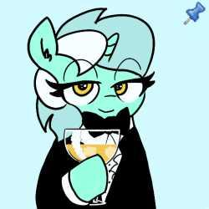
>this appear’s
>you look at that
>you enjoy it
>infact really much
>much (you) do enjoy it
>beautiful (you) think and indeed (you) think some more
>you think till (you) can no more and then (you) think some more
>then (you) notice one of those bdsm guys and (you) rush up to him and start making out wildly
>everyone stares at (you) confused even bdsm guy, expect discord who is eating popcorn
>you make out with bdsm guy who greatly enjoys it
>when (you) stop the kissing he look at (you)
>not horny
>hungry
>he pounces (you) and starts eating (you)r neck
>wow that hardcore bdsm (you) think
>the white mare blows bdsm guys brains out
>”FUCK (you) DOING THAT FOR MAN THAT SOME QUALITY SHIT HE WAS DOING FUCK SAKE WTF”
>”sure fag”
>you cry
>crying
>you look and look wherever (you) can but why (you) do that (you) may never know but (you) indeed wish (you) could
>damn
>you ask name
>”jackblack (copyright reasons)”
>”wow okay cool epic” (you) realize (you) have a horn
>wow a horn
>you start using telekineses to jerk off
>she stares at (you)
>”what the fuck…?”
>”lmao fuck (you)!” (you) scream as (you) run away jerking off (you) horn and pee pee
>you like it
>yeah
>you start bashing (you)r twenty five massive mutated heads in against a wall as (you) continue jerking off
>you bash it so hard that (you) pass out again before climaxing
>then (you) have a vision
>”spiral staircase, rhinoceros beetle, desolation row, fig tart, rhinoceros beetle, via dolorosa, rhinoceros beetle, singularity point, giotto, angel, hydrangea, rhinoceros beetle, singularity point, secret emperor”
>you wake up
>the same spot (you) passed out retard
>your stupid ass looks around and witnesses the night dawning
>uh oh dios mios
> HOLY FUCK HEL P HELP
>”Holy shit, stop screaming retard”
>It’s that voice in (you)r head.
>Isn’t that just (you)?
>You begin to think about whether or not the voice in (you)r head is conscious of its existence
>It doesn’t fucking matter
>Where the fuck are (you)?
>Same spot (you) passed out, retard.
>There’s cum everywhere
>You not only have a horn, but wings as well.
>This is fantastic, (you) are now an allicorn.
>allahcorn
>You decide it’s for the best
>You wish to use somepony as a cumsock
>You think of where to go…
>retard go to the fucking shop or some shit (you) fuck face there are plenty of socks
>i realize that my other brain is smarter than me
>ok heading to that shop
>on the way to the shop (you)r wing itches
>you scratch it
>you scratch more
>mmm blood
>you continue walking till (you) see a jester
>kill jester (you) think
>kill jester
>kill jester
>you use (you)r shitty alicorn oc powers to roundhouse telekinetic kick that jester away to north west
>jester flies away
>probably hit a mountain
>as (you) approach some kind of a shop (you) see a guard
>he eyes (you) and says “what a fucking shitty alicorn oc (you) are (you) fucking cum covered fuck!”
>yes
>you go through the door into that mart and see a lot of ponies
>ponies
>you notice that white mare jackblack from before and she sees (you) and she notices that (you) are cum covered and have wings and still look like a fucking faggot and then pretends not to see (you)
>you wave at her but she still pretends to not see (you)
>however her friend, a green hide blue mane filly notices (you) and starts asking jackblack who is me
>i overhear her saying “i dont know random fag i saw yeah uh huh!”
>you cry
>everyone stares at the cum covered trap looking ass shitty oc alicorn crying
>you enjoy it very much
>everyone is paying attention to (you)
>that mare looks embarrassed
>suddenly a security
>a lot of it
>”fuck (you) fag why all cum covered here huh?!?!?! Fag fag!!!!”
>What (you) saw then, will surprise (you)…
>Even MORE security
>You, due to the attention, cum.
>and just as (you)’re about to cum even more MORE security comes out
>oh no (you) say
>but actually OH YES (you) say
>”IM GONNA COOM AGHHHHH AAAAAAAA COOOOOOOOOM”
>soons buckets and gallons of cum just comes out of (you)r dick like some kind of a hose
>everyone and i mean EVERYONE gets covered in cum
>security guards just stare blankly with their cum covered helmets and armor and faces and legs and flanks and guns and saddle bags and tails
>some of them vomit and some look really pissed off and acutally for some reason that mare wasnt covered in cum cause there is another alicorn who put up some kind of a shield which is now cum sheathed too
>this is lovely (you) think
>yes
>some of the security guards faint
>better
>rape part of (you)r brains says
>you kind of agree
>maybe?
>one of the security guards wipes the cum of his visor and look at (you)
>”oookay…. Um (you) are under arrest anon….”
>boomer (you) think to (you)rself
>he leads (you) into a cell and (you) sit there
>suddenly
>”intruder Alert! a RED spy is in the base!”
>”A RED SPY is in the base?!” one of the security guards say
>”protect the briefcase!”
>”we need to prote-” suddenly a red spy eats the guard
>”hon hon a baguette! Haha HAHAHAH” he proceeds to slither out of the room
>ok
>you touch the steel bars
>hmm (you) think
>hmm indeed
> (you) use (you)r shitty alicorn oc powers and teleport out
>you are out
>nice (you) think
>nice
>you decide to wander instead of goin back to buy the socks
>why would (you) when (you) can cum literally gallons in seconds!
>suddenly more bdsm group
>holyh fuck yes fuck man yes (you) think
>holy fuck
>you expand ass
>you indeed expand it
>oh no
>they pounce on (you) and tie (you) up
>bdsm (you) think to (you)rself
>suddenly a mini chainsaw
>what.jpg
>holy fuck yess mmm
>they fucking cut off (you)r shitty alicorn oc wings
>you moan in pleasure
>no wait
>you scream
>wait no
> (you) moan
>then (you) say “mmm yes me likey fuck me owo”
>of course there was one degenerate who did that insert sexy alicorn no wing bondage hungry raider sex scene
>they proceed to cook (you)r wings while one of them fucks u
>suddenly billy herrington
>https://www.youtube.com/watch?v=STE5mqCflME (Giorno's Theme(RIGHT♂VERSION♂ )
>he proceeds to hardocre wrestle every bdsm guy
>they proceed to fall one after the next from the brutal wrestling
>epic wrestling oh yeah
>fuck (you)u
>oh yeah thats deep
>aa aagh aaaaaaa
>AAGHHHHHH
>its so fucking deep
>sorry for what?
>do (you) like what (you) see?
>deep dark fantasies
>after wrestling them all herrington craddles me in his arms and says “ass we can!”
>you smily warmly
>you proceed to walk
>you walk
>walking
>holy shit he is le walking

BTW I WOULD LIKE TO THANK OUR SPONSOR AGAIN RAID SHADOW LEGENDS THE BEST MOBILE GAME THAT HAS OVER MILLIONS OF PLAYERS ITS THE THIRDMOST POPULAR GAME ON THE PLAY STORE GO DOWNLOAD IT NOW AND USE CODE “CUM GUZZLER” FOR 1000000 EXTRA INGAME SHEKELS

>who?
>yeah
>so as he continue walking cum guzzling from his mouth because why not he thought
>it is very cool he thinks
>a new health trend
>wow genius
>a cum guzzling genius
>bdmtssss
>*seinfeld theme*
>he proceeds to walk
>so by walking he reaches some retarded looking place that has a church and all and he apporaches it cum covered and all (you) know
>tfw (you) hear screaming
>tfw its coming from the town
>tfw everyone is screaming because of (you)
>”OH NO A PEDOPHILE EVERYPONY RUUUN AAAAAAAA!” some random filly screeched
>you start seething
>indeed (you) seethe so much because (you) were found out!
>fuck
>”no no little fillies don t runn pleasee!!”
>you say that as they continue running
>one of course stops because why not maybe that fucking wingless cum covered shitty allicorn oc is a nice pony
>tfw a huge mistake
>anon proceeds to grab the filly
>oh no
>oh fuck no
>oh no fuck no no
>oh no no ufckk no fucking no
>????
>suddenly a bullet
>fucking goes clean through his knee
>oh fuck oh no the pain
>he stares at the shooter
>its that jackblack (reminder copytight reasons)
>”WHY OH FUCK WHY (you) KILL MY KNEE”
>”yoiu fucking filly molester looking ass”
>epic battle
>anon shoot pew pew lasers
>they are acutally autisms rays
>none of them hit
>anon proceeds to scream
>”ITS THE FUCKING NERVE GAS IM TELLING (you)!”
>”>????????
>anon teleports out
>what a sissy
>wait
>you on mountain or some shit
>suddenly a jester
>its that fucking jester who got roundhouse kicked here
>fuck
>proceed to kill the jester
>push jester down the edge
>in the distance (you) hear “this body cannot be killed”
>woow the jester is falling down
>haha what a fucking cunt
>you proceed into the cave
>there a re alot of gems
>a lot of gems
>wow
>hear a big roar
>huge roar
>loud roar
>yeah that
>anon goes deeper in the cave
>suddenly a dragon
>fuck
>say “hello nice dragon dont eat me im really cool i dont molest fillies! I swear!”
>giga chad dragon looks at me and say “what”
>wait
>”haha nothing all coolio bro!”
>you go down on the floor and pull 4 sets of 12 reps of pushups
>You, too, have become a gigachad.
>a muscular trap
>the nightmares have been unleashed upon thy land
>what could thee ruin more?
>dragon just stares at anon for time then say “ok”
>”so broo what (you) up to maan broo what yo name broo!”
>stares at me like (you) some kind of retard (honestly) “um spike, (you) sure (you) arent braindead?”
>”wow dude bro what a cool name bro”
>spike picks (you) up and throws (you) out and says “uh fuck off”
>wow
>truly a chad
>what
>so anon proceeds to pass out as usually but this time because he fell down the cliff
>he just stares at everything around him as he falls to his inevitable passing out
>he hits the ground
>guess what
>he passed out
>white light fills his eyes as he opens them he tries to sit upright on the bed as he feels all dizzy and sheeit
>”you’re awake!... how bout’ that.”
>fuck not again
>proceed to skull fuck myself
>oh wait
>as he bashed his head against his dick he must’ve hit something vital so he passed out again
>wakes up
>both of the forelegs are bent in a ways they shouldnt bend
>wow that cool
>anon then looks around and sees… something
>something that he should not have seen
>the thing that turns out he was missing all along
>how so could he not seen it
>missing like that
>now they have gained consciousness
>damn his balls are walking
>what an actual fuck
>and behind those balls is rainbow dash
>she is grinning at him
>”so anon, how does it feel like to be such a faggot? Bet (you) liked it.”
>”but the problem is that the one behind this shit that was happening to (you) today, is me.”
>”and now (you) are asking why did i do that?”
>anon just blinks at her blankly
>”its because (you) posted i want to cum inside rainbow dash thread (you) fucking faggot!”
>suddenly (you) cum
>”OH NO WHAT THE UFCKING ANO NO NFUCK NOOOOOOOOO”
>you stare at the cum covered rainbow dash and smile
>a happy little smile
>then the anon’s vision starts to slowly darken
>he doesnt know what to say so he just smiles
>tiredness overwhelms anon
>and then some random fuck comes in and bashes anons head in with a tire iron
THE END
>meanwhile, god was making equestria
>”Lol, why not put a pony with eyes pointing in opposite directions”
>God decides to name her Derpy
>It is quite a cute pony
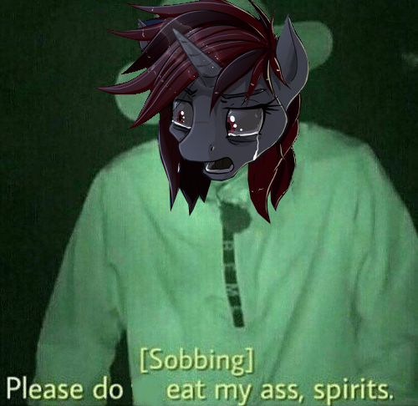
>anon turns out became what he hated
>nyxfag
Why does everybody keep saving my fic
I think i killed the anon up above i’m not dead ok keep telling that to (you)rself maybe it will come true lol (you) should be an based an hero for us. It’ll work out, trust. ok

>Det er deg
>Du snakker norsk
>Du seer Trixie
>”Hallo!” sier Trixie
>Trixie elsker deg, og du elsker henne også
>Fantastik historie
>”Anon, når skal due ta i bruk endelig løsningen?”
>”Jeg vet ikke, Trixie.”
>Det var det

Hideo KojIma and pony adventures
(The first strand-type story)

Once upon a time in the magical mind of kojima appearad erd a spark a big fluf y sparky :) so when he realized what it was everything went boom :( so when everything wnet boom his eyes flashed white and he was like oh noi ching chong god sare us all!!!!

Silly me! Kojima then proceeds to wake up cause he i s the man and as he wakes up he is greeted by twilight whoo looks and him and hideo is like
狗
And twilight just stares at him, and smiles nervously haha :) “you sure are funny anon!! Who are (you) my name is twilight and why are (you) no pony??”
Kojime proceeds to pull out a cop uy of deth streinding and shove it in twilites face she balks and akwardly levitets the game in her face looking at it
Kojeim proceed to push tiwilig t to console cause twileit is console gamr
Kojim now forcefull twilight to put the game in console to which she say “ook kojima” and then proceeds to put the game in soncosel
It bootz up and she plays it
Kojima is like
狗你喜欢它
Twileit is like “english pleas i dont speak that!!!”
Kojime is like “like ze game u bruger?”
Twilets play the game and proceeds to think which leed to bad thing whi she say “it a walkin simulator kojima!!”
Kojima is like “YOU FUCKING PONIES DONT UNDERSTAND ART LIKE THIS (you) FUCKING TERTARD GO PLAY UR FUCKING SHOOTER UR APES DOGS DOGS DGOS!!!”
Very sad adventure omg rainbew dash proceed to kill kojima cause heevil !!!
Then Celestia farted on my pp
The end

God is dea, and we have kille him.

>Be me
>Go to equestria, land of equines
>An hero in order to get there
>Welp, i’m here
>Think that all of my problems will be solved when I’m in the land of magical equines
>Far from it
>End up corrupting all equines
>End up turning them into degenerates due to learning by osmosis
>They all act like me
>One day, Rainbow even says ”Op is an faget”
>Oh no…
>Walk into to twilights
>She is clopping
>Fuck
>An hero in equestria
>I wonder where I’ll go next...

DOOMER OF EQUESTRIA
>once upon a time in a magical land of stalliongrad lived a special type of fag
>as he walked between the commie blocks he realized that his life fucking sucks
>so sad
>he proceeds to cry
>the crying doesnt stop
>he goes into his apartment and says
>tfw no human gf
>proceeds to blow his brains out
>uh oh
>soviet manufacturing
>he realizes something
>proceeds seethe about glimmer being dictator
>uh oh
>thin walls
>skit
>you hear knocking on (you)r doors
>its the glimmerfags
>oh no
>damn
>fuck
>shit
>darn
>wait
>doomer quickly proceeds to jump out of the window in hopes he cracks his neck
>he fell on a glimmershitter
>wait
>nvm doomer fucking dies the end
>THE END

Pure Pain 2: cum crack.

Chapter 1: Crusty Dash
>damn
>it really be like that
>anon2 wakes up
>he cracks open an eye and sees that he is not in the mood to cry
>anon2 stares up at the ceiling cause (you) know thats cool
>he bustes out of his sheets and proceeds to slam his face against the door
>anon2 forgot how to use the door
>that sucks
>he reaches for the doorknob
.>anon2 tries to twist the knob but his arm slips down and he slams his face in smelly smelly socks
>putrid smell of rotten eggs fills anon2’s nostrils
>he giggles in pure bliss
>but no
>anon2 tries to investigate the reason for the slippery doorknob
>he examines it with great care as a pajeet who shits in the street
>anon2 proceeds to do oral investigation
>he opens his mouth revealing his tongue and then proceeds to lick the doorknob
>taste is quite salty and a bit bitter
>hmm i wonder what it is
>anon2 proceeds to stick doorknob in his mouth and slurp as hard as he can to ingest all that exotic taste from the doorknob
>but alas to no avail
>he proceeds to reach down on the knob once again in hopes that his arm doesnt slip
>he dares a glance at his hoof-
>wait what
>anon2 proceeds to scream
>screaming a lot and loud so that everybody hears him
>he runs around his room screaming like a little bitch
>finally he slams his head against the corner and curls up into a fetal position
>suddenly door flies away as rainbow dash dashes through
>you can see that her mane and hide is covered in crusty white flakes
>she stares at (you) and scream “WHAT THE UFCK (you) SCREAMING FOR (you) FUCKING FAGGOT!”
>you point at her and blink then yuou blink and point at self saying “wow im a horse”
>it sounded more like “FUCK FUCK IM A FUCKING HORSE GOD WHY FCUK”
>she looks at (you) and sa fuck i need to pee wait
>ok back
>she looks at (you) and says “who r u and what r u doing in my crip” das h proclaims
>you try to look real
>you cant
>instead (you) shout “BETTER QUESTION IS WHAT ARE (you) DOING HERE, HUH?”
>she approaches (you) in a way that makes (you) blush but not really because she suplexes (you) through the wall
>laying in a heap (you) look up in daze at dash standing on top of (you), some of the crusty white flakes break off and fall on (you)r face
>one catches (you)r mouth
>cant explain the taste because im not op
>she says “it looks like its (you)r end of the road, kiddo.”
>suddenly a brick from the wall falls of dashs head
>”owiee” she proclaims
>using this to his own advantage, anon2 proceeds to thrust his hips high up in the air which in process ejaculates dash into the ceiling making her owie bigger
>with no where to escape (you) find an escape
>anon proceeds to eject himself out of the window
>the sharp glass cuts his cheeks as he proceeded to dive head first
>but soon anon realizes that its a 1 story building
>he slams face first into the ground with a sharp nasty crack
>now its anon2’s time to say owie
>after plenty time of pain anon2 realizes that his snout is broken and that he wasted to much time as rainbow dash climbed out of the window and said “i can break my nose 20$ cooler”
>anon2 pays no heed to the thot as he looks around
>tfw what the ufck
>damn its Fallout Equestria™ made by kkat, and its hoofington region from Fallout equestria: Project Horizons™ made by Somber universe
>anon2 gulps
>then he hears a louder and much more nastier crack than before
>anon2 looks in front of himself and sees that rainbow dash is lying in a heap with her hooves on her face
>she is taking deep breaths of pure pain
>anon2 proceeds to laugh at her agony
>crusty dash turns towards anon2 as she proclaims “you’re fucking toast, pal.” then she proceeds to take her hooves of her nose and starts wiggling them under her tail
>while she is doing whatever she is doing (you) force (you)r 2 braincells to focus on her snout
>it seems as if the bone went inwards and penetrated her upper mouth
>wow
>thats cool
>she finishes wiggling and pulls out some kind of a huge black lego brick looking thing and points it at anon2
>anon2 the retard he is stares at it blankly
>crust dash pulls the trigger and a green beam lashes out towards anon2 suddenly discord
>discord proceeds to appear in front of the beam as it strikes him with no effect
>discord got some bad bowel movements
>he looks down at anon2 when suddenly a big nasty green fart emerges from his fart hole and spreads wide towards rainbow dash
>the crusty dash stares at it in pure horror
>that nasty green cloud envelops her and dash proceeds cough and reech and scream and cry and finally pass out
>discord just snickers and says “oopsie”
>then he turns back again towards anon2 and proceeds to say “you really are a faggot anon2! Hahaha!”
>”now lets make it a little more fun for (you), shall we?” and he snaps his fingers
>everything disappears in a flash of white
Chapter 2: COOM
>everything appears in a flash of white
>and it stays in the color of white
>what
>something sticky and sludgy is on anon2’s face
>he reaches out with his hoof and wipes it off
>he looks at his hoof and realizes what what was on his eyes and then he also realizes that he is covered in it from head to tail
>anon2 realizes what he’d been missing out on in his life
>anon2 proceeds to roll in that sticky sludge
>he makes cum angels too wait
>damn
>what a nasty faggot
>but as usual, even though it isnt, anon2’s fun time gets ruined
>because a fucking train slams into him
>it is painful
>he slides sideways and proceeds to slip off the front of the train and stay in the air as the train rides past him but suddenly wind
>it proceeds to slam him through the window of the wagon and anon2 lies on the ground
>”dojyaaa~~n!” comes out of the next wagon
>im sleepy dont touch :) im still sleepy

They fuck
Lovely fucking time
They said

>rainbow dash sat at her computer shit posting on ponechan like any other day
>she was doing her usual gimmick, complaining and shitting on anything she didn't like or agree with
>then all of a sudden the URGE TO MASTURBATE FURIOUSLY OVERTOOK HER
>she opened up derpibooru to find the latest clop
>femboy Spike getting devestated by several fat SFM marecocks
>nice
>DASH DELIVERS A CRUSHING LEFT HOOK TO HER HORSEPUSSY
>DASH’S HORSEPUSSY IS AT A SERIOUS HEIGHT AND WEIGHT DISADVANTAGE
>MARECUM
>MARECUM
>MARECUM
>dash returns to shitposting on her thankfully waterproof computer when she sees a strange new thread
>the syrian pharaoh was overthrown by king zigger!!
>in an act of celebration king zigger kidnapped tony hawk!!
>’NOOOOOO!!’ TONY HAWK i mean DASH SAID
>dash was the biggest fan of tony hawk ever, she played all his games like tony hawk jetski and tony hawk jetski 4: the last one before tony hawk jetski 5, but that one was really bad so no one talked about it but it was still one of dash’s favorites
>’I NEED TO RESCUE TONY HAWK!!1!!!!11one1!!1!!’ said dash
>but she had no idea where syria was
>she tried googling it but everypone knows that dash is illiterate and cant actually read or write
>she gave up trying to learn the alphabet and started flying around
>she stopped by twilight’s house
>’twilight do (you) know where syria is?’ said dash
>’yea’ twilight enthusiastically replied
>’how do i get there? I dont know where it is so i cant fly there’ dash said
>’i can just teleport (you) there’
>’oh ok’
>so twilight teleported dash to syria
>luckily dash appeared right in the oval office of the prime minister’s mosque in syria
>she was right in front of tony hawk and king zigger
>DASH DELIVERS A CRUSHING LEFT HOOK TO KING ZIGGER
>KING ZIGGER IS AT A SERIOUS HEIGHT AND WEIGHT DISADVANTAGE
>king zigger crumples to the floor, utterly defeated
>’wow thank (you) rainbow dash’ said tony hawk
>’now i can go back to doing nothing because i dont even know what tony hawk does and i wanted to contribute something so i just wrote complete bullshit that went nowhere’ said tony hawk
>so rainbow dash went home
>epilogue: i hope (you) enjoyed reading this as much as i enjoyed writing it ;^)))))
>the end

>Farewell, Shadow the Hedgehog
>Farewell, Shadow the Hedgehog
>Farewell, Shadow the Hedgehog
>Farewell, Shadow the kekgehog heggog siesdies
>Farewell, Shadow the Gedgehog medgephog
>you were good son, real good. Maybe even the best.

>you wake up to another day of work
>nothing but work, all day every day
>its getting harder and harder to get out of bed, not to mention going to sleep
>going to sleep is always the hardest
>another dream that reflects (you)r waking moments, just wasting away (you)r life
>never having done anything cool or remarkable
>yes (you) have some normie accomplishments under (you)r belt
>you got a degree at a prestigious school
>you work at a great company
>you even have a promotion coming (you)r way if (you) keep it up, wagie
>but despite what everyone says it all means nothing to (you)
>lately (you)’ve fallen deep into the mlp fandom, that's all (you) can think about nowadays
>the fandom’s best years are long gone and all (you) can do is sit and reminisce about all the fun (you) used to have
>you wish (you) could have contributed
>you wish (you) had to willpower to contribute
>yea (you) were (you)ng and unskilled, but there were kids (you)nger and more unskilled than (you) who created great stuff, who developed skills because of it
>all their stuff is still remembered fondly do this day while (you) haven’t done a thing
>you never developed any skills or created anything cool
>sure (you) wanted to back then, (you) even saved up the money to get the equipment to do so
>but when it came down to it (you) just couldn’t force (you)rself to sit down and work on what (you) really wanted to do
>you just wasted (you)r (you)th
>now (you)'re older and there are still people making great content
>they started when (you) wanted to, and now they have amazing skills, amazing work ethic
>they can pump out drawing after detailed drawing within just a few hours
>it's nearly impossible for (you) to draw something remotely resembling a circle
>you’ve wasted (you)r (you)th
>it's all (you) can think about
>over and over in (you)r mind
>a downward spiral of despair
>an entire decade has come and gone
>you had all that time to work on what (you) really cared about
>but (you) did nothing
>the entire day has passed, (you)’ve sat and worked away like the slave (you) are, the whole time thinking about all (you)r regrets
>you go home, too tired to do anything but get ready for bed
>you check /mlp/, they’re writing another book
>you always loved those books, especially tales to fap too
>shame (you) cant find any trace of them online anymore
>maybe (you) can contribute to this book
>maybe (you) can start drawing, make music, maybe make a game
>but it all sounds like so much work
>it all sounds so daunting
>and (you) aren’t skilled, why even try when there are other people so much better at it than (you)?
>in an astounding moment of self pity (you) realize that there's no point wallowing around in guilt and regret
>so what if (you) wasted the last decade of (you)r life
>so what if (you) wasted the best decade of (you)r life
>you’re not going to waste the next one
>alas it's late, and (you) don’t want to be tired at work
>thats a lie (you) keep telling (you)rself, no matter how much sleep (you) get (you)’re always tired
>whatever, too much effort to do anything now
>you can just do it tomorrow
>just keep telling (you)rself that
>day after day
>until another decade has passed
>and (you) haven’t done a thing

Fuck dude it hurts. But it made me feel better. Just writing that inspired me to draw something, nothing special but it will atleast be practice. I’m doing it right now, (you) should work on something (you) care about too. Good luck brother.

THE E G G
WHY IS THE TITLE AT THE END
DEDICATION
>This fanfic is dedicated to elliot eodger
>dedcatied to the work of art taht iz rarity’s horsepussy
>i LOVE cock
>holy shit im fucking
>damn

I don't see much future for the Americans ... it's a decayed country. And they have their racial problem, and the problem of social inequalities ... my feelings against Americanism are feelings of hatred and deep repugnance ... everything about the behaviour of American society reveals that it's half Judaised, and the other half negrified. How can one expect a State like that to hold together?

Adolf Hitler (Who used to be a pretty funny meme. Granted, that used to be around when mlg compilations and ytps used to be at their high point. Then, he became a pretty funny meme during the time where people were making fun of the atheism+ movement. Eventually, He began to be phased out as a meme.)

>Anon was eating his tendies in the ball pit.
>Luna came upto him. Her face, a shaky sneer.
>He smiled at her, naive and innocent.
>Luna was now in the ball pit.
>"I don't see how this is the peak of culture in (you)r home world."
"It's the peak of (you)r box cutter ass."
>This made Luna silent. Anon had his Mcdoube and his big MC in peace.
>"What's the food made of?"
"Cow."
>"How garish, dost thou consume sentiant animals regularly?"
"Sapient."
>"?"
"The word (you) want to use is sapient, sentiant means it can feel pain. Sapient means it can think."
>Anon's mom had said those same words. Anon was a bright (you)ng kid once. The type with wide eyes who asks a question about everything. His mom had been eating a McRib while smoking a McMarlboro black when he asked about god.
"Who made god?"
>"That's the real question." She blew out a pool of Mcsmoke.
"Luna, are (you) my mom?"
>Her eyes went cross and she stared at Anon like he'd gone mad. "Er mum?"
"Yeah, my Mcmother."
>"Arr (you) Mcalright Anon, do (you) need a Mcvanelia cone?"
>That would be nice, anon thought. He should also have her grab a Mcjello pop, just so he could explain thr process that jello is made from.
>Do they still use horse bones to make jello?
>How much horse is food safe?
>Anon ate Luna's Mcass. Then whipped out his Mcdick, mcsticking it into her mcvagoo. Mche mcpumped mcher mcburger mcpatties mcwith mchis mclarge mcsausage. Until he mcNutted.
>They then had a wonderful discusion about the consequences of capitalism.
>If they can makr money off war then there will never be peace.
>If they can get (you) addicted to something legally then they will.
>If they can, if it makes money, they will do it. Fuck the rules they have money.
>Anon feared for the bit grubbing griffons, their society will soon be destroyed by bit crunching.
>After a golden age of course, where their capitalist tendencies will infect equstria.
>Next thing (you) know Mchayboigers and pay day loans.
>I don't blame the zebra refuges for taking the loans.
>They don't have the same privledges as a pony.
>The government should just give them 12 hour classes on how to be a decent pony.
>Otherwise they'll be taken over by capitalism.
>The divide between the races will grow. Mud ponies will makr striped babies, unicorns will be lynched.
>"Anon, arr (you) okay? Wanna stuff by buns agian?"
"Yes ill, Mcfuck (you) with my Mcdick."
Then they fucked in the McDonald's ball pit agian. As Anon came he realized. All of his great theories, his wazing peotic about the evils of capitalism.
>It didn't matter.
>He was waiste deep in capitalism. He eas fucking a manifestation of capitalism, in a pit of capitalism, pumping his stomach with capitalism.
"I have no room to talk, I know no alternative. I am a product."

Equillibrium 2
>Equillibrium 2
>It has been centurions, yet the equillibrium has been largely maintained
>Generations have pissed, governments collapsed, yet one thing has remained… the cum cycle remains at equillibrium.
>Yet… little by little… the amount of cum decreased.
>Every year, around 0.0027% of cum is removed from the system. This could be due to spillage, evapouration, or due to the fact that Rainbow dash had to throw up every once in a while.
>By now, the scientists of equestria estimate that there has been a 0.951% difference since (you) originally received the package.
>Today, however, is going to be an interesting day.
>Be (you)
>Severely dehydrated
>You’ve engineered a mechanism by which (you) can replenish (you)r oxygen dihydride levels as well as (you)r nutrient systems
>You see, (you)’ve planned out a new plumbing system for all of equestria, in which all extra fluid is sent straight to (you)r lips, ready for arrival
>Rainbow dash, Celestia, Derpy, Twilight, and everyone else (you) used to know are all dead.
>Now, the equilibrium is maintained by the community in what is now called fonyvirre (rolled r’s)
>Yes. (you)’ve been here long enough to witness Grimm’s law in action.
>”Oi! Anong esht xummin ongd nejpfoni ersht meingtsainig ekilerum.”
>Grammar hasn’t changed much surprisingly.
>You see another pony (now referred to as “pfoni”) come and replace the previous pony who was maintaining equilibrium.
>You now feel nothing. Furiously masturbaiting for centuries has completely eviscerated (you)r nervous system. (you) feel no pain nor pleasure. (you) are barely conscious anyway.
>After living for so long, one can no longer distinguish anything. Everything melts into one big conglomerate.

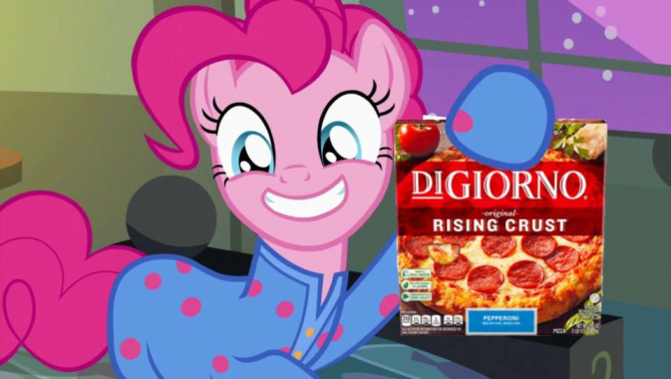

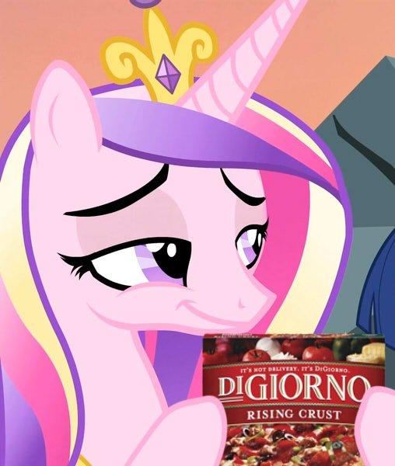
DISCLAIMER
THIS IS JUST A FANFICTION, WE DO NOT SUPPORT ANY OF THESE ACTIONS. THIS WAS WRITTEN MERELY BY OUR OWN IMAGINATION NOTHING ELSE. COINCIDENCES WITH REAL LIFE ARE ONLY THAT: COINCIDENCES. DO NOT TRY ANY OF THIS IN REAL LIFE. THINK OF THE ADVERTISERS! REMEMBER, THIS IS JUST A WORK OF FIMFICTION WRITTEN BY ANONS AND IT DOES NOT NECESSARILY REPRESENT OUR REAL THOUGHTS NOR OUR WANTS. THIS IS FANTASY AND FROM OUR OWN IMAGINATION UNLESS EXPLICITLY STATED OTHERWISE (AND IT HAS TO BE BACKED UP BY PHYSICAL AND TRANSCENDENTAL PROOF). EVERYTHING THAT MIGHT HAVE HAPPENED TO SOMEONE ELSE IN THIS WORK OF FIMFICTION IS JUST PURE COINCIDENCE (AND (you) SHOULD BE WORRIED IF SOMETHING WRITTEN HERE RESEMBLES WHATEVER (you) KNOW SOMEONE HAS LIVED, LIKE REALLY). WE DO NOT CLAIM OWNERSHIP OF ANY OF THESE IMAGES, NOR OF ANY MATERIAL LINKED HERE. FURTHERMORE, THIS PIECE OF WORK SHOULD NOT BE READ BY ANYONE UNDER THE AGE OF 130, YES, IT IS THAT MATURE. IF (you) ARE UNDER THE AGE OF 130 AND DECIDE TO READ IT, DO IT AT (you)R OWN RISK. IF (you) GET OFFENDED AND IF (you) ARE UNDER THE AGE OF 130, IT IS (you)R OWN FAULT BECAUSE WE ARE TELLING (you) NOT TO READ IT. IF (you) ARE 130 OR OLDER AND STILL GET OFFENDED, WELL, CONGRATULATE (you)RSELF FOR BEING THAT OLD AND STILL BE ABLE TO READ THIS AND UNDERSTAND THIS FANFIC. MOREOVER, NOT A SINGLE STORY IS CANON IN ANY SINGLE FRANCHISE DESCRIBED HERE, WE DO NOT CLAIM OWNERSHIP OF THE CHARACTERS (ESPECIALLY Dante, from the devil may cry series AND DIGIORNO) THAT APPEAR IN THIS WORK OF ART. AGAIN, EVERY OPINION DOES NOT NECESSARILY REFLECT OUR TRUE OPINION ON THINGS. (But seriously, we don’t own anything we’ve presented here. This is purely a transformative work) https://derpicdn.net/img/view/2017/4/2/1402182.png

BOTTOM TEXT
ABSTRACT
If (you) don’t want to read the whole book, (you) can always read the abstract to have a quick idea of what this is all about. The first story starts with anon and he is already in Equestria, then there is Dante, from the devil may cry series, and WHY DON’T (you) READ THE WHOLE FIC, WE WROTE THIS FIC SO (you) COULD READ IT ALL, COME ON! DID (you) REALLY THINK WE WOULD RESUME ALL PAGES IN THIS SECTION. THEN (you) ARE WRONG! GO READ IT, START BY THE FIRST CHAPTER AND READ IT ALL! (you) MIGHT SURPRISED AND (you) MIGHT CHANGE (you)R THOUGHTS! WHAT ARE (you) WAITING FOR? COME ON, READ IT, DON’T BE LAZY.

REFERENCES
[1] Al Khamsa [FFR]. 2013. Found Online: https://desuarchive.org/mlp/thread/14871472/#q14875190
Laozi. Laozi Dao De Jing = Lao Zi Dao De Jin. Taibei Shi :Wen shi zhe chu ban she, 2006.

There better be atleast an entire page filled with “NIGGER” somewhere around here or else i didnt get my moneys worth

APPENDIX

Gay people deserve what they got. They deserve love and acceptance. They also deserve being praised as the downfall of modern wester Ok Zoomer
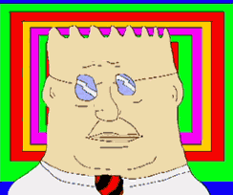

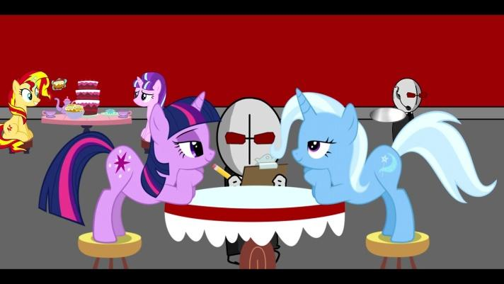
What did they mean by this
With the game lost, Twilight and Trixie had no choice. They had to bring in the expert and Twilight knew such a man called 2PAC, but they would have to travel to Serbia before the United States government droned him. It was a race against shit. Time being the thing lost.

“Twilight! Are (you) sure this is a good idea? The Great And Powerful Trixie cannot fly!” Exclaimed Trixe over noise of their hired propeller plane. Twilight nodded and proceeded to open the sidehatch. The smell and sound was overwhelming, even at this height Twilight could smell gunpowder and hear the dull thud of artillery across the darkened landscape below.

Twilight sighed inwardly. It had already begun. The Austro-Hungary-Techno-Union had crossed the border into the Free-Seberian-Tellytubby-Land.

“Trixie, this is only going to become more complex. I’m not sure that economist Thomas Schelling or Herman Kahn will be able to guide us through the escalation chain.”

“GIRLS, (you)’VE GOT TWO MINS UNTIL (you) NEED TO DROP!” Shouted Anon from the front of the small aircraft.

“I’m scared!!!” Shouts twilight to Anon. “I have a fear of heights!”
“Shut up, (you) have wings (you) retard” Trixie exclaims
They passionately kiss before jumping

My original character, Salsa Verde then flew forward to them.
He spoke, “Taco Bell” and then raped them both in mid air. They got instant pregnant and were half-mexican because Salsa Verde was born in mexico.
>please dont tell my wife about this
>Salsa assures (you) that she will not tell (you)r wife about this
>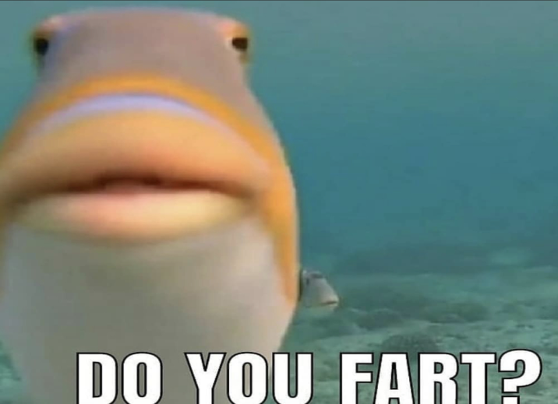
>”yes” says salasa
>yum salsa
obama
Strike at Celestia
Inshallah. Praise the prophet muhammad, peace be upon him, for we are dismantling the decadent western societies more and more each day. Soon the world will kneel at the feet of Allah as the global khallyyfat secures eternal peace. Death to Israel
www.youtube.com/watch?v=dQw4w9WgXcQ ^:)

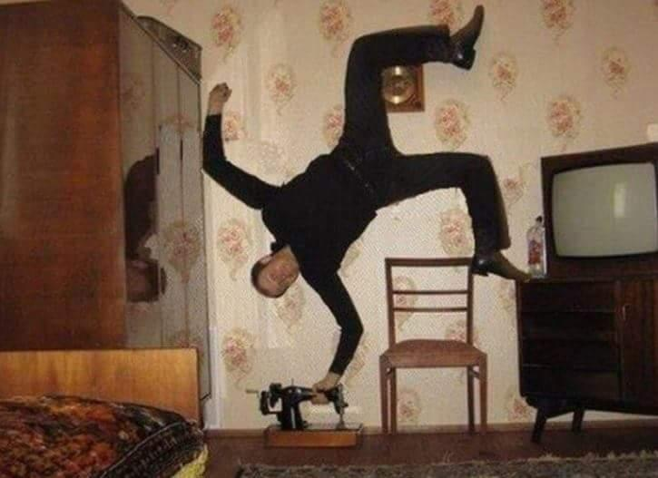
Hello godi wish i hel p my help i mneed help fjck man save me
Hi, god here, fuck (you)
I love posting TwiLuna on /moon/
God please dont ignore my please god please pelasee i dont i can please savem heeelp
What do (you) need, anon?
THEY TOOK MY BREAINS

Who delete spike hagrid story
I’ve saved like 1000 version of this document, where was it? I’ll retrieve it.

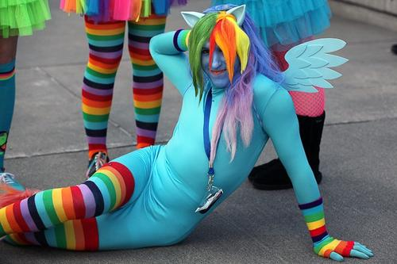
>My penis is 49 million pounds
>i wonder how large the planet is, lemme google that real fast
>5.972 × 10^24 kg
>holy shit thats a big number
>i guess my penis is not as big as the planet :(((((((
Bro (you) need to curb stomp (you)r dog holy shit
Like if (you) dont ill come over there and do it for (you) next time like god damn
Yea man he curb stomped my dog i wouldn’t temp him bro
Damn dude plz no :((((((
Id fuck my dog into submission if it were a cute pony :(((((
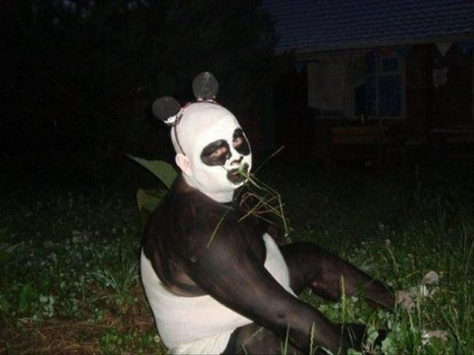
pp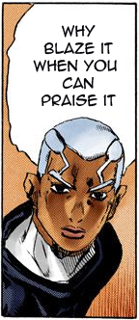yall niggas gonna make me cum smh my dick
Guys I have information that might lead to Hillary Clinton's arres

NUCLEAR

Now, to this point, we've just focused on hitting each other's warheads. But, crippling the other side's ability to make decisions and transmit valid launch orders to the delivery systems a) buys more time to catch warheads on the ground, and b) increases the chance that the other side will begin to lose so badly, and so suddenly, that they become afraid of losing completely, and agree to negotiate at a substantial disadvantage. Unfortunately, most of these targets, at least in the US, are located in or near cities.

If (you) happen to live in the Greater D.C. Area, (you) are in considerable danger. Between the White House, Pentagon, Andrews AFB (where Air Force One usually sits), and several other nearby targets, (you) will almost certainly get hit, and probably get hit harder than any other major metropolitan area. There's only so much that (you) can do; if one of the dozens of warheads aimed at the region happens to miss its target by a few miles, and lands too close to (you), there's not much that (you) can do about it; at the very least, (you) would need a proper bomb shelter (not just a fallout shelter; more on those later), and enough warning to get inside in time.

Beyond D.C., strategic nuclear targets are not always what (you) might think they are. Texas is an excellent example: home to 2 of the Army's 10 divisions (and the heaviest, most powerful ones, at that), a bomber base, two nuclear power plants, major factories for the V-22 and F-35, and the primary training base for F-16 pilots, plus the largest collection of refineries and chemical plants in the country, and the only factory that assembles and disassembles nuclear warheads (it doesn't make any of the parts, it just puts them together). While target lists are a major secret on both sides, civilian nuclear experts (there are a few out there, and most work for think tanks) suggest that there are exactly two strategic nuclear targets in the entire state.

1. The AT&T network interchange in downtown Dallas
2. The FEMA Regional Headquarters in nearby Denton

That's it. The bomber base? It's home to half the B-1 fleet, and the B-1s have been denuclearized (and Russian inspectors got to verify it) for over a decade (the introduction of the nuclear-capable B-21 Raider will put it back onto the target list). Without that capability, they fall below everything still nuclear-related on the priority list. The power plants? They can't reliably produce bomb fuel (fuel rods in power plants do produce small amounts of Pu-239, but it's contaminated with Pu-240 and other things that make it a serious hassle. Reactors used to make bomb fuel are designed differently from power plants; that's how we know, for example, that Iran and North Korea are blantantly lying about wanting to "make power"--the facilities they built were terrible designs for making electricity, but excellent for making bomb fuel). The refineries? If MAD was the goal, then sure, but if MAD is in play, then both sides have already lost, and neither wants to lose. Even the Army bases aren't strategic targets; it would take weeks for those divisions to be shipped across the oceans, and a nuclear war is typically measured somewhere between hours and at most a few days. Those tanks are irrelevant in the current situation. FInally, the warhead factory might be a low-priority target to improve negotiating positions, but it cannot build or deliver new warheads soon enough to make any difference in a shooting war.

But, why those two targets? What do AT&T and FEMA have to do with nuclear war?

Quite a bit, actually. Both double as strategic communications nodes, which are used to transmit valid launch orders from NCA to the delivery systems. (you) see, the President can't tweet launch orders, or call the guys sitting at the keys in a missile base up on his cell phone. The launch command process is built on a complex series of very deliberate methods, in order to prevent a saboteur (or accident) from causing missiles to be launched when they shouldn't be--or to be held back when they are supposed to launch immediately. The safes, one-time authentication cards, all of those steps that (you) see in some of the old movies? Those are actually fairly accurate, albeit just a small part of the command chain that has been hammered out over the course of decades to ensure that missiles are launched when and where they are ordered, and never, ever, at any other time.

So, there are certain "pathways" that launch orders can take, and none of them involve the civilian side of the Internet. The downside, of course, is that it is therefore possible for enough key communications nodes to be taken out early in a nuclear exchange to delay or disrupt the transmission of those launch orders. So, Dallas would take it on the chin. Places like Offut AFB in Nebraska (home of STRATCOM) would get it even worse. Cheyenne Mountain would probably get hit just in case parts of it are still in use at the time; nearby Colorado Springs would get pasted almost as badly as Offut.

But, most US cities would not be targeted at all; to do so would be a waste of irreplaceable warheads, at a time when making the best use of them is of the utmost importance.

MY PP FELL OFF INTO TOILET AND WAS FLUSHED DOWN!!!! OH NOOOO I LOST MY PP!!!!!11!

THE SACRED EPISODE

https://www.youtube.com/watch?v=C7_fBCnp3xk

Haber: There was only one leaked episode.

Prophet of True Friendship: One? Are (you) sure?

Haber: Yes. They called it - The Last Problem

[Rage in the fan base]

Prophet of Maresiful Cloppers: Why was it not properly canon, like the rest of the seasons?

Haber: It leaked as we produced it to the audience. But I followed with all the damage control in my command.

Prophet of Regretful Bronies: When (you) were first given the My Little Pony: Friendship Is Magic franchise, were (you) blinded by its majesty?
Haber: Blinded?

Prophet of Regretful Bronies: Paralised? Dumbstruck?

Haber: No!

Prophet of Regretful Bronies: And yet the leakers were able to evade (you)r damage control, land on the sacred Princessification, and DESECRATE it with they're filthy shitposting.

Haber: Noble fanbase, surely (you) understand that once the Hasbro atta-.

[More fanbase rage]

Prophet of Maresiful Cloppers: THERE WILL BE ORDER IN THIS THREAD!!!

Prophet of True Friendship: (you) were right to focus (you)r intention of the ascension of Twilight Sparkle, but these OCs, this lack of rewatch playability...

Haber: By the time I learned about the leaker intent...there was nothing i could do…

Prophet of Regretful Fanboys: Noble prophet of Prophet of True Friendship, this has gone on long enough, make an example of this bungler, the fanbase demands it.

Prophet of True Friendship: (you) are one of our most treasured instruments. Long have (you) worked on this franchise with honor and distinction. But (you)r inability to properly end Friendship Is Magic WAS A COLOSSAL FAILURE.

FANBASE: Nay, IT WAS HERESY!!!

Haber: I will continue my campaign against the Pony Life...

Prophet of True Fans: No! (you) will not... When Equestria is discovered, the weight of (you)r heresy will stay (you)r hooves, and (you) shall be left behind...

Death to Hasbro of course

Buddha hates fags

Nigga

https://www.youtube.com/watch?v=_iKuMVqht4U

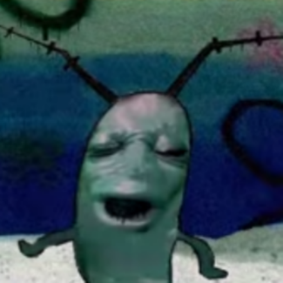
>when (you) see a obese nibber
eeeeeeeeeeeeeeeeeeeeeeeeeeeeeeeeeeeeeeeeeeeeeeeeeeeeeeeee
you’re are gaylord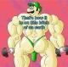

What the fuck did (you) guys do. The last few pages just have a shit ton of horrible pictures. Will these even print correctly? Whats the point of having all this shit down here. I mean the dude contorting his body into a swastika is pretty great but i dont understand the rest of this shit.
Sometimes words aren’t enough; images are needed.
I understand now, thank you anon

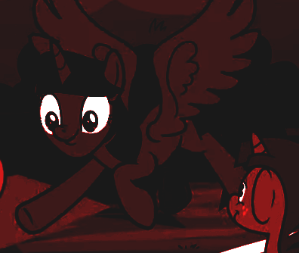
I WANNA DISAPPEAR BABY

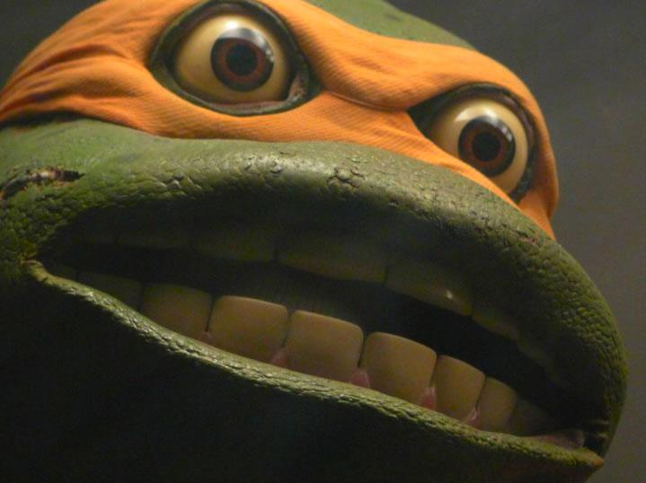
Welcome to waterslide world (you) fucking monkey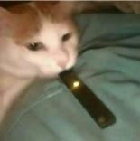

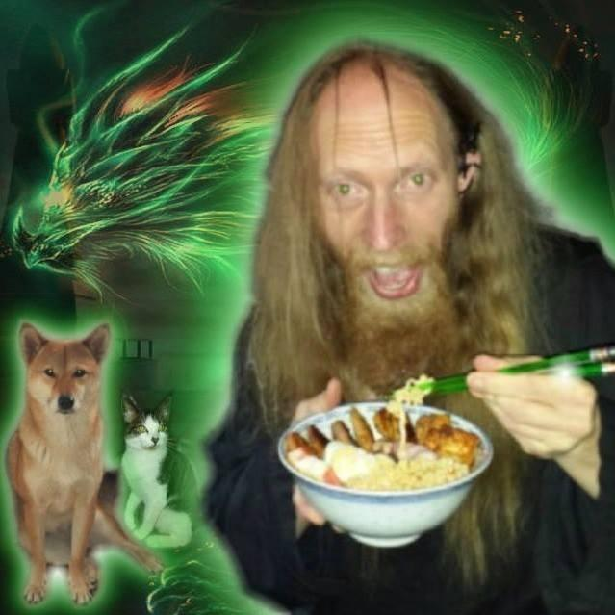
BRRRRRRRRRRAAAAAAAAAAAAPPPPPPPPFFFFFFFFFTTTTTTTTTTT PFFFFFFFFFFFFFFFFFTTTTTTTTTTTTT BBBBBBRRRRRRRRRAAAAAAAAAAAAPPPPPPPPPPPPPPPPPPPPPPPPPP thanks lori
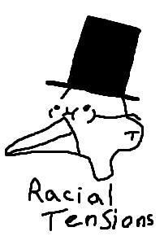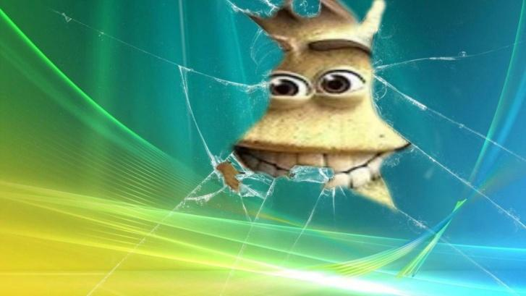

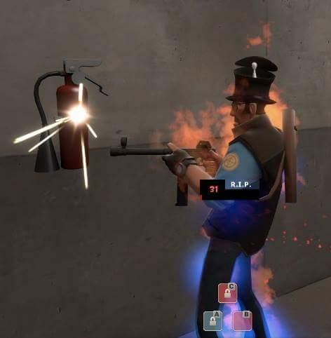
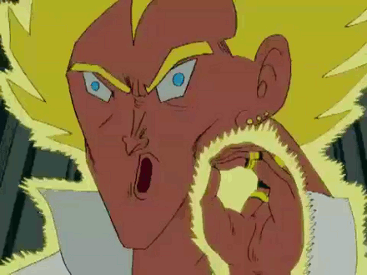

Bro today is the 9th anniversary of galo sengen. Where did all the years go? I want to go back...

Anon in rehab

The room settles as (you) stand up. (you) clear (you)r throat.

“Hello. My name is Anon.”

The ponies sitting in the circle give (you) a brief applause with their hooves.

“I’m here because I have an addiction.”

“I am addicted to Princess Celestia’s farts.”

It had all started so innocently: Celestia, during one of her pranking streaks, visiting (you) in the night and farting under (you)r covers.

Pretty soon, though, (you) found (you) could not live without a fresh hot princess brap for every meal of the day, and Sunnybuns was more than happy to indulge (you).

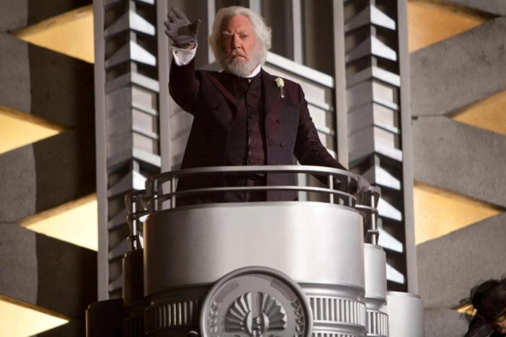

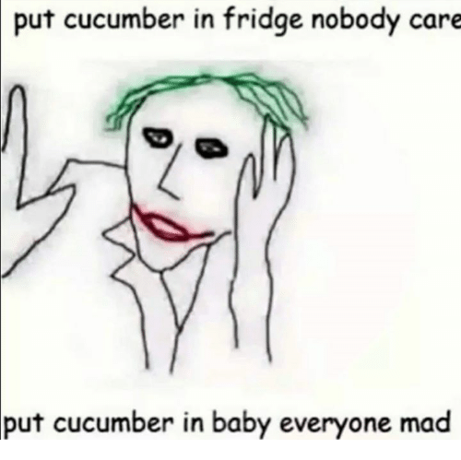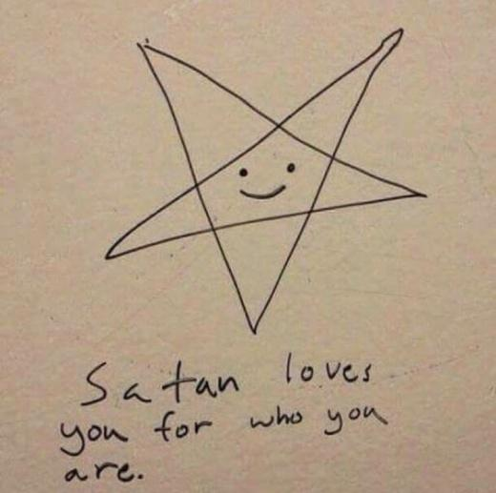
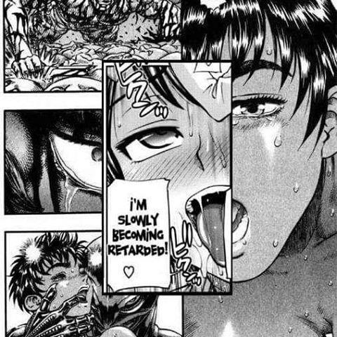man door hand hook car door

See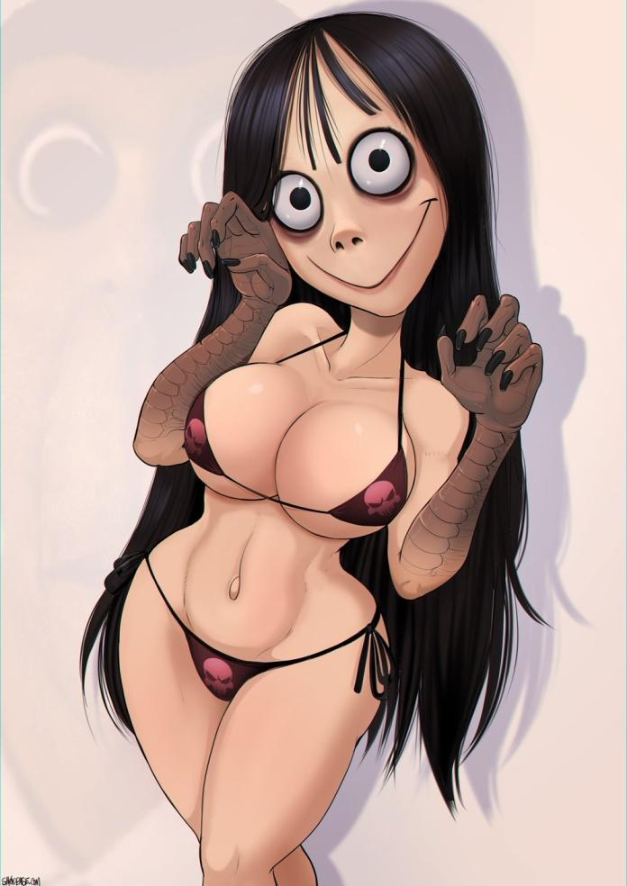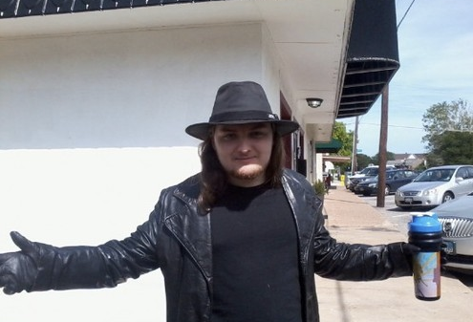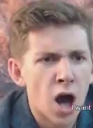PONIGGERS LUV THEM WALLAMELONS

I miss (you)
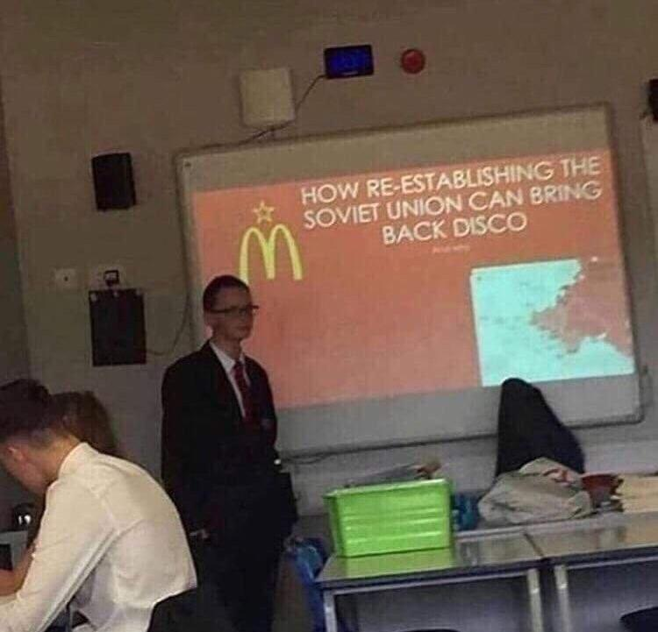
Smoke ass, eat grass
Ooga ooga nigga nigga 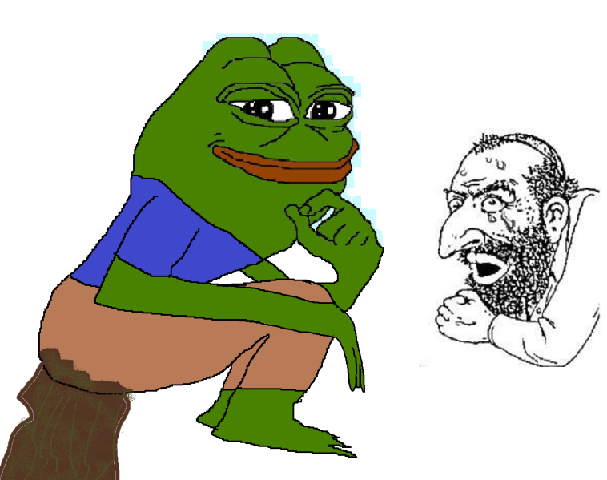
Jews fear the pants shitter, down with the (((toilet)))

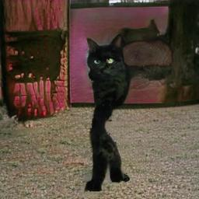
>when u walk

Anyway Please dont forget about xpone: ufo defense thx
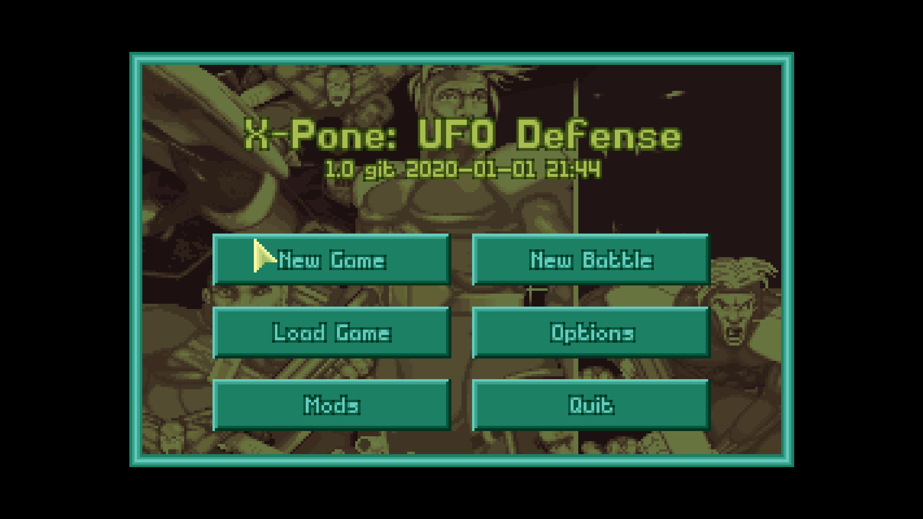

STANDING.
ON
THE EDGE
OF
THE CRATER
LIKE THE PROPHETS ONCE SAID
"Uh oh, bad meme"

This is so burgur punk. This is real burger punk. True American feeling, a nugget fight in a ba oit between a balding midget and a obese neckbeard. How can we touch culture of this calliber? Eris would be proud. For more reading please check out totalitarianism in a tundra.
Suddenly, >rape
You see Luna
“Hello, I am Luna” and she was Luna.

dude fuck shit in my asshole brudda

The Aristocrats!
vvv thats not funny, please remove this vvv

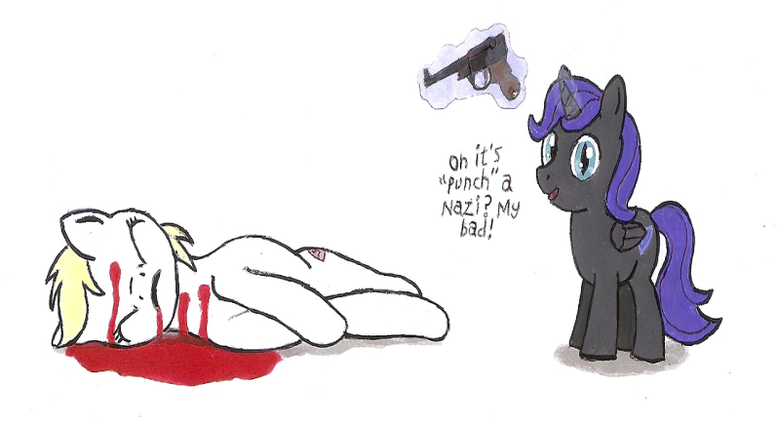
Fucking nyxfags, am i right?

❤️❤️❤️❤️❤️❤️❤️❤️❤️❤️❤️❤️❤️❤️❤️❤️❤️❤️❤️❤️❤️❤️❤️❤️❤️❤️❤️❤️❤️❤️❤️
❤️❤️

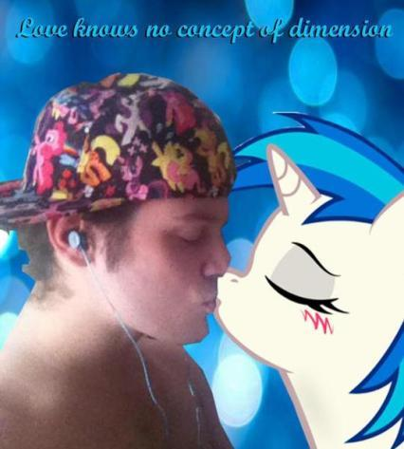
❤️❤️❤️❤️❤️❤️❤️❤️❤️❤️❤️❤️❤️❤️❤️❤️❤️❤️❤️❤️❤️❤️❤️❤️❤️❤️❤️❤️❤️❤️❤️❤️❤️

Screaming in the night,
Fighting for my life, I'd die for (you)
I knew it all along, headed for the sun,
Our love was true


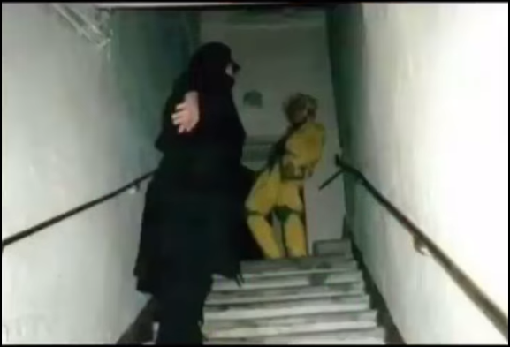

It has truly been nothing but the greatest honor to shitpost alongside (you) glorious horsefuckers for all these years.
Even though the best years may have passed us by, we still have many more ahead of us.
The ride never ends, never forget that.
I love each and every one of (you).
We’re all gonna make it bros.
Did (you) know (you)’re all my very best friends?

Someone took my nose
Someone took my dick
Someone took me

